A Point of Intersection
Student Worksheet

Directions: Solve each system of equation by graphing. Estimate the solution. Then, verify your solution by solving using a different method (substitution or elimination).

Let’s look at an example first.

y = x  y = -x + 2  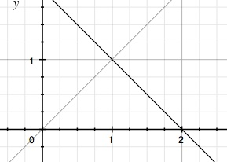 | Estimated Solution  (1, 1) | Verify Solution  Substitution Method  x = -x + 2  + x +x  2x = 2  2 2  x = 1  y = x  1 = 1    y = -x + 2  1 = -1 + 2  1 = 1

Remember: If the lines don’t cross at a point of two integers, it’s OK to estimate. Then, when you verify the solution, you will find the exact point.

y = 2x + 2  y = -x + 1  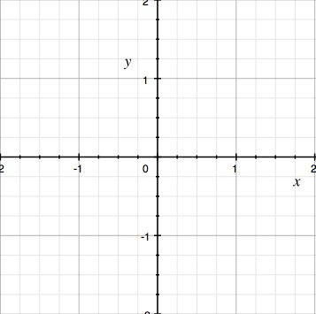 | Estimated Solution | Verify Solution
y = 2x + 1  y = x + 1 | Estimated Solution | Verify Solution

Now it’s your turn! Create 2 linear equations by filling in each blank with the following numbers: -2, -1 1 2. Graph the lines on the coordinate plane. Estimate the solution. Then verify the solution by solving the system using a different method (substitution or elimination).

Linear Equation 1  y = ____x + ____  Linear Equation 2  y = ____x + ____ | Estimated Solution | Verify Solution

