SPIRIT 2.0 Lesson:
A Point Of Intersection

================================Lesson Header=============================
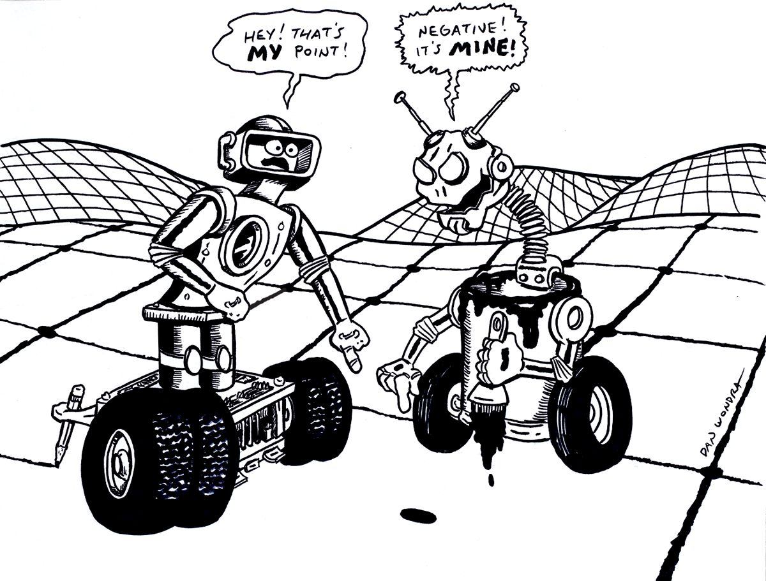
Lesson Title: A Point of Intersection
Draft Date: 6/17/08
1st Author (Writer): Jenn Spiess
2nd Author (Editor/Resource Finder): Rachael Neurath
Algebra Topic: Graphing Systems of Linear Equations
Grade Level: 6-10

Content (what is taught):
- Solving systems of linear equations by graphing
  - Definition of a solution to linear systems with two equations
  - Review graphing of a linear equation
  - Review writing linear equations from a graph

Context (how it is taught):
- Two robots are driven across a grid dragging a string behind them.
- The solution to the system is identified.
- The solution to the system is verified algebraically.

Activity Description:
Robots will be equipped with a string that will be dragged behind the robot across a grid to create a system of two lines. Students will estimate the solution (the point where the lines meet), write the equations of the lines drawn if they are not provided (prior knowledge), and verify that the solution satisfies both equations algebraically.

Standards: (At least one standard each for Math, Science, and Technology - use standards provided)
- Math – B1, B2, B3
- Science—A1
- Technology – F1, A3

Materials List:
- Two robots per group
- Large grid on the ground per group
- String for each robot
- Copy of worksheet for each group or person

ASKING Questions

Summary:
Discuss the concept of a solution to a system of two linear equations graphically.

When 2 lines are graphed on the same coordinate plane, one of 3 things happens.

The lines may be parallel.

The lines may intersect at a point.

The lines might be the same line.
Lines are Parallel-0 solutions
Lines Intersect-1 solution
Same Line-many solutions

Outline:
- Using two rulers to represent lines, hold them up to show two intersecting lines
- Ask questions to help students identify the number of solutions possible in a system (one, none, or many)
- This lesson focuses only on systems with one solution.

Questions | Possible Answers
1. A system of equations is made up of two or more equations… let’s start with just two for now. Holding up two rulers that cross forming an X: Do these two lines meet? | 1. Yes.
2. If these lines were on a grid, the spot where they meet would be called what? (May need to prod some here… Is it a line?) | 2. A point.
3. What do we know about points? | 3. There’s an x and a y value.
4. Is a point always made up of natural numbers like (2, 3)? | 4. No.
5. What could it look like then? | 5. Sample (2.75, 3.1). Answers may vary.
6. Ask students to identify the solution to various systems. Use either resource listed. | 6. Answers will vary.

Resources:
- See http://www.mathwarehouse.com/algebra/linear_equation/systems-of-equation/real-world-application.php for sample real-life scenarios.

Explore learning Gizmo http://www.explorescience.com/index.cfm?method=cResource.dspDetail&ResourceID=120

EXPLORING Concepts (A Point of Intersection)

Summary:
Students explore that a single point satisfies two equations, and is therefore the solution to the system of equations.

Outline:
- Groups use robots to draw system.
- Rest of class identifies the solution.
- Split class into two groups so that each group may verify the solution to one of the two equations.
- Rotate and repeat.

Activity:
1. Have a group of three or four students “draw” specific equations/lines on a large grid on the floor with the robots dragging the string behind and have a student stand at the “solution”.
2. The rest of the class should then identify the solution/point. Split this larger group in two, assign each group a different equation, and have each group determine algebraically whether the solution works for their assigned equation. Students should discover that the point “works” for either equation.
3. Rotate groups so that each group has an opportunity to be out of their seats to create the graph once and to verify algebraically the solutions multiple times. Another station may be added where students use the Classzone animation Chapter 7: Solve by Graphing to see these concepts in another format.

Resources:

Explorelearning Gizmo http://www.explorescience.com/index.cfm?method=cResource.dspDetail&ResourceID=120

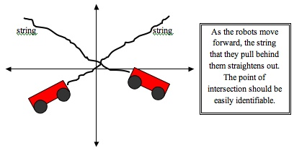

INSTRUCTING Concepts (A Point of Intersection)

Linear Functions

Putting “Linear Functions” in Recognizable terms: Linear functions are equations that generate a [straight] line when ordered pairs that satisfy the equation are plotted on a rectangular coordinate system.

Putting “Linear Functions” in Conceptual terms: A linear equation represents the relationship between two variables, so does a straight line on a rectangular coordinate system. In fact, we can make four statements, that when taken together, show that the plotted straight line and the linear equation each carry exactly the same amount of information about the relationship of the two variables:

1. Any ordered pair that satisfies the equation would represent a point on the plotted straight line.
2. Any point on the plotted straight line will have coordinates whose ordered pair will satisfy the linear equation.
3. Any ordered pair that does not satisfy the equation would represent a point, which is not on the plotted straight line.
4. Any point that is not on the plotted straight line will have coordinates whose ordered pair will not satisfy the linear equation.

Putting “Linear Functions” in Mathematical terms: A linear function is an equation representing the variable y as a function of the variable x that can be written as: y = f(x) = mx + b, where m and b are any real numbers. This form is called the slope-intercept form of the linear equation.
This form can be rearranged into another form (the Standard Form) of a straight line:
Ax + By = C, where A, B, and C are all Real numbers.

Putting “Linear Functions” in Process terms: Thus, for any linear equation, if you know either the x value or the y value, you can compute the unknown value since there are an infinite number of unique ordered pairs that represent solutions to (or that satisfy) the linear function. We often use x-y (ordered pair) tables to simplify this process.

Putting “Linear Functions” in Applicable terms: Place a piece of masking tape in a straight line on your axes on the floor (plane). The tape may be oriented in any random direction. Drive the robot from the origin along the abscissa for a random amount of time. This value represents the x coordinate of an ordered pair that will satisfy the equation representing the straight line. Turn the robot 90 degrees toward the tapeline. Drive the robot to the tapeline. Turn the robot 90 degrees toward the ordinate and drive to the vertical axis. This value represents the y coordinate of the ordered pair that satisfies the equation of the straight tapeline. Now you have identified (by your ordered pair) one of many possible solutions to the equation representing the straight line.

ORGANIZING Learning (A Point of Intersection)

Summary:
Groups of students will use the robots to draw the two lines of a system, determine its solution, and verify the solution in both equations.

Outline:
- Draw given lines with robots.
- Record the lines on a worksheet.
- Identify the solution.
- Verify algebraically the solution in both equations.
- Validate graphs and solutions using graphing calculators.

Activity:
A worksheet will be provided requiring students to graph two different lines using the robots and to record their graphs. The worksheet will also ask them to write the equations of both lines, estimate the solution to the system, and verify the solution satisfies both equations.

Worksheet:
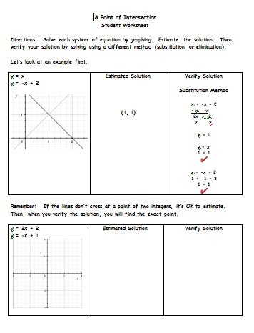
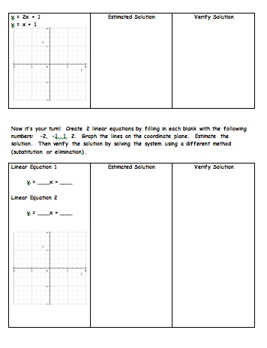

UNDERSTANDING Learning (A Point of Intersection)

Summary:
Students write a description of how to solve a system of equations by graphing.

Outline:
- Formative assessment of solving a system of equations by graphing
- Summative assessment of solving a system of equations by graphing

Activity:

Formative Assessment
As students are engaged in learning activities ask yourself or the students these types of questions:
- Were students able to graph both lines successfully?
- Were students able to estimate the solution successfully?
- Can students explain how to verify a solution algebraically?

Summative Assessment
    - In a written or verbal interview with the teacher, students will describe how to graph each line in a system and determine the solution to the system. Students should also describe whether the solution is correct algebraically.
    - Ask students to write their own word problem(s) using graphing systems to solve a problem.
    - Students should be able to answer the following quiz questions:
- The solution to which system is shown by the following graph? (Answer: C)
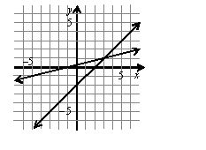
A. | 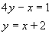 | B. | 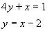
C. | 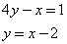 | D. | 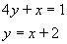

2. Destiny is renting a bicycle for a day. She has two options for renting the bicycle as shown in
the following chart.
Rent Option | Deposit | Price Per Hour | Equation
A | $10 | $4 | (C = 4x + 10)
B | $15 | $2 | (C = 2x + 15)
a. Write an equation that shows the total cost for each option.
b. When will the two options cost the same amount? (2.5 hours)
c. If Destiny plans to ride for two hours, which is the best option? (A)
d. If Destiny plans to ride for five hours, which is the best option? (B)

