SPIRIT 2.0 Lesson:
Amazing Consistent Ratios

==============================Lesson Header ==============================
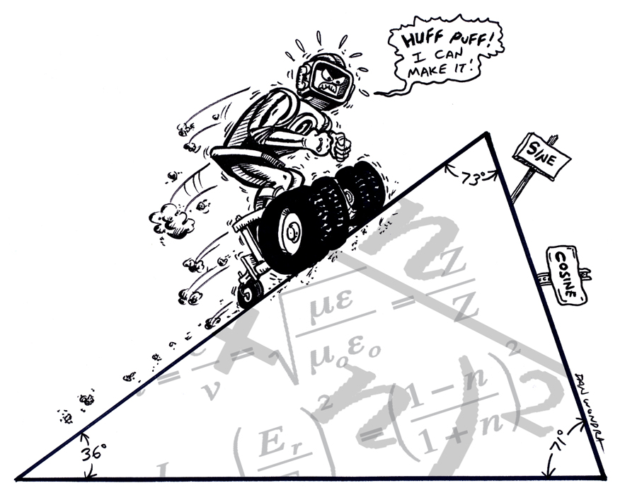
Lesson Title: Amazing Consistent Ratios
Draft Date: June 11, 2008
1st Author (Writer):
2nd Author (Editor/Resource Finder): Sara Adams
Algebra Topic: Trig Functions
Grade Level: Secondary

Content (what is taught):
- Application of Trigonometric Functions
- Measurement, creation, and analysis of data
- Using mathematical modeling to make predictions using recognized/learned patterns

Context (how it is taught):
- The robot is driven up a ramp.
- Measurements are taken relating to the robot’s position.
- Data collected is analyzed and patterns are discerned.
Activity Description:
The robot will drive up a ramp at a set angle creating a triangle formed by the ground, a vertical leg from the ground to the center of the axle, and the ramp. The horizontal and vertical distances will be measured and the sloping side (hypotenuse) will be measured or calculated using the Pythagorean Theorem (). These measurements will be recorded. The process will be repeated until sufficient data is collected. The data will be analyzed and the concept of consistent trigonometric ratios for similar angles will be derived.

Standards: (At least one standard each for Math, Science, and Technology - use standards provided)
- Math—D1,E1,E2,E3
- Science—A1, A2, F5
- Technology—D1, D2, D3

Materials List:
- Robot
- Meter stick/measuring tools
- String
- Ramp
- Calculators
- Data Sheet
ASKING Questions (Amazing Consistent Ratios)

Summary:
Students will be asked if there are any patterns or relationships in the triangles and will be asked how potential relationships could be measured and calculated.

Outline:
- Present several similar triangles on the chalkboard or overhead and ask students if there are any relationships present in them, guiding the discussion toward ratios of sides for the purpose of trigonometry.
- Drive the robot up a ramp and show the triangles that it creates.
- Ask students to design an experiment to collect data to explore possible relationships.

Activity:
Discuss how the sides of similar triangles could be related by using templates or models of triangles. Drive a robot up a ramp and look at how, if you stop it, the robot forms similar triangles.

Questions | Answers
What relationships are present in the sides of similar triangles? | The ratios of any two sides are the same as the ratio of the corresponding sides in any similar triangle.
How can you measure the sides of the triangles formed by driving the robot up the ramp? | The sides can be measured by using a meter stick. The vertical distance can be measured by using a string and then by measuring the length of the string (non-elastic).
How can data relating similar triangles be created using a robot? | Drive the robot up a ramp with a fixed angle. Stop the robot along the ramp several times and measure at each stop.
What is important to consider in this experiment? | Important considerations include measurement error, consistency in measurement, and sufficient data points.

EXPLORING Concepts (Amazing Consistent Ratios)

Summary: Students will drive the robot up the ramp stopping multiple times at different points to measure and record the sides of the triangles formed by the horizontal, vertical, and hypotenuse of the ramp.

Outline:
- Students will drive the robot up a ramp stopping it and measuring the sides of the triangle that is created.
- Students will record the data collected.
- The ramp angle can be changed and the process redone as many times as deemed necessary by the group or by the teacher.

Activity:
Working with the robot, students will build a ramp with a fixed angle to the ground. Students will measure the angle and then drive the robot up the ramp varying the distance. Students will measure the horizontal and vertical components (and measure or calculate) the hypotenuse. The robot must be driven and measurements taken multiple times up the same ramp angle, creating data for several similar triangles. The wheels on the robot can be modified to increase traction, so it can climb steeper angles. The experiment can be repeated with different ramp angles to find multiple sets of similar triangles.

Students will analyze the data collected and consider what types of relationships are present in the similar triangles found in each experiment. Students will investigate the quantity and quality of the data collected, and then begin to think about the validity of the experiment. To provide assessment of the quality of student work, ask yourself these questions:

1. Did the students try different ramp angles to see if there are consistencies in many different groups of similar triangles?
2. Did the students think clearly about how the data will be collected and how to measure properly, keeping in mind measurement error?
3. How did the students measure the ramp angle and record the data collected relative to each group of triangles?

INSTRUCTING Concepts (Amazing Consistent Ratios)

Basic Trigonometric Functions

Putting “Trig Functions” in Recognizable terms: Trig functions are ratios of the legs and hypotenuse of the right triangles used in the Pythagorean Theorem. The basic trig functions are related to the reference angle (the given angle or its equivalent).

Putting “Trig Functions” in Conceptual terms: If we look at a rectangular coordinate system and place an angle (θ) so that its vertex is located at the origin and the adjacent leg of the angle lies on the abscissa, the basic trigonometric functions of that angle are defined to be:

1. Sine—the ratio of the length of the leg opposite the reference angle divided by the length of the hypotenuse.
2. Cosine—the ratio of the length of the leg adjacent to the reference angle divided by the length of the hypotenuse.
3. Tangent—the ratio of the length of the leg opposite the reference angle divided by the length of the leg adjacent to the reference angle.

Putting “Trig Functions” in Mathematical terms: The basic trig functions for an angle θ positioned as above are defined, then, to be:

1. sin θ = y/r
2. cos θ = x/r
3. tan θ = y/x

where x is the x coordinate of any point on the terminal side of the angle other than the origin, y is the y coordinate of that point, and r is the length of the line segment from the origin to that point. (Remember from the Pythagorean Theorem that x ² + y ² = r ²).

Putting “Trig Functions” in Process terms: Since the trig functions of an angle are defined to be the ratios above, and those ratios do not change based upon the position of the point (x,y) on the hypotenuse, the sine, cosine, and tangent are related to the angle θ and not to the (x,y) point chosen to calculate the ratios.

Putting “Trig Functions” in Applicable terms: Drive the robot along a straight line from the origin and stop it at irregular (random) time intervals. Determine the coordinates of the robot’s location and calculate the definition ratios for sine, cosine, and tangent at several different points along the line (the hypotenuse of the right triangle formed by connecting the [x,y] point to the abscissa with a vertical line).
ORGANIZING Learning (Amazing Consistent Ratios)

Summary: Students use data tables that show the angle, the measured sides of the groups of right triangles, and the ratios of the sides.

Outline:
- Analyze the data collected previously.
- Calculate the trig ratios of the sides of all triangles.
- Explore and generalize about the nature of trig ratios in groups of similar triangles.

Activity:
The data collected in the experiments designed by students will be organized in a chart in groups. The trig ratios learned will be calculated and labeled as sine, cosine, and tangent. Each set of similar triangles that were previously created and measured will be calculated and labeled. The results will be discussed and generalizations will be made about trig ratios in any set of similar triangles. Also, the students will examine the angles and will determine how the trig ratios change as the angles increase or decease. At this time, the students will explore the concept of percent error and allowable error in this type of experiment.

Sample Chart for Data Collection

Angle of Ramp | Horizontal Measure | Vertical Measure | Hypotenuse Measure | Sine | Cosine | Tangent

UNDERSTANDING Learning (Amazing Consistent Ratios)

Summary: Students write a lab report to explain the experiment conducted and the relationships found.

Outline:
- Formative assessment of trig functions
- Summative assessment of trig functions

Activity:
Formative Assessment
As students are engaged in the lesson ask these or similar questions:
1. Are students able to apply trig ratios and explain how they relate to each other?
2. Can students explain the meaning of sine, cosine, and tangent?

Summative Assessment
First, students will be asked to write a formal lab write-up with the experimental procedure, the data, and the relationships calculated. Next, students will be given the length of the sides of a right triangle and the length of one side of a right triangle similar to the given triangle. Finally, students will calculate the length of the other two sides of the triangle by utilizing the trig ratios that have been learned.

Students will answer the following writing prompt:
- Explain how the sides of similar right triangles are related using the concepts and mathematical terms learned in the lesson.

Students will answer these quiz questions:
- The robot climbs a 5.7 feet along a ramp to a height of 3 feet. Calculate the sine, cosine, and tangent of the triangle.
- Use the visual representation below to find the trig ratios for the triangles.

9 12

6
22

