SPIRIT 2.0 Lesson:
Consistent Circles

===============================Lesson Header ==============================
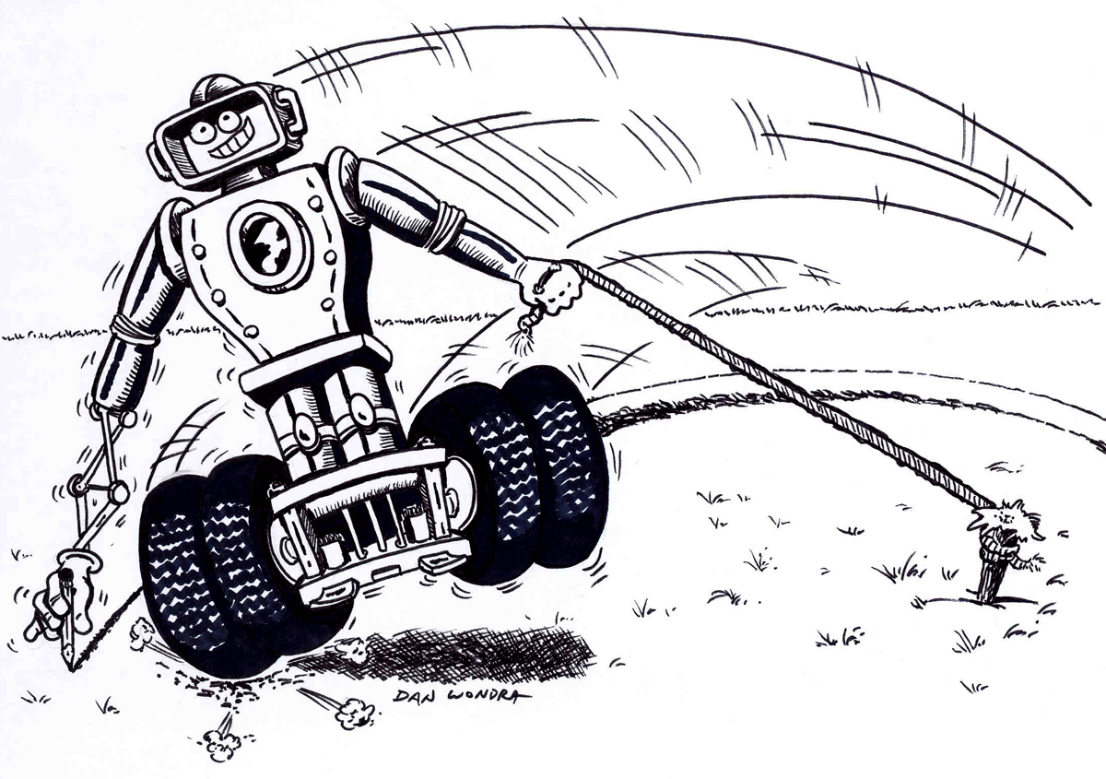
Lesson Title: Consistent Circles
Draft Date: July 2, 2008
1st Author (Writer):
2nd Author (Editor/Resource Finder): Sara Adams
Algebra Topic: Direct variation
Grade Level: 8 - 12

Content (what is taught):
- Introduction to direct variation
- Application of experimental design
- Analysis and inference from data

Context (how it is taught):
- The robot will be driven in a circle and the diameter and circumference of the circle will be measured. This process will be repeated to create a data set.
- The data will be graphed and analyzed and a model will be created to fit the data.
- The robot will drive a circle not previously driven. The diameter will be measured and the model will be used to predict the circumference.

Activity Description:
In this lesson, the concept of direct variation will be explored using a robot driven in many different sized circles. The diameter and circumference of each circle will be measured and recorded. Using a grafting utility, the data that is collected will be graphed and modeled. The students should discover the constant “pi” in this model. Finally, the robot will be driven in a circle different from any previous circle. The diameter will be measured and the circumference calculated using the model. This calculation can be verified by measuring the circumference of the circle driven. The activity will conclude with a formal lab write-up that will explain the results and what was learned.

Standards: (At least one standard each for Math, Science, and Technology - use standards provided)
- Math—B1, B3, D1, E1, E2, E3
- Science—A1, A2, E1, F5
- Technology—A4, C1, C2, C4, D3

Materials List:
- Robot equipped to drive in circles by using resistance or other means
- Measuring equipment
- Graphing utility (calculator or computer)
- String to place along the circumference of the circle as the robot is driven
ASKING Questions (Consistent Circles)

Summary:
The concept of variation will be explored by looking at circles and discussing the relationships between diameter and circumference. Students will design an experiment to confirm this relationship.

Outline:
- Present various circles to students, either on the chalkboard or on the computer.
- Ask about possible relationships that could be present between the circles.
- Determine how an experiment could be designed using a robot to collect data to test their theories.

Activity:
The teacher will present many different circles and ask students if there are any patterns or relationships present in the circles. There will be many relationships but the teacher will need to steer the students to circumference and diameter that will be an example of direct variation. Students will need to decide on an experiment using a robot driving in circles to test their hypothesis.

Questions | Answers
What relationships are present in these circles? | There are many relationships such as radius to diameter, radius to area, radius to circumference, and circumference to area but should be concerned with a relationship between the diameter and circumference.
What will be necessary to test for the suspected relationships? | An experiment where many data sets are collected.
How can a robot be used to test this theory? | Drive the robot in circles and measure the diameter and circumference.

EXPLORING Concepts (Consistent Circles)

Summary: Students will modify a robot so that one wheel goes faster than the other causing it to drive in a circle. The diameter and circumference will be measured and recorded for each circle created. The process will be repeated to create a data set.

Outline:
- Students will modify a robot so that it drives in circles.
- The robot will be driven in circles and the diameter and circumference will be measured and recorded.
- Students will repeat this process at least five times until and adequate data set is created.

Activity:
Students will create different sized circles using the robot. Different sized circles may be created by placing resistors on one motor but not the other, thus slowing only one motor. Also, with practice, different sized circles can be created by driving in circles. If you use a resistor, you can discuss parallel and series physics concepts as well.

The diameter and circumference will need to be measured for each circle created. Place a string along the path of the robot marking the circle it created. The diameter can then be measured and the circumference can be found by measuring the length of the string. Students can come up with this technique on their own or you can determine the process. The process needs to be repeated until there are a minimum of five data points.
INSTRUCTING Concepts (Consistent Circles)

Direct Variation

Putting “Direct Variation” in Recognizable terms: Direct Variation occurs frequently in different situations that we encounter in the “real” world. As one variable increases, another linked variable also increases in a proportionate manner.

Putting “Direct Variation” in Conceptual terms: Direct Variation is a special case of a linear relationship (or a linear function) where a phenomenon can be translated into an equation where the dependent variable is equal to the independent variable times a constant k (called the constant of proportionality or the variation constant).

Putting “Direct Variation” in Mathematical terms: If the dependent variable is called y and the independent variable is called x, the equation representing the function is: y = kx and y is said to be directly proportional to x. As x increases, the corresponding y value also increases by the “k factor”. And as x decreases, y decreases by the same variation constant. This, then, is a linear function such that: y = f(x) = mx + b where the slope (m) is noted by the constant of proportionality, k, and the y-intercept (b) is equal to zero. Thus, the straight line representing this relationship will pass through the origin; i.e., when x is 0, y also is equal to 0.

Putting “Direct Variation” in Process terms: Since direct variation is a situation that can be represented as a linear equation consisting of two variables and a single constant, if two of the values are known, the third may be determined. The constant of proportionality can be calculated if a single instance of an (x, y) pair is available by dividing the value of the dependent variable by the corresponding value of the independent variable (k = y/x). Once the variation constant is known, the value of either the dependent variable or the independent variable can be found if the other is known: y = kx or x = y/k.

Putting “Direct Variation” in Applicable terms: Generate a situation where the robot can drive in a circle with a measurable diameter. The circumference of the circle varies directly with the diameter of the circle. Collect data from several different circles (diameter and circumference) and calculate the constant of proportionality (pi).
ORGANIZING Learning (Consistent Circles)

Summary: Organize the data collected in the experiment in a chart. The data will be graphed and a model created by using a graphing utility (or calculator). The constant of “pi” should be “discovered”. All models that students create should be $C=pd$. They might not be exact because of the possibility of measurement error. Remember the concept of direct variation is where both variables either increase or decrease in a constant manner.

Outline:
- Organize the data collected previously in a chart.
- Graph the data.
- Analyze the data for a trend that is present.
- Create a mathematical model using a graphing utility or calculator.

Activity:
Students collect data, organize the data in a chart, then graph the data. Students can decide how to perform this process or they can be guided. Ensure that students understand how to use the charts and know exactly what they are trying to discover or prove through the lab. Upon completion of the experiment, look over the students’ charts and assess how they are doing. After the data is graphed, students need to look for patterns that can be modeled. Push students to study the data and analyze the results.

Below are questions that the teacher should ask students to make them think about the experiment and how well the collection of data went. The questions should help students think critically about the process.

Question 1: Did the collection go as desired?
Question 2: Were there any problems that might have caused data to be flawed?
Question 3: Is there a relationship in the data, be sure to consider all possibilities?
Question 4: Are there any other things that possibly affected the results of the experiment?

Calculate a model for the data using a graphing utility.

Circle | Diameter | Circumference
1
2
3
4
5
UNDERSTANDING Learning (Consistent Circles)

Summary: Students compose a formal lab write-up with the experimental procedure, the data collected, and the model calculated. Discuss the possible errors that might have occurred during the process. At this point, it may be a good time to talk about measurement error and allowable error for experiments. The students will then drive the robot in a circle of size not previously completed. The diameter will be measured and the circumference calculated using the model created. The result can be tested by actually measuring the circumference that was driven.

Outline:
- Formative assessment of direct variation.
- Summative assessment of direct variation.

Activity:
Formative Assessment
As students are engaged in the lesson ask these or similar questions:
1. Can students explain the concept of direct variation?
2. Are students able to apply the concept of direct variation to other real life situations?

Summative Assessment
Students will write a formal lab write-up including the experimental procedure, the data, the model calculated, and issues that might have effected the results. They will then “drive” the robot in a circle of size not previously completed. The diameter will be measured and the circumference calculated using the model created. The result can be tested by actually measuring the circumference that was driven.

Students will answer the following writing prompt:
- Explain how direct variation worked on the variables in this experiment using the concepts and mathematical terms learned in this lesson and then state another real life example of direct variation and why.

Students could answer these quiz questions:
- A racecar is traveling on a circular track that has a diameter of 2.5 miles. Using this data, and what you have learned today, find the circumference of the racetrack.
- Given that a circle has a circumference of 30 feet, calculate the diameter of the circle.

