SPIRIT 2.0 Lesson:
Growing Circles

=============================== Lesson Header =============================
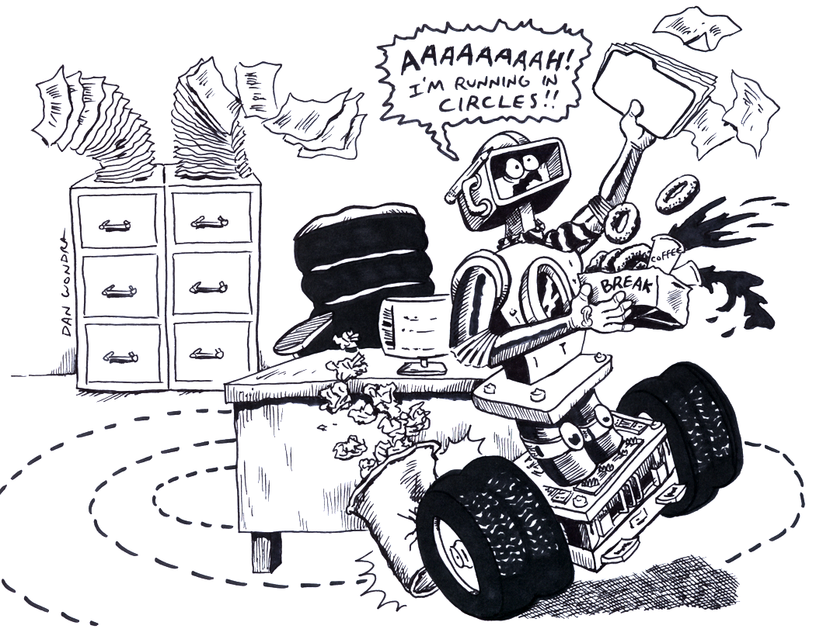
Lesson Title: Growing Circles (Finding$A={pr}^{2}$ by experiment)
1st Author (Writer): Brian Sandall
2nd Author (Editor): Sara Adams
Algebra Topic: Quadratics
Grade Level: 9 - 12

Content (what is taught):
- Modeling of quadratic functions
- Application of Experimental Design
- Analysis of and inference from data

Context (how it is taught):
- The robot will be driven in circles on the floor marked with a small grid.
- The radius and area of each circle will be measured (estimated).
- The data will be graphed, analyzed, and a model created to fit the data.
- The robot will drive a circle not previously driven. The radius will be measured and the mathematical model/formula will be used to predict the area. The prediction then can be checked by estimating the area using the floor grid.

Activity Description:
In this lesson, the concept of quadratic data will be explored using the area of a circle. The formula for the area of a circle ($A={pr}^{2}$) will be derived. To derive the formula, a robot will be driven in a circle and the radius and area of the circle will be measured (estimated) using a small grid marked on the floor. Using a graphing utility, the data collected will be graphed and modeled. Finally, the robot will be driven in a circle different from any previous circle. The radius will be measured and the area calculated using the mathematical model/formula. This calculation can be verified by estimating the area of the circle driven. The activity will conclude with a formal lab write-up explaining the results and concepts learned.

Standards: (At least one standard each for Math, Science, and Technology - use standards provided)
- Math – B1, B3, D1, E1, E2, E3
- Science—A1, A2, E1
- Technology—A4, C1, C2, C4, D3

Materials List:
- Robot equipped to drive in circle
- Floor of room marked with a small grid
- Record Sheet and Measuring equipment
- Graphing utility (calculator)
ASKING Questions (Growing Circles)

Summary:
The teacher presents numerous different circles. Students will be asked if patterns or relationships are present in the circles. Also, students will be asked how potential relationships could be measured and data collected.

Outline:
- Present various circles to students on either the chalkboard or computer.
- Ask students about possible relationships that could be present in the circles.
- Instruct students to think about how they can design an experiment using a robot to collect data that will test their theories.

Activity:
Demonstrate many different circles. Ask students if there are any patterns or relationships present in the circles. Guide the students to radius and area ($A={pr}^{2}$), which will be an example of quadratic data. Students will decide on an experiment using a robot driving in circles to test their hypothesis.

Questions | Answers
What relationships are present in these circles? | There are many relationships but we are concerned with the area and how it seems to grow bigger as the radius increases.
What will be necessary to test for the suspected relationships? | An experiment where many data sets are collected.
How can a robot be used to test this theory? | By driving the robot in circles and measuring the diameter and circumference.
How can the area be found in the experiment? | Mark the circle in the floor with a small grid and then estimate the area by counting the grid squares within the circle. The smaller the grid the better the estimate.

EXPLORING Concepts (Growing Circles)

Summary:
Students will modify a robot causing it to drive in a circle. The radius of the circle driven will be measured and the area estimated by using the small grid on the floor. The process will be repeated to create a data set.

Outline:
- Students will modify a robot so that it drives in circles.
- The robot will be driven in circles.
- The radius will be measured and the area estimated using the grid on the floor.
- Students will record all data on a data chart.
- Students will repeat this process until an adequate data set (at least five different circles) is created.

Activity:
Students will create different sized circles using the robot. The robot can be modified so that one wheel goes faster than the other one, by placing resistors on one motor but not the other thus slowing only one motor. Also, with practice, different sized circles can be created just by driving in circles. Your method for creating circles will depend on the depth of the experiment you wish to create. If you use resistors, you can discuss parallel and series physics concepts as well. The radius will need to be measured and the area will need to be estimated. The robot can have a marker or chalk attached to it to mark the circle driven. Different colors can be used for the different sizes of circles. Another possibility is to place a string along the path of the robot marking the circle it “drove” to help with this process. The radius can then be measured and the area estimated by using the string. (Students can be given techniques or they can come up with techniques on their own.) The process needs to be repeated until there is a minimum of five data points.
Instructing Concepts (Growing Circles)

Quadratic Functions

Putting “Quadratic Functions” in Recognizable terms: Quadratic functions are equations that generate a parabola when ordered pairs that satisfy the equation are plotted on a rectangular coordinate system.

Putting “Quadratic Functions” in Conceptual terms: A quadratic equation represents the relationship between two variables where one of the variables is raised to the second power (squared), i.e. multiplied by itself.

Putting “Quadratic Functions” in Mathematical terms: A quadratic function is an equation representing the variable y as a function of the variable (the distance from the center of the circle to the edge) x that can be written as:
y = f(x) = ax ² + bx + c where a, b and c are any real numbers. This form is called the standard form of the quadratic equation.

Another form of a quadratic function that can sometimes be helpful is:
y = f(x) = a(x – h) ² + k where h and k are the horizontal and vertical displacement of the parabola’s vertex from the origin and a represents a stretch (for a > 1) or shrink (for 0 < a < 1) factor applied to the graphed curve.

Putting “Quadratic Functions” in Process terms: Thus, for any quadratic equation, if you know the x value, you can compute the corresponding y value since there are an infinite number of ordered pairs that represent solutions to (or satisfy) the equation.

One interesting case occurs when b = c = 0 and a = pi and we let x represent the radius (the distance from the center of a circle to its edge) called r: A = pi x r ². Then A represents the area of the circle with radius equal to r.A is a function of the radius, f(r), and pi is an irrational number equal to the ratio of the circumference of any circle to its diameter, which is approximately equal to 3.14159 in value.

Putting “Quadratic Functions” in Applicable terms: Drive the robot so that it traces a circle with the origin of a Cartesian grid as its center. The area (in square units) enclosed by the circle can be calculated to be equal to the square of the radius multiplied by pi.
ORGANIZING Learning (Growing Circles)

Summary:
Students organize the data collected in the experiment in a chart. Graph the data and create a model using a graphing utility (or calculator). The data should appear parabolic.

Outline:
- Organize the data collected in a chart.
- Graph the data.
- Analyze data for a trend and students will decide if that trend fits their hypothesis about the problem that was presented.
- Create a mathematical model using a graphing utility or calculator. The model should be very close to $A={pr}^{2}$.

Activity:
The data previously collected will need to be organized in a chart and graphed by the students. (Students can decide how to organize and graph the data or they can be guided.) Make sure students understand how to use the charts and what they are trying to determine when solving these problems. Upon completion of the experiment look over their charts and quickly assess how students are doing. After the data is graphed, students need to look for patterns that can be modeled. Push students to look at the data and analyze constantly about the results. Below are questions that the teacher should ask the students to help them process the experience.

1. Did the collection go as desired?
2. Were there any problems that might have caused data to be flawed?
3. Is there a relationship in the data being sure to consider all possibilities?
4. Are there any other things that possibly affected the results of the experiment?

Calculate a model for the data using a graphing utility.

Circle | Radius | Estimated Area | Notes
1
2
3
4
5

UNDERSTANDING Learning (Growing Circles)

Summary:
Students write a formal lab write-up with the experimental procedure, the data, and the model calculated. Discuss possible errors that might have occurred during the process and discuss measurement error and allowable error for experiments. Then, the students will drive the robot in a different sized circle. The radius will be measured and the area calculated using the model created. The result can be tested by estimating the area of the circle driven in the same manner as the data collection.

Outline:
- Formative assessment of quadratic functions
- Summative assessment of quadratic functions

Activity:
Formative Assessment
As students are engaged in the lesson ask yourself or your students these or similar questions:
1. Can students explain the concept of a quadratic function including the shape?
2. Are students able to apply the concept of quadratic functions to other real life situations?

Summative Assessment
Students will write a formal lab write-up including the experimental procedure, the data, the model calculated, and issues that might have effected the results.

Students will complete a performance assessment by “driving” the robot in a circle of size not previously completed. The radius will be measured and the area calculated using the model created. The result can be tested by estimating the area of the circle driven in the same manner as previously done.

Students will answer one of the following writing prompts:
1. Explain why this experiment was modeled with a quadratic function using the concepts and mathematical terms learned in this lesson.
2. State another real life example that could be modeled with a quadratic function and why.

Students will complete the following quiz questions as follows:
- The classroom robot travels in a circle with a radius of 6.5 inches. Use your model to determine the area of the circle created.
- A circular NASCAR racetrack is 2.3 miles in diameter. Use your understanding to determine the area of the circle created by Jeff Gordon as he drives a lap.

