SPIRIT 2.0 Lesson:
It’s a Drag!

===============================Lesson Header ==============================
Lesson Title: It’s a Drag!
Draft Date: July 1, 2008
1st Author (Writer): Deb Hipnar
2nd Author (Editor/Resource Finder): Rachel Neurath
Algebra Topic: Linear Functions
Grade Level: Upper Elementary
Cartoon Illustration Idea: Robot Dragster

Content (what is taught):
- Measurement and construction of whole number/decimal number lines
- Measurement of time and motion
- Creation of data tables and graphs
- Plotting ordered pairs on coordinate graph
- Algebraic equations

Context (how it is taught):
- Create a ‘drag strip’ (number line) divided into four equal parts.
- Label the following points: ‘Start, Finish, Checkpoints 1, 2, & 3.
- Drive robot to travel the ‘drag strip’ crossing ‘Checkpoints 1, 2, 3 and Finish’.
- Measure and record in a table the time the robot crosses each point.
- Write an equation that can be used to calculate times on longer courses.
- Use table to make an x/y graph showing the slope.
- Repeat the process with other robots and compare slopes.

Activity Description:
Student groups create and label a drag strip that is divided into fourths. One student drives the robot past each checkpoint while another student measures and records the time at each point. Groups will use the time at each point to make a data table and coordinate graph showing the slope. Students identify the equation that can be used to calculate times for longer courses. Students will repeat the activity with different types of robots and will compare the slopes of all the robots’ times.

Standards:
- Math—A1, B1, B2, B3, E1, E3
- Science—A1, B1, E1
- Technology—B4, D3

Materials List:
- Different Types of Robots | - Colored Pencils
- Meter Sticks | - Data Table
- Fine-tipped markers | - Graph Paper
- Masking Tape | - Stopwatches
Asking Questions (It’s a Drag!)

Summary:
Students are asked how to set up a robot drag race.

Outline:
- Show a video clip of a drag race.
- Discuss the components: cars, straight course, distance, speed, and time.
- Ask questions to instigate ideas for creating a robotic drag race (course, materials, process, data collection, etc.).

Activity:
Students will view a video clip of a drag race followed by a teacher-led discussion to generate interest and initiate thinking about creating a robot drag strip activity.

Questions | Answers
How could we design a drag race for the classroom robots? | To design a drag race for the robots, make a straight line on the floor. Mark ‘start and finish’ lines. Place a robot on ‘start’. Determine how much time it takes the robot to finish the course. Compare the time with the time it takes other types of robots to finish the course.
How can the progress of the robot on the drag strip be measured? | Use a stopwatch to measure the time it takes the robot to pass marked points and to complete the course.
How would the robot drag race be similar to a car drag race? What would be some differences? | Similarities include a straight track, start and finish points and the manner in which time is measured. Differences include the speed of cars vs. robots, and that cars accelerate while robots move at a constant speed.
How could we organize and show the results of the robot drag race? | Make a table and graph.

Image Idea: Picture of a car racing on a drag strip
Video Link: Drag Race http://www.challengevideos.com/2008/08_NCC/08_NCC_Bracket_tt.wmv
Start
Finish

Exploring Concepts (It’s A Drag!)

Summary:
Students will time various robots’ progression at four points on a straight-lined course.

Outline:
- Students measure and mark a straight line on the floor that can easily be divided into fourths.
- Mark the fourths: ‘Start, Checkpoints 1, 2, 3, and Finish’.
- One student drives the robot from ‘Start to Finish’.
- Other students measure and record the time as the robot passes each point.
- Repeat until all robots have finished the course.

Activity:
In groups of three, students will make a ‘drag strip’ by measuring a straight line on the floor with masking tape. Students will divide the line into fourths and mark ‘Start, Checkpoint 1, 2, 3, and Finish’.
Start
Finish
Checkpoint 1
Checkpoint 2
Checkpoint 3

One student will place a robot on the ‘Start’ line and will begin to drive it to the ‘Finish’ line. As the robot moves along the straight line, another student will use a stopwatch to time the progress of the robot at each checkpoint and at the finish line. The third student will record the time the robot crosses each mark. Students will repeat the activity for each classroom robot. If only one robot it available, adaptations will be made to the robot such as adding weight, changing wheels, or driving backwards and the robot, with these changes, will be timed on the course again..

Student Worksheets:
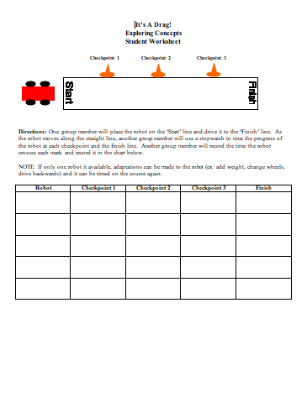
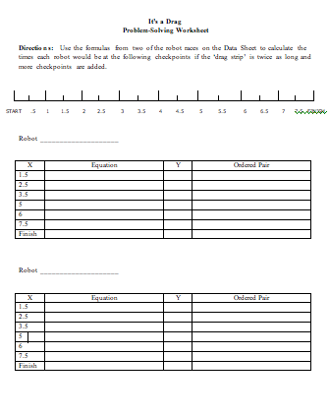

INSTRUCTING Concepts (It’s a Drag!)

Systems of Linear Equations

Putting “Systems of Linear Equations” in Recognizable terms: Systems of Linear Equations are found in many different phenomena that we encounter every day where two variables are related in several different ways, each a linear function. A solution of a system of linear equations is an ordered pair of values that satisfies both (or all) of the linear functions relating the two variables.

Putting “Systems of Linear Equations” in Conceptual terms: The values of the ordered pair that satisfies a system of linear equations are the coordinates of the point where the lines (representing the linear functions relating the two variables) intersect.

Putting “Systems of Linear Equations” in Mathematical terms: Since a line is composed of all the points whose ordered pairs satisfy an equation, and since every point on a line has coordinates that solve that linear equation, then the point where two lines intersect (cross) has coordinates that satisfy both linear functions, thus being a solution to the system of linear equations.

Putting “Systems of Linear Equations” in Process terms: When we plot any two straight lines, we may have one and only one of the following three circumstances:

1. One point of intersection—one solution to the system of equations (independent, consistent system of equations)
2. Coincident lines (the same line)—an infinite number of solutions to the system of equations (dependent equations)
3. Parallel lines (which never intersect)—no Real solutions to the system (independent, but inconsistent situation)
Putting “Systems of Linear Equations” in Applicable terms: After solving a system of simultaneous linear equations by using either the Substitution Method or the Elimination (Addition) Method, drive the robot to the point which represents the ordered pair of the solution. Note what happens when the system is either dependent or inconsistent; i.e., there will not be a single solution point.

Organizing Learning (It’s A Drag!)

Summary:
Students use the time data to create X/Y tables with equations and a coordinate graph to show and compare slopes.

Outline:
- Organize the times each robot passed the checkpoints and the finish line in a data table for each robot tested.
- Write and use an equation to calculate the times when the robots would cross checkpoints on a longer course.
- Use the data table to construct a coordinate graph showing the slopes for each robot timed.

Activity:
Students organize the time information from each of the robots’ drag race in a data table (see Sample Chart and Data Worksheet). Each group will develop an equation that will be used to calculate times at other checkpoints along the same course as well as along the length of a longer course. Student groups will use a piece of graph paper to create a coordinate graph to plot the slopes for each robot drag race. Students will plot the ordered pairs for each race by using a different color for each robot.

Sample Chart:

X  checkpoints | Equation  Y=2X | Y  time in seconds | Ordered Pair
0 (start) | Y= 2 (0) | 0 | (0,0)
1 | Y= 2 (1) | 2 | (0,2)
2 | Y= 2 (2) | 4 | (0,4)
3 | Y= 2 (3) | 6 | (0,6)
4 (finish) | Y= 3 (4) | 8 | (0,8)

Student Data Sheet:

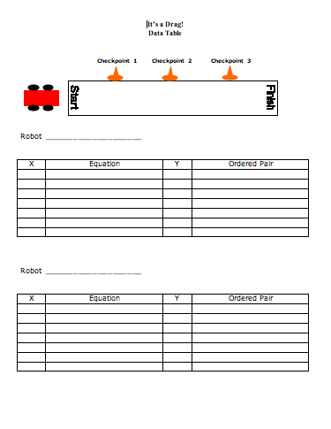

Understanding Learning (It’s A Drag!)

Summary:
Groups hand in their completed Data Worksheet for group assessment and each student completes an Individual Assessment Sheet to show his or her ability to accomplish the following:
- Use an X/Y data chart to organize information
- Create a coordinate graph to show and compare slopes
- Create and use an algebraic equation to make probable predictions

Outline:
- Collect and assess each group’s Data Worksheet and Coordinate Graph for the following:
- Organization
- Clarity
- Accuracy
- Observe participation as each group completes the activities.
- Use Individual Worksheet to assess each student’s ability to achieve the following:
- Write and use an algebraic equation to predict times for other checkpoints
- Use an X/Y Data Chart to solve problems
- Create a coordinate graph to show slope

Activity:
Each group will hand in their completed Data Worksheet(s) and Coordinate Graph to be assessed on Organization, Clarity, and Accuracy of information. Participation can be observed as groups are completing the activities. Each student will complete an Individual Assessment sheet that will be evaluated based on his/her ability to accomplish the following:
- Accuracy of the data chart
- Understanding and writing correctly an algebraic equation that can be used to solve problems
- Utilizing data to accurately make a coordinate graph showing slope

Individual Assessment and Key:
