SPIRIT 2.0 Lesson:
Meter Marker Mania

================================Lesson Header =============================
Lesson Title: Meter Marker Mania
Draft Date: July 20, 2008
1st Author (Writer): Deb Hipnar
2nd Author (Editor/Resource Finder): Rachael Neurath
Algebra Topic: Real Numbers, Decimals (tenths)
Grade Level: Upper Elementary
Cartoon Illustration Idea: Robot on highway with mile markers

Content (what is taught):
- Measurement and construction of whole number/decimal number lines
- Application of positive and negative movement on a number line (forward and backward)
- Addition and subtraction of decimals
- Comparison of decimals to determine greater and lesser amounts

Context (how it is taught):
- Students will create roads marked off in tenths of a meter (minimum length of three meters).
- The classroom robot will travel various distances forward and backwards on a number line.
- Students will add and subtract distances traveled.
- Students will compare distances traveled for the journeys of two or more robots.

Activity Description:
Students will use masking tape and a meter stick to make a three-meter course for the robot to travel. Students will mark and label the course in increments of 1/10th of a meter. Using Worksheet #1, the students will complete the activities with the robot on the course and record their answers. Student activities will include locating points on a number line, moving the robot forward and backward on the course, adding and subtracting decimal numbers, and comparing distances.

Standards:
- Math—A1, B3, D2, E1
- Science—B1, E1
- Technology—B4, D2

Materials List:
- Classroom Robots
- Meter Sticks
- Fine-tipped marker
- Masking tape
- Worksheet #1
- Pencil
- Paper
- Pictures or PowerPoint slides showing road mile markers

ASKING Questions: Meter Marker Mania

Summary:
Ask questions to introduce and generate interest in using mile markers as a tool for calculating distances.

Outline:
- Show pictures/slides of mile markers along highways.
- Discuss the information that the markers provide and discuss how they are used.
- Discuss number systems that can be used to create mile markers.
.
Activity:
Show examples of road markers using PowerPoint slides. Ask questions and discuss the use of road markers to locate position and calculate distances. Discuss the real numbers that are used and that could be used on markers. Practice distance calculations using pictures.

Questions | Answers
What are mile markers, where would you see them and what information is given? | Mile markers are small signs placed at equal increments along a roadway that mark the distance from one point to another.
How can mile markers be useful for people traveling the road? | Mile markers can be used to mark a specific point on the road. Calculations can be performed to determine distance between markers.
What types of numbers are most often used on road markers? | Positive integers are the numbers most often used on road markers.
What are some other real numbers that could be used? | Other real numbers that could be used include decimals, fractions, and whole numbers.

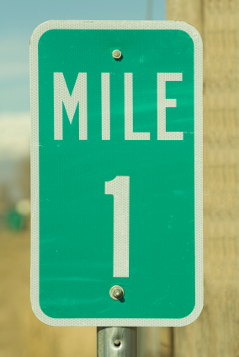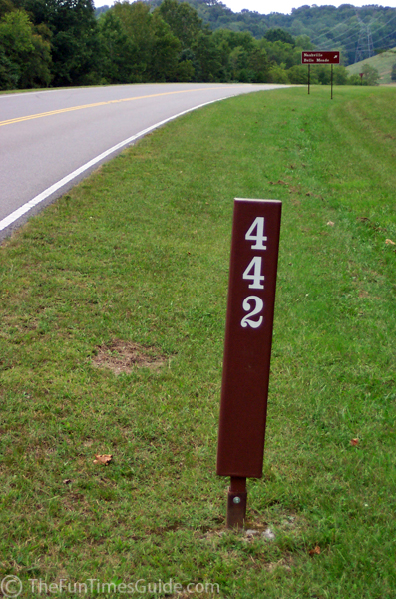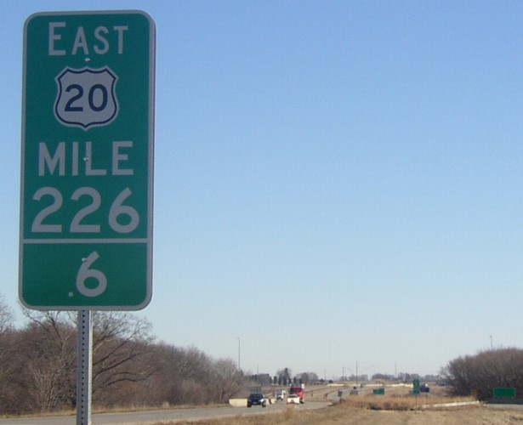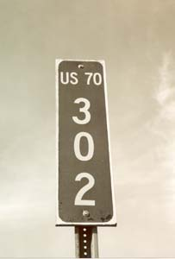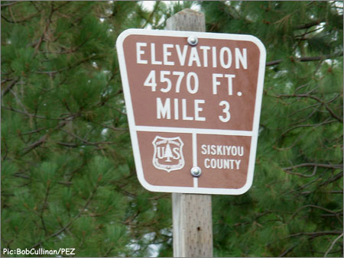

EXPLORING Concepts: Meter Marker Mania

Summary:
Students will explore finding decimal positions and will add and subtract decimals by moving the classroom robot on a course divided into tenths of a meter.

Outline:
- Students create a three-meter road with markings showing tenths of a meter increments.
- Students drive the robot to the positions and distances noted on Meter Marker Mania Group Worksheet.
- Students use the information gathered to help solve the problems on the worksheet.

Activity:
In groups of 2-3, students will first set up a three-meter road on the floor with masking tape. Students will measure and mark the road in tenths of a meter increments.

Give each group a copy of Worksheet #1 that has position and distance problems to solve. Students will drive the classroom robot to positions, using the given distances to gather information needed to solve the problems.

Video Idea: Clip of students moving the robot along the road..

0
.1
.2
.3
.4
.5
.6
.7
.8
.9
1
1.1
1.2
1.3
1.4
1.5
1.6
1.7
1.8
1.9
2
2.1
2.2
2.3
2.4
2.5
2.6
2.7
2.8
2.9
3

INSTRUCTING Concepts: Meter Marker Mania

Real Numbers

Putting “Real Numbers” in Recognizable terms: Real numbers are all of the different kinds of numbers that we use in day-to-day life.

Putting “Real Numbers” in Conceptual terms: Real numbers are all of the numbers that can be represented by points on a number line. We also need to understand the concept of “sets” and “subsets”: A set is a collection of objects, or “elements” (order and/or sequence does not matter). A subset is a set that is a part of another set. The empty set (or null set) is a set with no elements in it. The null set is a subset of every set.

Putting “Real Numbers” in Mathematical terms: Real numbers are a 1-1 mapping of the set of all of the points on a [Real] Number Line to a set of the values that each of these points may represent. A subset of the set of Real Numbers is the set of positive integers, the counting numbers, also known as the natural numbers {1,2,3,…}. Each of the natural numbers has an opposite integer, called a negative integer {-1, -2, -3, …}. A special integer is zero {0}. Zero separates the positive numbers from the negative numbers. Zero is the only number whose opposite is itself. The set of Real numbers may be broken into two mutually exclusive subsets: Rational numbers have values that can be represented by the ratio of two integers, while irrational numbers have values that cannot be represented by the ratio of two integers.

Putting “Real Numbers” in Process terms: Since the Real numbers can be represented by points on a number line, we can describe the relationship of any two real numbers by their relative positions on the line. They may be equal in which case they occupy the exact same point. One may be greater than the other (positioned to the right of the other). Or one can be less that the other (positioned to the left of the other).

Putting “Real Numbers” in Applicable terms: As we drive the robot along a straight line, stop it at irregular (random) time intervals and estimate its position by using Real numbers from each of the different subsets of the set of Real numbers.

ORGANIZING Learning: Meter Marker Mania

Summary:
Students use the information gathered on the Meter Marker Mania Group Worksheet to create a chart showing each distance the robot traveled.

Outline:
- Use data from the Meter Marker Mania Group Worksheet to determine distances the robot traveled.
- Fill in a chart showing these distances.
- Use the chart to find the total distance the robot traveled.

Activity:
Students will continue to work in their groups of 2-3 to organize the distances the robot traveled along their three-meter course from the problems on the Meter Marker Mania Group Worksheet. Students will put this data into a chart and calculate the total distance the robot traveled.

Meter Marker Mania Group Worksheet:
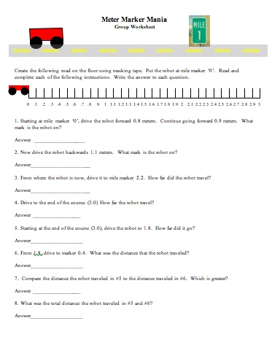
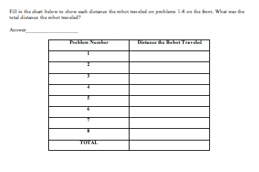

Answers to Meter Marker Mania Group Worksheet:
- 1.7
- 0.6
- 1.6
- 0.8
- 1.2
- 1.4
- #6, 1.4
- 2.6
- 7.3 meter

UNDERSTANDING Learning: Meter Marker Mania

Summary:
Groups hand in their completed Worksheet #1 for group assessment and each student completes an Individual Assessment Sheet to show their understanding of placement and location of decimals to tenths on a number line as well as addition, subtraction, comparison of tenths decimals, and making a chart to show information.

Outline:
- Use the Group Worksheet to assess each group’s:
  - Level of participation
  - Understanding of concepts such as location, addition, subtraction and comparison of decimal numbers to the tenths of a meter
- Use the Individual Worksheet to assess each student’s understanding of the following:
  - Location, addition, subtraction, and comparison of decimal numbers to the tenths of a meter
  - Use of information to create a chart

Activity:
Each group will hand in their completed Group Worksheet to be assessed on Correctness of Problem-solving, Group Participation, as well as Chart Accuracy and Clarity. Each student will be individually assessed using the Individual Assessment Sheet. The student will demonstrate his/her understanding of placement and location of decimals to tenths on a number line as well as addition, subtraction, comparison of decimals, and making a chart to show data. The completed assessment may be evaluated on Accuracy of decimal labels on a number line, Correctness of Problem-solving, Chart Accuracy, and Clarity.

Individual Assessment:

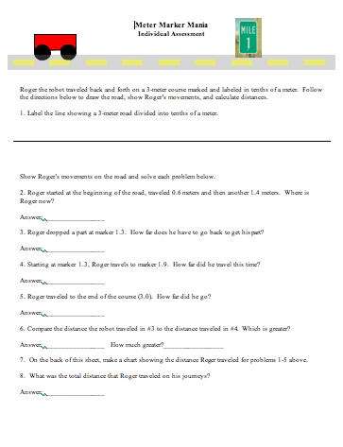

Answers to Individual Assessment:
- Make sure all marks are correct on the number line
- 2 meters
- 0.7 meters
- 0.6 meters
- 1.1 meters
- #3, 0.1 meter
- Check to see that chart is organized
- 4.4 meters

