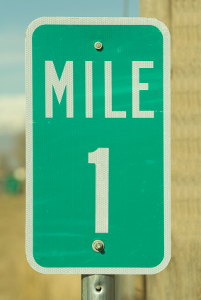
Meter Marker Mania
Group Worksheet

Create the following road on the floor using masking tape. Put the robot at mile marker ‘0’. Read and complete each of the following instructions. Write the answer to each question.
0
.1
.2
.3
.4
.5
.6
.7
.8
.9
1
1.1
1.2
1.3
1.4
1.5
1.6
1.7
1.8
1.9
2
2.1
2.2
2.3
2.4
2.5
2.6
2.7
2.8
2.9
3

1. Starting at mile marker ‘0’, drive the robot forward 0.8 meters. Continue going forward 0.9 meters. What mark is the robot on?

Answer __________________

2. Now drive the robot backwards 1.1 meters. What mark is the robot on?

Answer_____________________

3. From where the robot is now, drive it to mile marker 2.2. How far did the robot travel?

Answer_____________________

4. Drive to the end of the course. (3.0) How far the robot travel?

Answer _________________

5. Starting at the end of the course (3.0), drive the robot to 1.8. How far did it go?

Answer__________________

6. From 1.8, drive to marker 0.4. What was the distance that the robot traveled?

Answer__________________

7. Compare the distance the robot traveled in #5 to the distance traveled in #6. Which is greater?

Answer _________________

8. What was the total distance the robot traveled in #5 and #6?

Answer__________________

9. Fill in the chart below to show each distance the robot traveled on problems 1-6 on the front. What was the total distance the robot traveled?

Answer__________________

Problem Number | Distance the Robot Traveled
1
2
3
4
5
6
TOTAL

