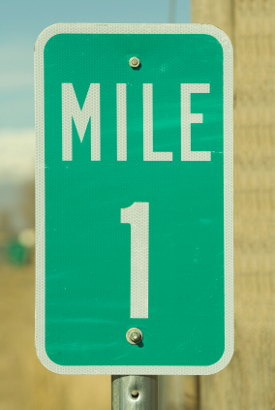
Meter Marker Mania
Individual Assessment

Roger the robot traveled back and forth on a 3-meter course marked and labeled in tenths of a meter. Follow the directions below to draw the road, show Roger’s movements, and calculate distances.

1. Label the line showing a 3-meter road divided into tenths of a meter.

Show Roger’s movements on the road and solve each problem below.

2. Roger started at the beginning of the road, traveled 0.6 meters and then another 1.4 meters. Where is Roger now?

Answer:_________________

3. Roger dropped a part at marker 1.3. How far does he have to go back to get his part?

Answer:_________________

4. Starting at marker 1.3, Roger travels to marker 1.9. How far did he travel this time?

Answer:_________________

5. Roger traveled to the end of the course (3.0). How far did he go?

Answer:_________________

6. Compare the distance the robot traveled in #3 to the distance traveled in #4. Which is greater?

Answer:_________________ How much greater?_________________

7. On the back of this sheet, make a chart showing the distance Roger traveled for problems 1-5 above.

8. What was the total distance that Roger traveled on his journeys?

Answer:_________________

