SPIRIT 2.0 Lesson:
Pythagorean Theorem…Easy as ABC!

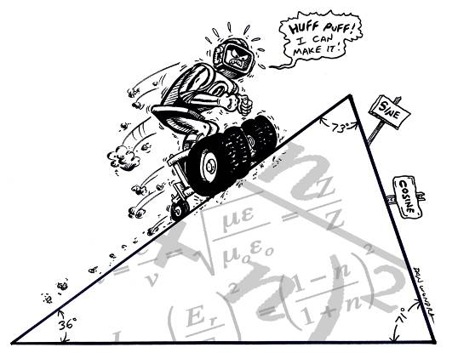
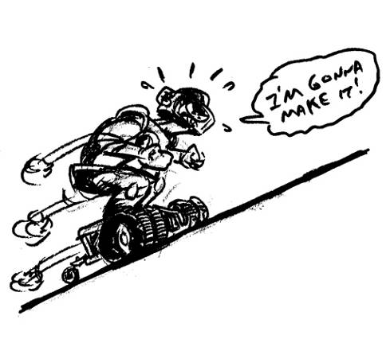
============================== Lesson Header ==============================
Lesson Title: Pythagorean Theorem…Easy as ABC!
Draft Date: June 20, 2008
1st Author (Writer): Lynn Spady
Algebra Topic: Pythagorean Theorem
Grade Level: Middle School

Content (what is taught):
- Vocabulary associated with right triangles
- Pythagorean Theorem – calculating the length of the hypotenuse of a right triangle
Context (how it is taught):
- The robot is attached to a string, which is attached to the wall. The robot drives until the string is pulled tight, thus creating a right triangle.
- The legs of the triangle are measured and recorded.
- The hypotenuse is calculated using the Pythagorean Theorem.

Activity Description:
Pieces of string (various lengths) will be taped to the wall. The height at which these strings are taped will vary. The bottom of the string will hang freely so that students can attach the string to their robot. Students will drive the robot as far as it can go, stretching the string and creating a right triangle. Students will measure the two legs and use the Pythagorean Theorem () to calculate the hypotenuse (string length).

Standards: (At least one standard each for Math, Science, and Technology - use standards provided)
- Math—A3, D2
- Science—A1, A2
- Technology—B4, C4

Materials List:
- Classroom Robot
- String
- Notebook
- Meter Sticks
ASKING Questions (Pythagorean Theorem…Easy as ABC!)

Summary:
Students are asked to identify different types of triangles and are asked where they are located and how they are used in the world.

Outline:
- Draw different types of triangles on the board and/or write triangle vocabulary on the board.
  - Right, acute, obtuse
  - Isosceles, scalene, equilateral
- Ask students where triangles are found and how they are used in the world.

Questions | Answers
Where do you see triangles in the world? | Triangles are found on sailboats, bridges, instruments, chips, quilts, floor tiles, etc.
What words are used to describe triangles? | Sides  - Equilateral triangle—all sides are equal  - Isosceles triangle—two sides are equal  - Scalene triangle—all sides are different.  Angles  - Right triangle—one 90-degree angle  - Acute triangle--all angles are between 0 and 90 degrees  - Obtuse triangle—one angle measures between 90 and 180 degrees  Right Triangles: legs and hypotenuse  - 30-60-90  - 45-45-90
What types of triangles do you see in these images? Are some more common than others? Why? | - Triangle 1.jpg: right triangle in window, isosceles triangle on bars  - Triangle 2.jpg: equilateral triangle, right triangle  - Triangle 3.jpg: isosceles triangle  - Triangle 4.jpg: scalene right triangle  - Triangle 5.jpg: isosceles triangle, obtuse triangle  - Triangle 6.jpg: scalene right triangle  - Triangle 7.jpg: obtuse isosceles triangle  - Triangle 8.jpg: right triangle  - Triangle 9.jpg: obtuse isosceles triangle

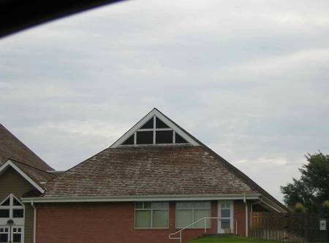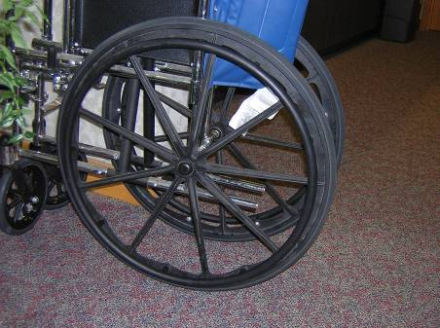

Triangle 1 Triangle 2 Triangle 3

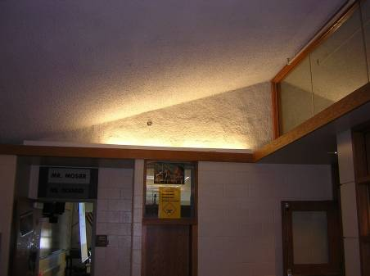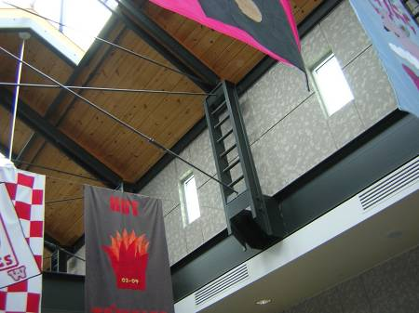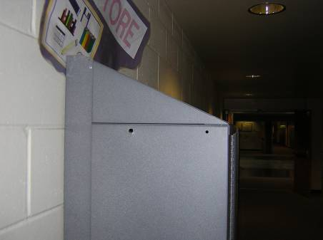

Triangle 4 Triangle 5 Triangle 6

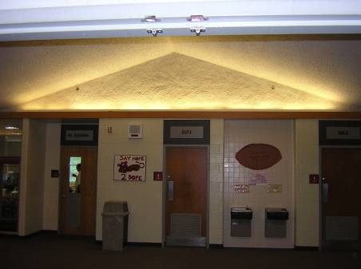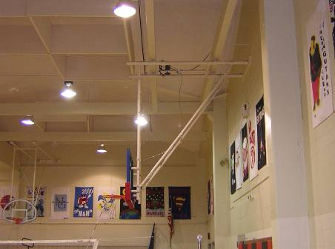

Triangle 7 Triangle 8 Triangle 9
EXPLORING Concepts (Pythagorean Theorem…Easy as ABC!)

Summary:
Students will connect their robot to the string and drive it until the string is pulled tight creating a right triangle.

Outline:
- The robot is attached to a free-hanging string attached to the wall.
- Students drive the robot until the string is pulled tight, thus creating a right triangle.
- Students measure the two legs of the right triangle.
- Students predict/estimate the length of the string.
- Students connect a different robot to another string (different length and height) and create another right triangle by driving the robot until the string is pulled tight. Students predict/estimate the length of the string.
- Students compare/contrast the triangles created.

Activity:
Two pieces of string (different lengths) will be taped to the wall. The height at which these strings are taped will be different. The bottom of the string will hang freely so that students can attach the string to their robot. Students will drive the robot as far as it can go, stretching the string, and creating a right triangle. Students will repeat this process with a different string and another robot.

Students will have a discussion about the triangles created. As a formative assessment, you can note whether students are using triangle vocabulary (right, acute, isosceles, scalene, etc.) to describe the triangles. If students do not come up with it on their own, it should be pointed out that the string is the hypotenuse of the right triangle and the hypotenuse is always the longest side in a right triangle. Also, point out the legs of the triangle, which students might want to measure and record. Students can also measure the angles using a protractor.

Video Clip Idea: Video clip of procedure

wall
String taped at a measurable height
Students will attach the end of the string to the robot

leg
hypotenuse

leg

INSTRUCTING Concepts (Pythagorean Theorem…Easy as ABC!)

Pythagorean Theorem
Putting “Pythagorean Theorem” in Recognizable terms: The Pythagorean Theorem establishes the quantitative relationship between the three sides of any right triangle. It applies to all right triangles. A right triangle is any triangle that contains one right angle (90 degrees).
Putting “Pythagorean Theorem” in Conceptual terms: The hypotenuse of a right triangle is the side across from the right angle. The hypotenuse does not touch the right angle. The other two sides, the sides that include the right angle, are called the “legs” of the right triangle. These legs may be called “a” and “b”. The hypotenuse is often called “c”. The sum of the squares of the lengths of the legs of a right triangle is equal to the square of the length of the hypotenuse of that right triangle.
Putting “Pythagorean Theorem” in Mathematical terms: a ² + b ² = c ² . Then by algebraic rearrangement the following relationships are also true for all right triangles:
- c = SQRT(a ² + b ²)
- a ² = c ² – b ² and b ² = c ² – a ²
- a = SQRT(c ² – b ²) and b = SQRT(c ² – a ²)
Putting “Pythagorean Theorem” in Process terms: Due to the Pythagorean Theorem, we can solve for any unknown side of a right triangle if we know the lengths of the other two sides (by simple substitution).
Putting “Pythagorean Theorem” in Applicable terms: Drive the bot along a [straight] line from the origin. Stop it at irregular (random) time intervals and estimate its position by looking at the coordinates of its position at rest. Calculate the distance it has travelled by taking the square root of the sum of the squares of the legs of the right triangle formed by the x coordinate, the y coordinate, and the origin.

ORGANIZING Learning (Pythagorean Theorem…Easy as ABC!)

Summary:
Students will use their notebook to draw the triangles created and record measurements. Students will use the Pythagorean Theorem to calculate the length of the string.

Outline:
- Connect the end of the string to the robot.
- Drive the robot so that the string is pulled tight, thus creating a right triangle.
- Measure the two legs and record.
- Use the Pythagorean Theorem to calculate the hypotenuse (string) length.

Activity:
Two pieces of string (different lengths) will be taped to the wall. The height at which these strings are taped will be different. The bottom of the string will hang freely so that students can attach the string to their robot. Students will drive the robot as far as it can go, stretching the string, and creating a right triangle.

Students will draw the triangle in their notebook and record the measurements of the two legs. Next, students will calculate the length of the string by applying the Pythagorean Theorem.

UNDERSTANDING Learning (Pythagorean Theorem…Easy as ABC!)

Summary:
Students will use the Pythagorean Theorem to solve for missing lengths of a right triangle.

Outline:
- Formative assessment of right triangle vocabulary (leg, hypotenuse, 90 degree angle, Pythagorean Theorem)
- Summative assessment of Pythagorean Theorem (a² + b² = c²)

Activity:
Formative Assessment
As students are engaged in learning activities, ask yourself or your students these types of questions:
- Can students identify the legs and hypotenuse in a right triangle?
- Do students understand that the hypotenuse is the longest side of the triangle?
- Were the students able to apply the Pythagorean Theorem and solve for the hypotenuse?

Summative Assessment
1. A set-up can be created as illustrated below. The two legs can be measured and given to the students. Students can solve for the hypotenuse using the Pythagorean Theorem. Students can do a write-up of the problem and the solution. A rubric can be used to assess understanding.

2. Students could answer these quiz questions:
30 mm
50 mm
Answer the following questions using the triangle given.

  - The square in the corner tells you this is a _________ triangle.
40 mm
  - The sides that measure 40 mm and 30 mm are called the __________ of the triangle.
  - The side that measures 50 mm is called the __________ of the triangle.
  - How do you know which side is the hypotenuse?

Find the length of the hypotenuse if the legs measure 8 cm and 15 cm.

