SPIRIT 2.0 Lesson:
Where am I located?

===============================Lesson Header ==============================
Lesson Title: Where am I located?
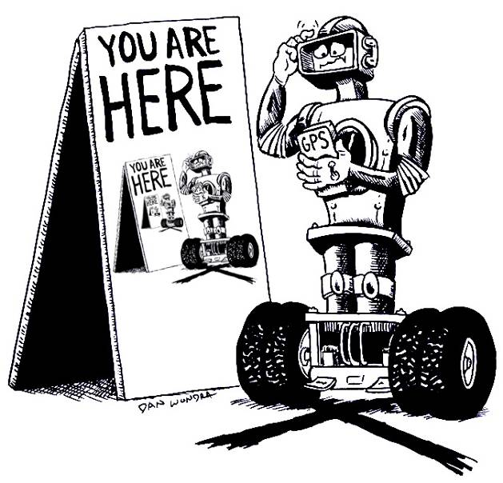
Draft Date: June 25, 2008
1st Author (Writer): Neil Hammond
2nd Author (Editor): Sara Adams
Algebra Topic: Rectangular Coordinate System
Grade Level: Algebra I – 8th/9th Grade

Content (what is taught):
- Plotting points on a coordinate plane
- Using the coordinate plane to determine quadrants
Context (how it is taught):
- Use robot to drive on the coordinate plane.
- Plot four or five different points with the robot.
- Talk about the points in regard to the quadrants and the axes.

Activity Description:
In this lesson, a coordinate grid will be laid out on a flat surface such as a table or on the floor. The students will take turns driving the robot to all of the different points on the plane. The students will then discuss where the quadrants are located and what a quadrant is. After this lesson, the group will discuss how to determine the quadrant in which a point is located just by looking at the point.

Standards: (At least one standard each for Math, Science, and Technology - use standards provided)
- Math—B1, C1, D1
- Science—B2
- Technology—A3

Materials List:
- Classroom Robot
- Coordinate Grid
- Graph Paper

ASKING Questions (Where am I located?)

Summary:
Students are shown a coordinate plane and are asked how to represent the ordered pair on the plane.
Outline:
- Draw the coordinate plane on the table or floor.
- Ask students how to represent certain numbers or ordered pairs on a graph.
- Work with different types of numbers (positive, negative, and zero).
- Determine how to plot the ordered pairs.
Negative #’s
Negative #’s
Positive #’s
Positive #’s
origin
x-axis
y-axis

Activity:
Start by asking the questions below to see if students understand numbers and ordered pairs.

Questions | Answers
How can we represent the number 12 on a graph? | We could use a number line and travel over 12 units.
How can we represent a set of two numbers together on a graph? | Since we use a number line going right to left (x-axis) for the first number, we could use a number line going up and down (y-axis) for the second number. These two number lines will create the coordinate plane.
On a number line, which way is positive and which way is negative? Why do you think we represent numbers in this way? | We represent positive in the right direction and negative in the left direction because we read from left to right.
How can we do the same thing with two different number lines? | We can do the same thing for the other axis using “up” for positive and “down” for negative. We choose “up” for positive because it shows the increase in value.
What variables should we use to represent the ordered pair? | We could use any two letters but we prefer to use ‘x’ and ‘y’ so that all ordered pairs are represented the same way. Also, using x and y for the ordered pairs relates directly to the x and y axis.
Where do we need to start (zero) when we use the coordinate plane? | We should start where the two number lines intersect (the origin).

Resources:
- http://www.shodor.org/interactivate/activities/GeneralCoordinates/
- “What’s the Point?” at http://www.funbrain.com/cgi-bin/co.cgi?A1=s&A2=2&INSTRUCTS=1
EXPLORING Concepts (Where am I located?)

Summary:
Students use a robot to plot points on a coordinate plane.

Outline:
- The students are given a certain point that they need to graph.
- The students will use the robot to plot the ‘x’ variable as well as the ‘y’ variable
- The students will then use the robot to travel a certain distance and will be able to tell what ordered pair will be represented when the robot stops moving.

(0,0)
(6,0)
(6,5)

Activity:
The students will each be given four or five points that they need to graph. Students will take turns using the robot to plot the points on the coordinate plane that is laid out on the floor or on the table. The students need to make sure that they always begin at the origin (0, 0) when they start plotting their points. When the students are given a point such as (6, 5), they need to make sure and plot the ‘6’ first and they need to understand that the ‘6’will be along the horizontal axis (right-left). Also, make sure students understand the positive direction and the negative direction. After the students have driven the robot the correct distance for the ‘x’ variable, then they will travel either up or down to graph the ‘y’ variable.

Make sure that the students are using the robot in the correct way and are actually accomplishing the task-at-hand. After the students have plotted these four or five points on the floor, they will see the points laid out on the coordinate grid. Students will now need to label the quadrant in which each point is located. There are four different quadrants (I, II, III, and IV) and they will need to label one of these four quadrants.

Quadrant I
Quadrant II

origin
x-axis

Quadrant III
Quadrant IV

y-axis

Once the students have completed these two activities, they will need to transfer the knowledge and work pertaining to looking at a point and recognizing the ordered pair that corresponds to this point. Therefore, the students will begin at the origin and they will drive in whatever direction they choose for five seconds. After five seconds, the students will need to stop the robot and label the ordered pair at the point where the robot stopped moving. After they have labeled four points, other students may take a turn plotting points and reading where the points are located.

To ensure that the students understand these concepts, ask yourself these questions to assess the effectiveness of the lesson:

1. Did the students plot the points in the correct order? (x then y)
2. Did the students know the four different quadrants? (I, II, III, IV)
3. Did the students read the points in the correct order when they were labeling the points (right-left, then up-down).

Resources:
- http://www.learningwave.com/lwonline/algebra_section2/alg_coord.html
- Student can play “What’s the Point?” at
http://www.funbrain.com/cgi-bin/co.cgi?A1=s&A2=2&INSTRUCTS=1
INSTRUCTING Concepts (Where am I located?)

Putting “Rectangular Coordinate System” in Recognizable terms: Graphing on a rectangular coordinate system is a method of representing pairs of Real numbers on a flat (plane) surface.

Putting “Rectangular Coordinate System” in Conceptual terms: Every Rectangular Coordinate System has to start somewhere. Choose any plane on the surface and call it the “origin”, or the starting point. Position a Real number line so that the zero is at your chosen point of origin. Then plane another Real number line at right angles to the first one so that its zero is also at the origin. These two lines are the axes. One line will be the horizontal axis, or abscissa, and the other line will be the vertical axis, or the ordinate. Notice how the intersecting Real number lines have subdivided the plane surface into four sections, or quadrants.

Putting “Rectangular Coordinate System” in Mathematical terms: Ordered Pairs are necessary to define, or place, any particular point on the grid completely and accurately. An ordered pair is comprised of two real numbers; the first, which represents the position of the point with respect to the abscissa, and the second, which represents the location of the point with respect to the ordinate.

Putting “Rectangular Coordinate System” in Process terms: Pinpoint the location of any point (ordered pair) by finding the intersection of the first element of the pair of coordinates with that of the second item in the pair. These ordered pairs can be called (x,y) pairs, where the ‘x’ (or first element of the pair) refers to the abscissa location and the ‘y’ (or second element in the pair) refers to the ordinate location.

Putting “Rectangular Coordinate System” in Applicable terms: As we drive the robot around the plane surface (or rectangular coordinate system), stop it at irregular (random) time intervals and estimate its position by using ordered pairs of Real numbers. Generate an ordered pair randomly and then drive the robot to the location that is represented by that given ordered pair.
ORGANIZING Learning (Where am I located?)

Summary:
Students are looking at points on the coordinate plane and trying to determine the quadrant in which the points are located.

Outline:
- Plot points on the coordinate plane.
- Discuss the four quadrants and the quadrant in which the points are located.
- Analyze points and determine the quadrant without looking at the coordinate plane.

Activity:
Students will be given a number of different points that they will need to plot on the coordinate plane. They will use the robot to plot the points on the plane. Make sure the students are always starting at the origin when they are plotting the points. After they have plotted the four different points, they will need to work on locating the quadrant. Since there are four different quadrants in which the points could be located (as well as the axes), the students will work with a table and will try to devise a way to determine the quadrant without looking at the coordinate plane.

The six different types of points that the students will observe are as follows: (pos, pos), (pos, neg), (neg, pos), (neg, neg), (0, anything), (anything, 0). Using the chart located below, the students will plot two points from each of these categories. After the students have collected their data, they will be able to return to the group and talk about their findings.

Worksheet Idea:
A simple chart that has points and the quadrants in which they are located.

Point | Quadrant | What do you notice? | Point | Quadrant | What do you notice?
(3, 4) |  |  | (2, -5)
(0, 5) |  |  | (-4, -3)
(6, -3) |  |  | (-4, 4)
(-2, 0) |  |  | (4, 5)
(-1, 7) |  |  | (-9, -2)

Expansion activity:
Give clues for an ordered pair and then students must use their knowledge to find the point. This activity may be on the overhead (whole group), or in card form (independently or in partners).
UNDERSTANDING Learning (Where am I located?)

Summary:
Students will use a robot to plot points on a coordinate plane and will use the robot to determine the point where the robot stops moving.

Outline:
- Assessment of Pythagorean Formula

Activity:
Each student will be called to the table and each will complete the following tasks:

1. The students will plot the three points below on the coordinate plane:
  - (1, 5)
  - (-2, -6)
  - (4, 0)
2. After the students have finished this activity, they will drive the robot wherever they choose on the coordinate plane. The students may choose to drive in a straight line, in a circle, or in any combination of the two. After they have driven three different times, the students will define the ordered pair at the point where they have stopped the robot.
  - 3 sec
  - 5 sec
  - 8 sec
3. Once they have defined the six points on the graph, they will name the quadrants in which each of the six points are located.

