SPIRIT 2.0 Lesson:
What in the World is x⁻³?

==============================Lesson Header ==============================
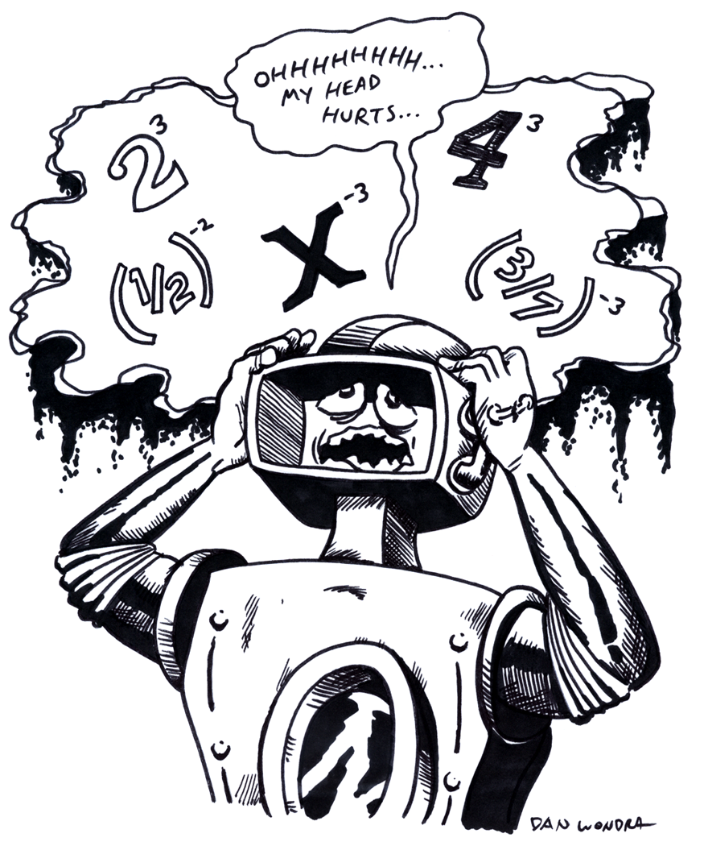
Lesson Title: What in the World is x⁻³?
Draft Date: October 3, 2008
1st Author (Writer): Brian Sandall
2nd Author (Editor/Resource Finder): Davina Faimon
Algebra Topic: Negative integer and zero exponents
Grade Level: 8 - 12
Cartoon Illustration Idea: Robot with exponential expressions floating above it.

Content (what is taught):
- Negative and zero exponents
- Pattern recognition
- Analysis and inference from data

Context (how it is taught):
- The robot starts on a number line at a power of 2 and is driven to a smaller power of 2, etc.
- Patterns are noticed and identified.
- The process is repeated with a power of 3 to see if the same pattern exists.
- The pattern is generalized to all exponents.

Activity Description:
In this lesson, the concept of negative integers and zero as exponents will be explored. A large number line will need to be placed on the floor with graduations of at least 10 parts per number. Explore 2³ by placing the robot at 8. Ask the students, what is 2²? Students will drive the robot to 4, and repeat with 2¹ driving the robot to 2. Look for patterns. Next, drive the robot to 2⁰ to fit the pattern then to 2⁻¹, 2⁻², etc. Repeat the process for 3³ using the same format as used for the set of base 2 numbers. Repeat the process with (1/2)³, (1/2)² etc. Students will find that the same pattern applies. Have students state the pattern and then generalize using a variable expression.

Standards: (At least one standard each for Math, Science, and Technology - use standards provided)
- Math—A1, B1, E1, E3
- Science—A1, A2, E1
- Technology—C1, C2, D3

Materials List:
- Robot with the ability to closely mark relative position on the floor
- Large number line with many subdivisions (probably 10) between integers
- Chart to record information and patterns
Asking Questions (What in the World is x⁻³?)

Summary:
Students will explore exponential expression with positive exponents to establish the idea of exponential notation and what exponential notation means. Many examples will be completed leading into zero and negative integers as exponents.

Outline:
- Students will explore exponential expressions.
- When students feel comfortable with positive exponents, list some exponential expressions with zero and negative integers for the exponents, and ask for their thoughts.

Activity:
Students will explore exponents with positive integers. Write several examples of exponential expressions on the board, some expressions in expanded form, and others in exponential form. Students can work with transforming one form into the other and computing the value of the expressions by hand as well as on a calculator. After you have completed several examples of positive exponents and students are comfortable with this concept, list the following exponential expressions:$5^{0}$,$5^{−3}$,$3^{0}$, $4^{−1}$, $x^{−3}$, etc. and ask for students’ thoughts.

Questions | Answers
What does 2⁶ mean? | 2*2*2*2*2*2
Why do we use exponential form? | It allows us to write long multiplication problems with the same number (base) quickly.
Do exponents have to be positive? | NO
What would it mean to have a negative exponent or zero as an exponent? | Do not answer this question; instead, design an activity that allows students to discover the patterns.

Exploring Concepts (What in the World is x⁻³?)

Summary:
A robot will be driven to successively lower powers of a base to look for a pattern that is present (the value is divided by the base each time the exponent is decreased by one). The process is repeated several times to see that the pattern exists for each base tested.

Outline:
- Place the robot at a power of 2, reduce the exponent by one, and drive the robot to that point. Repeat until zero as the exponent is reached.
- Next, continue driving the robot until you reach -3 as an exponent.
- Look for patterns and record.
- Repeat the process for power of 3.

Activity:
Create a large number line on the floor with graduations of at least 10 parts per integer. Students should start with 2³ by placing the robot at 8 on the number line. Ask students the value of 2² and have them drive the robot to that answer. Next, ask the students the value of 2¹ is and have them drive the robot to that location. Students should record the exponential expressions they use, the values, and any patterns that become evident. Next, have students determine the value of 2⁰ and have them drive the robot to a location that fits that pattern. Proceed with 2⁻¹, 2⁻² etc. and continue to have the students drive the robot to the expected location. Push students to think about the patterns present and what they might represent. (Sample graphs are provided below.) Repeat this process for powers of three. Finally, repeat this process for powers of ½ and record the patterns.

Exp. | Value | Pattern | Exp. | Value | Pattern | Exp. | Value | Pattern

Resource
Graphs of Exponentials
Instructing Concepts (What in the World is x⁻³?)

Negative Exponents

Putting “Negative Exponents” in Recognizable terms: In mathematics there is often more than one way to represent a number, negative exponents fit into this category. They are simply another way of writing fractions. A negative exponent can be from any number set including integers, rational, real and complex numbers.

Putting “Negative Exponents” in Conceptual terms: Conceptually a negative exponent is another way to write a fraction. For the most part they are undesirable if left in the final answer but sometimes you want to write ½ as $2^{−1}$. For instance when dealing with logarithms, which cancel out exponential expressions but not fractions if both have the same base.

Putting “Negative Exponents” in Mathematical terms: A negative exponent means to switch positions in the fraction. If the numerator has a negative exponent the numerator moves to the denominator and becomes positive and vice versa. Mathematically, the rules for negative exponents are 1) $x^{−n}=\frac{1}{x^{n}}$ and 2) $\frac{1}{x^{−n}}=x^{n}$. Specifically this means that $3^{−3}=\frac{1}{3^{3}}=\frac{1}{\text{27}}$ or $\frac{1}{4^{−2}}=4^{2}=\text{16}$.

Putting “Negative Exponents” in Process terms: Thus, negative exponents are used to write fractions in a form that might be more usable. This is particularly true when you are trying combine exponential expressions. If you can make them have the same base you will be able to combine the exponents using the rules of exponents. Often this method is simpler than working with the fractions.

Putting “Negative Exponents” in Applicable terms: Negative exponents can be used anytime that fractions are present in the expression or equation. They are an efficient method for representing fractions and are often used in science, engineering, and mathematics for representing very small numbers in scientific notation and other applications.
Organizing Learning (What in the World is x⁻³?)

Summary:
Look at the patterns created concerning exponents and generalize the patterns into a rule. Next, present a new case, use the rule to arrive at a solution, and then drive the robot using the recognized patterns to “test” the rule. Students will complete a worksheet using negative exponents to demonstrate their mastery of the topic.

Outline:
- Look at the pattern in exponential expression with the same base.
- Generalize the patterns for all exponential expressions.
- Solve a new problem with the rule and then test it by “driving” the pattern with the robot
- Complete a worksheet with negative and zero exponents.

Activity: Look at the patterns that are present in exponential expressions with the same base (as the exponent decreases by one, the value of the expression is divided by the base) and generalize a rule that can work for all bases (a rule in terms of “x” i.e., $x^{−n}=\frac{1}{x^{n}}$ and$\frac{1}{x^{−n}}=x^{n}$). Present the exponential expression ${\left(\frac{1}{4}\right)}^{x}$to students, and for a predicted answer to ${\left(\frac{1}{4}\right)}^{−2}$, and then “drive” the pattern with the robot by starting at ${\left(\frac{1}{4}\right)}^{2}$to test the student’s prediction. Finally, give students a worksheet with zero and negative integer exponents. See sample worksheet below.

Negative Integer and Zero Exponential Worksheet
 | Expression | Pattern
1. | $5^{−3}$
2. | $${\left(3\text{xy}\right)}^{0}$$
3. | $$\frac{4x^{−2}}{5y^{−3}}$$
4. | $$\frac{−4{\text{xy}}^{2}}{z^{−3}}$$
5. | $${\left(\frac{2x}{y}\right)}^{4}$$
6. | $$\frac{3x^{7}y^{4}}{x^{2}y^{7}}$$
7. | $${\left(4a^{0}b^{3}\right)}^{3}$$
8. | $$\frac{2^{−2}d^{7}r^{0}}{{\left(x^{4}y\right)}^{2}}$$
Understanding Learning (What in the World is x⁻³?)

Summary:
Students compose a formal lab write-up with the process that they carried out in the lesson describing the pattern that they found. The write-up needs to include the generalizations of the patterns, which may be stated as formulas or which may be stated in the students’ own words.

Outline:
- Formative assessment of negative and zero exponents
- Summative assessment of negative and zero exponents

Activity:
Formative Assessment
As students are engaged in the lesson ask these or similar questions:
1. Are students seeing the patterns?
2. Can students explain what is happening?
3. Are students able to go from the specific cases to general cases by reasoning out the patterns?

Summative Assessment
Students compose a formal lab write-up describing the process that they carried out in the lesson and describing the patterns that were present in the trials using the robot. The write-up needs to include the generalizations of the patterns (stated as formulas or in the students’ own words).

Students will answer the following writing prompt:
- Explain what negative integer exponents represent and how you simplify them in algebraic expressions.

Students could answer these quiz questions:
1. Simplify the following problems:
a. $2^{−4}$
b. ${\left(7x^{2}y\right)}^{0}$
c. $\frac{6x^{−5}}{7y^{−2}}$
d. $\frac{−5{\text{xy}}^{3}}{z^{−7}}$
e. $\frac{2^{−3}d^{4}r^{0}}{{\left(x^{0}y\right)}^{2}}$
f. ${\left(\frac{4}{3}\right)}^{−2}$
g. $\frac{1}{{\left(2x\right)}^{−4}}$

