SPIRIT 2.0 Lesson:
Robo-Pull

============================== Lesson Header ==============================
Lesson Title: Robo-Pull
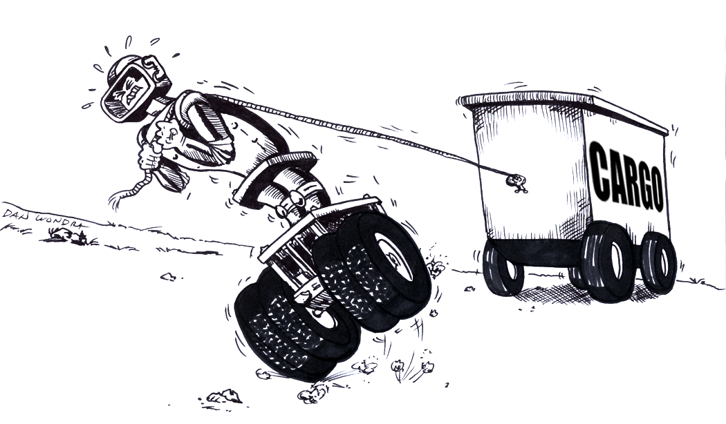
Draft Date: July 18, 2008
1st Author (Writer): Lynn Spady
2nd Author (Editor/Resource Finder): Rachel Neurath
Algebra Topic: 2-Step Equations
Grade Level: Middle School
Cartoon Illustration Idea: A robot pulling cargo

Content (what is taught):
- Solving 2-Step Equations
Context (how it is taught):
- Different cargo (containers) will be available for students to attach to their robot. Students may not open the containers; however, the number of items in each container will be listed on the outside.
- Students will use a triple beam balance to measure individually the mass of their robot and cargo. Students will use this information to set up a 2-step equation and solve for the mass of the individual items in the container.
- Groups will determine the maximum load their robot can carry. As an alternative or extension, students can set up different ramps for the robot to travel. A robot may only be able to pull x up the first ramp, but may pull 5x on a flat surface, or (1/3) x up a steeper ramp.

Container = 500g
Robot = 250g
x = mass of the items in the container
250g + 6x = 750g
-250 -250
6x = 500
6 6
The mass of each item is 83.3 grams

Standards:
- Math—B2, D2
- Science—A1, A2
- Technology—B4, C4

Materials List:
- Classroom robot
- Different cargo (labeled with the number of items in each container)
- String
- Triple beam balance
- Notebook
ASKING Questions (Robo-Pull)

Summary:
Ideally, different robots and/or remote control toys would be available. Different cargo containers (various sizes and masses) would also be available so that students could hypothesize which robot could pull which cargo. The containers should be opaque so students cannot see the items inside. The outside of the container should be labeled with the number of items inside. To add variety, ramps could be set up and students could be asked to think about different situations. For example, given two ramps at different slopes, what is the best way for Robot A to get “x” amount of cargo from point A to B?

This is a remote control dog
3
7
5

Cargo containers
Robots and/or Remote Control Toys

Point B

Point B
Point A

Ramps
Point A

Outline:
- Lay out the different cargo, robots, and ramps.
- Ask students to hypothesize which robot could carry which cargo and explain their conclusions.

Questions | Answers
Which robot could carry cargo 3 (the one with 3 items in the container)? | - Neither. The robots are both too small to carry that large of a container  - It depends on what is inside the container
A robot has to carry all the cargo containers from Point A to Point B. Which ramp would you use? | - The steeper ramp because it is shorter  - The longer ramp. It would be too hard for the robots to climb the steeper ramp  - It depends, I would have to see how the robots travel up the ramps
What would you like to know about the materials in front of you? | - How much does each cargo container weigh?  - How fast does each robot go?
EXPLORING Concepts (Robo-Pull)

Summary:
Students will practice attaching different cargo to their robot to see which cargo it can pull
the easiest. Different scenarios could be set up for students to explore the best way to get “x” amount
of cargo to a location.

Outline:
- Students predict which cargo will be the easiest for their robot to carry.
- Students attach individual cargo containers to their robot and make observations about how easy or hard it is to pull each cargo container.
- Students predict which ramp will be the easiest for their robot to climb.
- Students drive the robot (with and without cargo attached) up the different ramps and make observations about how easy or hard it is to climb the ramps.

Activity:
Robots will be available along with different cargo containers. Containers should be of varying sizes and have a different amount of items inside of them. Students will attach one end of a string to the container and the other end of the string to their robot. As the robot pulls the container, students will take notes (in their notebook) and will describe how easy or hard it was for the robot to pull the cargo.

Ramps will be available for the robots to climb. Students will drive their robot up the different ramps without cargo first and record observations about how easy or hard it is for their robot to climb the ramps. Students will then attach the different cargo containers to their robot and then repeat the process of climbing the ramps. Students will record all observations in their notebook.

INSTRUCTING Concepts (Robo-Pull)

Two Step Equations

Putting “Two Step Equations” in Recognizable terms: Two Step Equations are common in algebra. They involve two steps to get the variable by itself. This means that 2 numbers are “connected” to the x and have to be canceled out.

Putting “Two Step Equations” in Conceptual terms: The idea of solving for x is an abstract algebra skill. Two-step equations are one of many types of equations that are solved using algebra. The process of solving algebraic equations is a very complex process but by learning to solve two-step equations you can begin to understand the process.

Putting “Two Step Equations” in Mathematical terms: To solve two-step equations it is necessary to keep the equation balanced. What you do to one side of the equal sign you must do to the other. A two-step equation will fit one of the forms: 1) ax + b = c, 2) ax + bx = c, or 3) ax = bx + c where a, b, and c are constants. To solve an equation of the first form you must undo the number added or subtracted to the x first and then either multiply or divide to get the x alone. Combining like terms and then multiplying or dividing to get the x alone can solve equations of the second form. Equations of the third form can be solved by moving bx to the other side of the equal sign, combining terms, and then multiplying or dividing to get the x alone.

Putting “Two Step Equations” in Process terms: Thus, the process for solving two-step equations is a basic algebra skill. It is used to solve problems that can be used to model the real world. The process for solving linear equations can be done in 5 steps: 1) distribute, 2) combine like terms, 3) move the variable to one side and combine, 4) undo addition and subtraction, and 5) undo multiplication and division. This process will always work to solve linear equations. It is worth noting that there is sometimes a more efficient process depending on the equation but it is specialized and won’t always work.

Putting “Two Step Equations” in Applicable terms: Two-step equations can be used to model many real world situations. One case would be a trip of 500 miles and we have driven 100 miles already. We will drive the remaining distance at 60 miles per hour. How long will it take to make our destination? This can be modeled by 60x + 100 = 500. This is only one of many applications of two-step equations.

ORGANIZING Learning (Robo-Pull)

Summary:
Students will use their notebook to make drawings of their setup (robot, cargo container, and ramp), record masses of the container and robot, and calculate the individual mass of each object in the container.

Outline:
- Draw the setup (robot, cargo container, and ramp).
- Measure the mass of the container and record.
- Record the number of items in the container (which should be marked on the outside of the container).
- Measure the mass of the robot and record.
- Set up an equation to solve for “x” (the mass of the individual items in the container).

Activity:
The activity will start by completing a sample problem together. Then, each group will attach a different cargo container to the robot (or a different cargo container to a different robot) and complete the calculations in groups.

Worksheet Idea: Record sheet, sample student sheet

Drawing of Setup

6

Mass of Container | # of Items in Container | Mass of Robot | Equation | Notes
400 grams | 6 | 160 grams | 6x + 160 = 560  - 160 -160  6x = 400  - 6  x = 66.7 | Each item in the containers has a mass of 66.7 grams. The robot was able to climb halfway up the ramp with the cargo container before it stopped.

UNDERSTANDING Learning (Robo-Pull)

Summary:
Students will solve 2-step equations.

Outline:
- Formative assessment of setting up and solving 2-step equations
- Summative assessment solving 2-step equations

Activity:
Formative Assessment
As students are engaged in learning activities, ask yourself or your students these types of questions:
- Given a situation with an unknown value, can students set up an equation to solve?
- Do students know the steps to solve an equation?

Summative Assessment
1. A setup can be created as illustrated below. Students can do a write-up of the problem and
solve for the unknown value (the mass of individual items in the container). A rubric could be
provided for grading.
x = mass of the items in the container
250g + 6x = 750g
-250 -250
6x = 500
6 6
The mass of each item is 83.3 grams
Container = 500g
Robot = 250g

2. Solving 1-step and 2-step equations:

a) b) c)

d) e) f)

