SPIRIT 2.0 Lesson:
Robot Ramps

==============================Lesson Header ==============================
Lesson Title: Robot Ramps
Draft Date: September 18, 2008
1st Author (Writer):
2nd Author (Editor/Resource Finder): Davina Fiamon
Algebra Topic: Linear Functions
Grade Level: 7 - 9
Cartoon Illustration Idea: “Happy” robot driving up a ramp

Content (what is taught):
- Calculating slope
- Slope families (positive, negative, etc.)
- Writing equations of lines

Context (how it is taught):
- The robot will be driven up a ramp positioned relative to a wall with a coordinate plane on it.
- Points that the ramp passes through will be located and recorded.
- Pictures will be taken of the robot and ramp relative to the wall grid and notes will be recorded describing the robots “drive” particularly the difficulty of ascent or descent. (These descriptions will help students analyze why the robots did or did not have difficulty traversing the slope.)
- The points found will be used to calculate slope and will be extended into writing equations.

Activity Description:
In this lesson, slope and writing equations will be explored. A coordinate system will need to be placed on the wall and a ramp that can be adjusted to different slopes will need to be leaning against the wall. First, the ramp must be set up and the robot driven up the ramp. Second, the points that the ramp passes through will need to be located and recorded. Finally, students will record the difficulty the robot had driving up the ramp (easy, moderate, hard, impossible, etc.). Students will take a picture of the ramp to note the relationship of the ramp to the wall (this will be used to help understand why it is sometimes more difficult for the robot to move up the ramp). Students will experiment many times to collect data about different slopes both positive and negative. Students will calculate the slope from the pictures and will use the slope to find the equations of lines.

Standards: (At least one standard each for Math, Science, and Technology - use standards provided)

Math—A1, B1, E1, E2

Science—A1, E1

Technology—A1, C4, D3

Materials List:
- Robot
- Adjustable ramp
- Wall of room marked with a Cartesian grid
- Record Sheet
- Digital camera
Asking Questions (Robot Ramps)

Summary:
Students will be looking for slope in the real world. This exercise will demonstrate the importance of the concept of slope and will demonstrate how slope affects us all.

Outline:
- Ask students for examples of where slope is found in the world.
- If needed, supply students with some examples. Places where slope can be found include roofs, stairs, ramps, highway and train track grades, mountain slopes, etc.

Activity:
Ask students for places that slope can be found in the real world and the occupations that need a good understanding of the concept of slope. During this process, guide the students and provide pictures of stairs, ramps, rooflines, highways, and mountains to show that there is a different “steepness” to things in the real world.

Questions | Answers
Where in the world can we find things that slope? | Roofs, ramps, stairs, highways, ski slopes, etc.
Why does it matter how sloped (steep) something is? | If you are climbing, walking, or driving, the steepness makes those activities easy or hard depending on the steepness (slope).
Why would it matter in some jobs that the people understand slope? | Carpenters need to build things with a certain slope to meet building code. The same is true for engineers that build roads, railways, ramps, etc.
Does slope affect you? | Yes, everyday on your walk up that hill, climbing the stairs, driving your car…

Images:
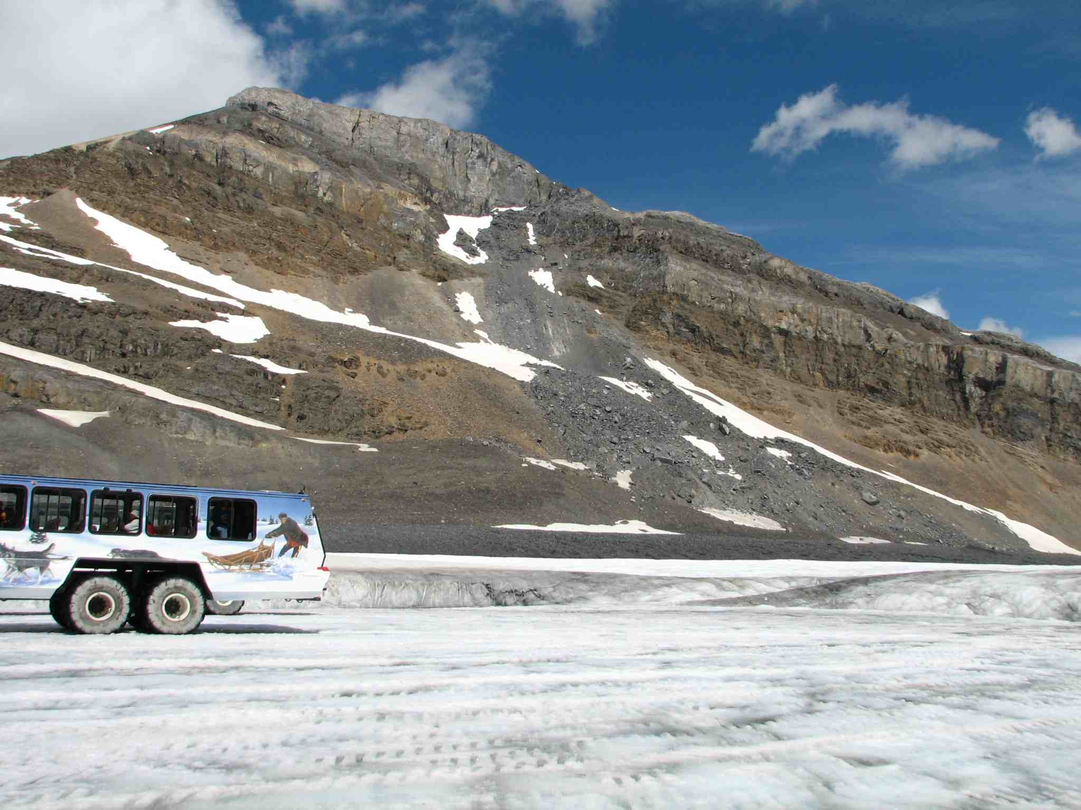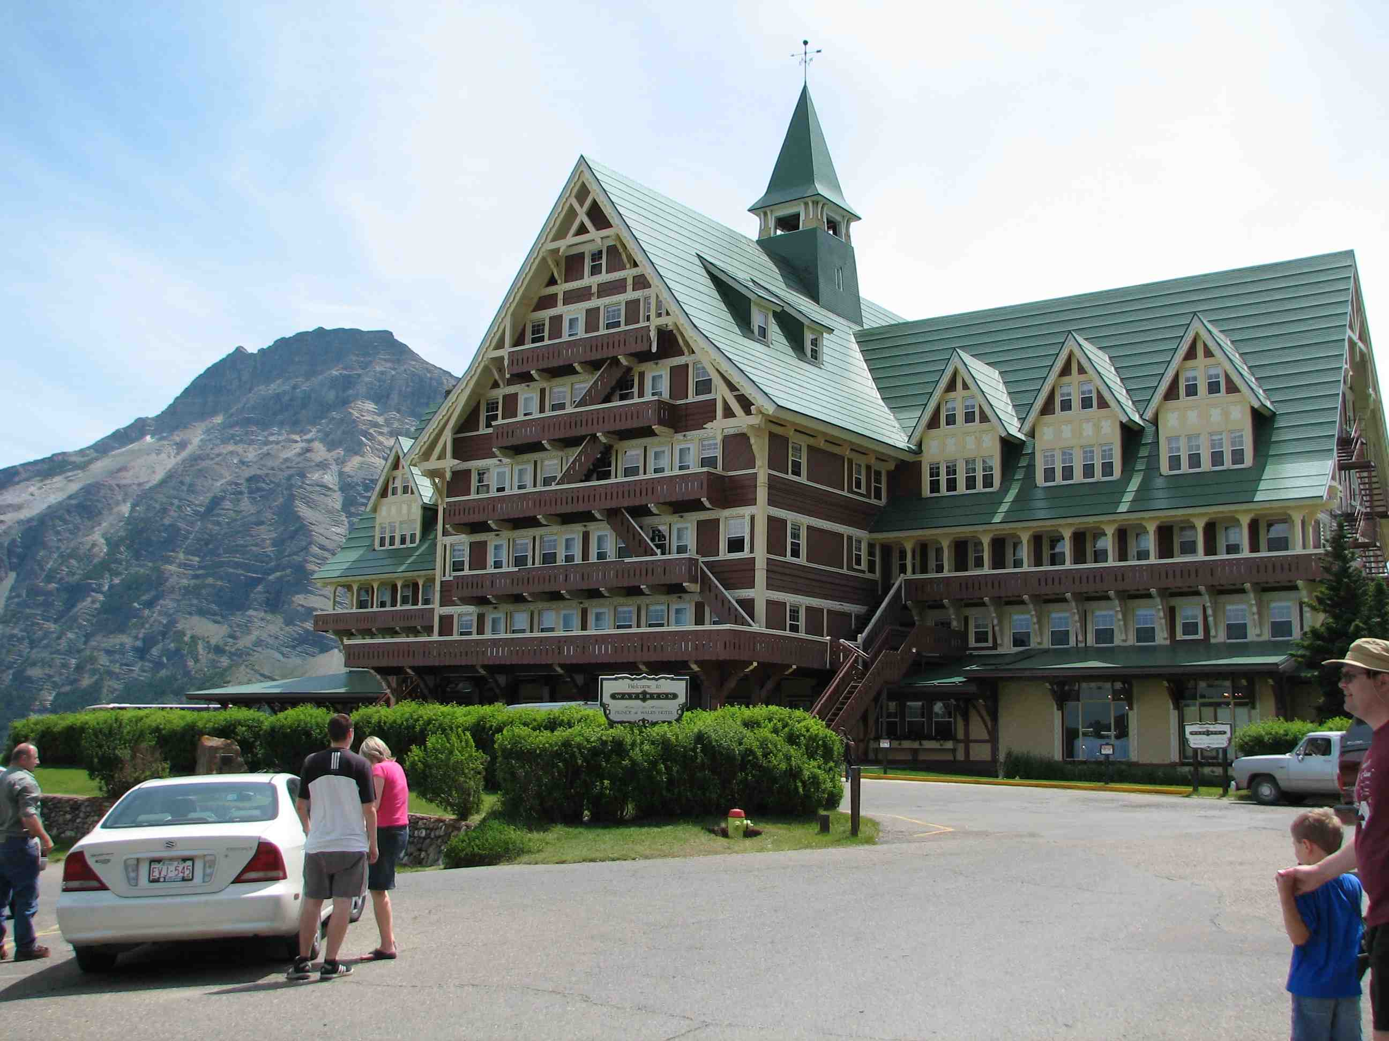

Exploring Concepts (Robot Ramps)

Summary:
Students will drive robots up and down ramps and will record their position relative to the grid on the wall. Students will record also the difficulty of climb/decent. Students will create many different ramp configurations so that they can document different data points.

Outline:
- Students will set up a ramp, drive the robot up the ramp, locate points that the ramp goes through, take a picture of the position, and record the difficulty of the trip.
- Students will repeat the process and later will calculate the slope and find an equation.

Activity:
You will need to have a coordinate system on the wall and a ramp that can be adjusted to different slopes sitting against the wall. First, set up the ramp, drive the robot up the ramp, and record the difficulty driving. Next, take a picture of the ramp to note the relationship of the ramp to the wall by finding points that the ramp goes through. Finally, repeat this process several times to collect data about different slopes both positive and negative. (It would be better if you move the ramp horizontally as well so that the y-intercept of the line will change.) The difficulty driving up or down is important for later.

Trial Number | Points that the ramp passes through | Written description of the ramp position | Description of robot driving

Ramp 1
Ramp 2
Ramp 3
Coordinate System
on Wall
Instructing Concepts (Robot Ramps)

Slope

Putting Slope in recognizable terms: Other words for slope include steepness, pitch, grade, angle of elevation, angle of inclination/declination, and rise over run.

Putting Slope in Conceptual terms: Slope is a relationship between two rates (related rates) or a comparison of two distances (remember that rate is just a distance divided by a measure of time, r = d/t). The distance the robot travels in the y direction varies (or changes) as a factor (m) of the distance the robot travels in the x direction. So, some number (m) times x gives us y. Therefore, m (distance of x) = (distance of y). If we solve for the variable m by dividing both sides of the equation by (distance of x), we get a related rate (slope). This related slope is also called rise over run.

Putting Slope in Mathematical terms: We could also call the distance traveled in the y direction the change in distance of y or the difference in the y-coordinate values of two points. We could call the distance traveled in the x direction the change in distance of x or the difference in the x-coordinate values of the same two points. This gives us a formula: $M=\frac{Δy}{Δx}$ (difference in y values over the difference in x values or, delta y divided by delta x). When we use calculus, we simplify by saying, $m=\frac{\text{dy}}{\text{dx}}$.
Putting Slope in Process terms: Algebraic computation of slope: $m=\frac{y_{2}−y_{1}}{x_{2}−x_{1}}$. Provide examples of calculating slope between points. Be sure to include examples and explanation of negative value slopes.

Putting Slope in Applicable terms: Randomly angle the robot. Drive the robot for three seconds from a given point, measure the vertical and horizontal components, and define the slope.
Organizing Learning (Robot Ramps)

Summary:
Data will be analyzed and slopes calculated for each situation. After the slope is calculated, an equation of the line can be found. Students will be asked how the “difficulty” that the robot had driving is related to the equation.

Outline:
- Students will analyze the data collected.
- Students will use the coordinates found previously and calculate the slope of the ramp.
- Students will write the equation of the line in point-slope form.
- Students will be asked to think about the difficulty (easy, moderate, hard, impossible, etc.) the robot had driving and how it relates to the equation. Students can use the pictures to help them remember the specific ramp positions.

Activity:
Revisit the data collected in the “Exploring Concepts” section and have students locate coordinates that can be used to find the equation of the line formed by the ramp. The students can calculate the slope with coordinates found using the pictures. Next, students can write the equation of the line formed by the ramp in point-slope form (you can have the students transform the equation into slope-intercept or standard form if you want to.) Discuss the difficulty factor that the robot had driving both up and down the ramp and how that relates to the equation (or how that relates to the slope). As an ending activity, students can look into the concept of handicap ramps. Students can research the design and building of the ramps and can calculate a grade (slope) that would be acceptable for the ramps. The answer can be in the form of a compound inequality by looking at a minimum and maximum acceptable grade for the ramps.
Ramp 1
Ramp 2
Ramp 3
Coordinate System
on Wall

(0,0)

Ramp  # | Two Coordinates  on Ramp | Slope | Equation in  Point-Slope Form | Equation in Slope-Intercept Form | Driving Difficulty
3 | (2,0) and (12,5) | 5-0 = 5 = 1  12-2 = 10 = 2 | y – 5 = 1/2 (x – 12) | y = ½ x - 1 | The robot stalled about half-way up the ramp.

Understanding Learning (Robot Ramps)

Summary:
Students will write a formal lab write-up about the process that they carried out to collect data, arrive at the linear equations, and design their ramp. Students may write several other writing projects as well including traditional problem-based assessments.

Outline:
- Formative assessment of linear functions.
- Summative assessment of linear functions.

Activity:
Formative Assessment
As students are engaged in the lesson ask these or similar questions:
1. Do students understand the connection between slope and the real world?
2. Do students know the formula for slope? Do they understand that it takes two points to find it?
3. Can students relate the difficulty of the robot traveling the ramp to why it is easier/harder?

Summative Assessment
Students will write a formal lab write-up of the process that they used to collect the data from the robot driving on the ramp and how they found the equation represented by the ramp. The write-up needs to include an explanation of the concept of slope; and where slope is applicable in the real world.

Students will complete a performance assessment by building the handicap accessible ramp that they designed and see if it will work for all people who might require use of a ramp. Students need to consider if the ramp can be used by a child, elderly person, or person confined to a wheel chair.

Students will answer one of the following writing prompts:
1. Explain how the slope of the ramp relates to the difficulties of the robot driving on it.
2. Discuss what occupations must understand slope and why.

Students will complete the following quiz questions as follows:
- Write the equation of a line containing the points (4, - 7) and (-2, 4) in point-slope form.
- Write the equation of a line that passes through the origin and (8, -2) in point-slope form and describe the line as trending positive, negative, horizontal or vertical.

