SPIRIT 2.0 Lesson:
Trig is SOH Easy!

==============================Lesson Header ==============================
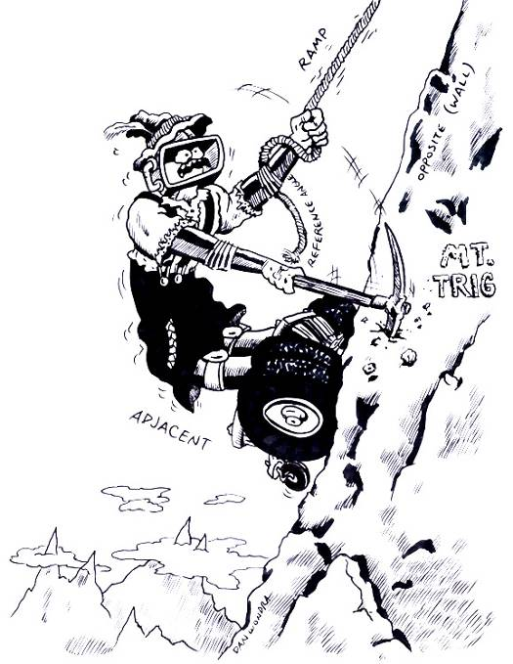
Lesson Title: Trig is SOH Easy!
Draft Date: June 27, 2008
1st Author (Writer): Lynn Spady
Algebra Topic: Basic Trig Functions
Grade Level: Algebra I – 8th/9th Grade

Content (what is taught):
- Identification of opposite and adjacent (from reference angle), and hypotenuse in a right triangle
- Understanding trig ratios (sine, cosine, and tangent)
- Application of trig ratios to find a missing side length
Context (how it is taught):
- The robot will travel up a ramp set at different angles.
- The angle measurement and ramp length will be recorded.
- The opposite side of the reference angle (wall) and adjacent side (floor) will be calculated.

Activity Description:
In this lesson, students will investigate the steepest ramp possible for a robot to travel. The angle of the ramp and ramp length will be used to find the opposite and adjacent side lengths using sine and cosine. Students will first investigate a given ramp angle and perform the calculations. Then, students can try different angles to find the maximum angle possible for the robot to travel.
Opposite
(wall)
ramp
Reference Angle
Adjacent (floor)

Standards:
- Math—C4, D2, E1, E3
- Science—A1, A2
- Technology—C4, A3,

Materials List:
- Classroom Robot
- Protractors
- Meter Sticks
- Ramps
ASKING Questions: Trig is SOH Easy!

Summary:
Students are asked to make observations as the robot travels up and down a ramp.

Outline
- Demonstrate the robot traveling up a ramp.
- Demonstrate the robot traveling down a steeper ramp.
- Ask students what they think is the steepest ramp the robot can travel.
- Determine vocabulary.

Activity:
Demonstrate the robot traveling up a ramp and then demonstrate the robot traveling down a steeper ramp. Point out the angle of the ramp and the right angle formed.

Questions | Answers
What is similar about the two ramps? | Both ramps form right triangles.
What is different about the ramps? | The robot is traveling up one ramp and down the other. The second ramp is steeper than the first.
How could we find out how steep the ramp is? | We could estimate or use a protractor.
How could we find out the other measurements (how far the top of the ramp is from the floor and how far the bottom of the ramp is to the floor)? | We could estimate it or use a meter stick.
What is the steepest angle of the ramp you think the robot can travel? | ???

Image Idea: Picture of the set-up of both ramps.

Ramp 1

Ramp 2

EXPLORING Concepts: Trig is SOH Easy!

Summary:
Students will be using the robot to travel up different ramp angles while recording the information in a chart.

Outline:
- The robot travels up a ramp at a set angle.
- Students record the ramp angle measurement, ramp length, floor distance, and wall distance.
- Students explore and record different ramp angles.

Activity:
Students will work in groups of 3-4 to observe the robot traveling up a ramp that is set at different angles. Students will use a chart to record the information and will set up trig ratios although the trig ratios have not formally been taught. Students will try to find the maximum ramp angle the robot can travel. Students may want to make notes next to each ramp angle describing how the robot climbed the ramp. Groups may then share the process by which they found their maximum angle. The groups may also explain how they would do things differently if they were to carry out the same activity again.

a
(wall
distance)
b (floor distance)
c

Angle of Ramp | a | b | c | a/b | a/c | b/c

INSTRUCTING Concepts: Trig is SOH Easy!

Putting “Trig Functions” in Recognizable terms: Trig functions are ratios of the legs and hypotenuse of the right triangles used in the Pythagorean Theorem. The basic trig functions are related to the reference angle (the given angle or its equivalent).
Putting “Trig Functions” in Conceptual terms: If we look at a rectangular coordinate system and place an angle (θ) so that its vertex is located at the origin and the adjacent leg of the angle lies on the abscissa, the basic trigonometric functions of that angle are defined to be:
- Sine – the ratio of the length of the leg opposite the reference angle divided by the length of the hypotenuse.
- Cosine – the ratio of the length of the leg adjacent to the reference angle divided by the length of the hypotenuse.
- Tangent – the ratio of the length of the leg opposite the reference angle divided by the length of the leg adjacent to the reference angle.
Putting “Trig Functions” in Mathematical terms: The basic trig functions for an angle θ positioned as above are defined, then, to be:
- sin θ = y/r
- cos θ = x/r
- tan θ = y/x
where x is the x coordinate of any point on the terminal side of the angle other than the origin, y is the y coordinate of that point, and r is the length of the line segment from the origin to that point. (Remember from the Pythagorean Theorem that x ² + y ² = r ² ).

Reference Angle
Side Adjacent to Reference Angle
Side Opposite Reference Angle
Hypotenuse

Putting “Trig Functions” in Process terms: Since the trig functions of an angle are defined to be the ratios above, and those ratios do not change based upon the position of the point (x,y) on the hypotenuse, the sine, cosine, and tangent are related to the angle θ and not the (x,y) point chosen to calculate the ratios.
Putting “Trig Functions” in Applicable terms: Drive the bot along a [straight] line from the origin and stop it at irregular (random) time intervals. Determine the coordinates of the bot’s location and calculate the definition ratios for sine, cosine, and tangent at several different points along the line (the hypotenuse of the right triangle formed by connecting the (x,y) point to the abscissa with a vertical line).
ORGANIZING Learning: Trig is SOH Easy!

Summary:
Students will use a data table to record the ramp angle and the ramp length. The students will then calculate the floor distance and the wall distance trig ratios (sine and cosine).

Outline:
- Set up ramp for a 30 angle using a protractor.
- Record angle and ramp length.
- Calculate the floor distance, using cosine (adjacent over hypotenuse).
- Calculate the wall distance, using sine (opposite over hypotenuse).
- Measure floor and wall distance with meter stick to compare accuracy.

Activity:
Students will set the ramp angle at 30 using a protractor. Students will then drive the robot up the ramp making sure it makes it to the top without problems. Students will calculate the floor distance using cosine and wall distance using sine. Students will then measure the floor and wall distance using a meter stick to check accuracy. As an extension, students could calculate the percent error (difference of the calculated measurement and the actual measurement divided by the calculated measurement).
NOTE: Students may wonder why it is necessary to use the trig functions to find the measurements when it would be easier to measure the distances using a meter stick. If students do not come up with the idea on their own, point out that if you were to extend significantly the ramp, it would not be possible to measure using a meter stick.

Worksheet Idea: A chart that has the ramp angle, ramp length, calculation of floor and wall distance, and actual floor and wall measurement. Also, a second worksheet with expected results.

a
(wall
distance)
b (floor distance)
c

Angle of Ramp | Ramp Length | Floor  Distance | Actual Floor Distance | Wall  Distance | Actual Wall Distance
30

UNDERSTANDING Learning: Trig is SOH Easy!

Summary:
Students will write a summary of the basic trig ratios including vocabulary and pictures (sample rubric attached). Students will also calculate a missing side using trig ratios.

Outline:
- Formative assessment of trig ratios
- Summative assessment of trig ratios and vocabulary
- Summative assessment of table calculations

Formative Assessment:
As students are working, ask yourself or your students these types of questions:
- Were the students able to set up the trig ratios and solve for a missing side?
- Can students explain the reason for needing to know the trig ratios?

Summative Assessment:
Students will complete the following essay question about the basic trig ratios:

Using the diagram of Bot City below, write a story about the classroom robot traveling from its home to the part store. What is the distance the robot has to travel if it needs to travel both hills? Is there another route that is shorter? Be sure to include mathematical vocabulary and calculations in your story.
Home
Part Store
40
3 miles
2 miles
45

