SPIRIT 2.0 Lesson:
Robot Cartography

==============================Lesson Header ==============================
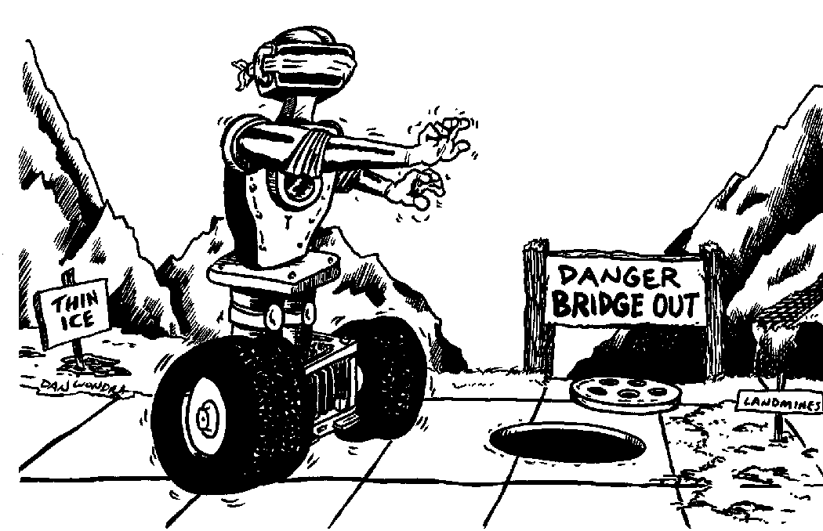
Lesson Title: Robot Cartography
Draft Date: September 14, 2008
1st Author (Writer): Brian Sandall
2nd Author (Editor/Resource Finder):
Davina Faimon
Algebra Topic: Coordinate System
Grade Level: 6 - 8

Content (what is taught):
- Coordinate plane
- Communication skills
- Map reading

Context (how it is taught):
- Form two groups of students. One group has a map covered with obstacles and the other group has a robot on a plane grid equipped to mark its path.
- The map group determines a path and communicates the path to the robot drivers using coordinates. A record keeper records information.
Activity Description:
One group of students has a complex map with obstacles and the other group of students has a robot with a marker attached to show its path. The two groups cannot see one another other. A grid is laid on the floor with the robot starting at the origin. The group with the map communicates to the group with the robot the path that they are to drive the robot by giving the drivers the specific Coordinate (x,y) on the path. The students continue the process until the robot traverses a path to a specific goal. Points may be awarded to map-readers based on the information they give the drivers and points may be awarded to drivers based on the quality of their driving, and on the work that they perform. A record keeper for the map group will write down the instructions given to the drivers and a record keeper for the driving group will note the quality and the difficulty of the driving. Groups will then switch. As an alternate activity, students may place obstacles on a grid and then plot the path on a map.

Standards: (At least one standard each for Math, Science, and Technology – use standards provided)

Math—A1, C2, C4

Science—A2, E1, F5

Technology—B1, B4, D2

Materials List:
- Robot equipped with marker
- Floor marked with Cartesian grid.
- Record sheet
- Pre-maps with marked obstacles.
Asking Questions (Robot Cartography)

Summary:
Have students randomly drive the robot around a grid on the floor and write down its various locations. Give no instruction about how to write down the coordinates. Hopefully, students will come up with many different answers to describe location. The number of possibilities in describing location will demonstrate to students the need for a standard coordinate system.

Outline:
- Students drive a robot and record a location
- After numerous locations, many different answers will demonstrate to students the need for standardization.

Activity:
Students will randomly drive the robot around a grid on the floor, stop it anywhere, and then write down the robot’s location. No instruction should be given about how to write down the location. This process should be repeated a number of times (possibly 10). Hopefully, students will generate many different answers for each location. The numerous varied responses will help students to realize that they need a standard coordinate system.

Questions | Answers
What do you need to consider in finding a location for the robot? | To find a location, you need to consider which direction to go first, either the positive direction or the negative direction.
Why do different people have different answers? | Different people look at location in different ways.
Should we all have the same answer for a location? | Yes, we should all have the same answer so that we all agree on each point’s location.
How can we standardize the location? | We can standardize the location by deciding on direction such as positive and negative as well as on the specific notation to describe location.

Exploring Concepts (Robot Cartography)

Summary:
Students will explore a standard location by examining the axes and the origin, by determining which direction is positive or negative, and by continuing to drive the robot. The group will decide on “rules” for a location for points.

Outline:
- Drive the robot to a location.
- Ask students how to label points
- Guide them toward areas such as the starting point

Activity:
Students will drive the robot to a location. The teacher will ask guided questions using active participation to help students realize that they need a starting point (origin), that they need to determine positive and negative direction, and that they need to be consistent in the direction to travel first. Students should drive the robot until they arrive at a system that is agreed upon and consistent (not necessarily conventional, but consistent).

…origin, quadrants, positive, negative, x, II, y, right, IV, left, up, down…
Instructing Concepts (Robot Cartography)

Putting “Rectangular Coordinate System” in Recognizable terms: Graphing on a rectangular coordinate system is a method of representing pairs of Real numbers on a flat (plane) surface.

Putting “Rectangular Coordinate System” in Conceptual terms: Every Rectangular Coordinate System has to start somewhere. Choose any plane on the surface and call it the “origin”, or the starting point. Position a Real number line so that the zero is at your chosen point of origin. Then plane another Real number line at right angles to the first one so that its zero is also at the origin. These two lines are the axes. One line will be the horizontal axis, or abscissa, and the other line will be the vertical axis, or the ordinate. Notice how the intersecting Real number lines have subdivided the plane surface into four sections, or quadrants.

Putting “Rectangular Coordinate System” in Mathematical terms: Ordered Pairs are necessary to define, or place, any particular point on the grid completely and accurately. An ordered pair is comprised of two real numbers; the first, which represents the position of the point with respect to the abscissa, and the second, which represents the location of the point with respect to the ordinate.

Putting “Rectangular Coordinate System” in Process terms: Pinpoint the location of any point (ordered pair) by finding the intersection of the first element of the pair of coordinates with that of the second item in the pair. These ordered pairs can be called (x,y) pairs, where the ‘x’ (or first element of the pair) refers to the abscissa location and the ‘y’ (or second element in the pair) refers to the ordinate location.

Putting “Rectangular Coordinate System” in Applicable terms: As you drive the robot around the plane surface (or rectangular coordinate system), stop it at irregular (random) time intervals and estimate its position by using ordered pairs of Real numbers. Generate an ordered pair randomly and then drive the robot to the location that is represented by that given ordered pair.
Organizing Learning (Robot Cartography)

Summary:
Play a game where one group reads a map, determines directions (coordinates), and then communicates to another group where to drive the robot to successfully navigate a path.

Outline:
- A group reads a map with obstacles and determines a path for the robot to travel to safely avoid the obstacles.
- The route is communicated to another group via coordinates.
- A second group drives the robot along the dictated route.

Activity:
One group has a complex map with obstacles and the other group has a robot with a marker attached to show its path. The groups cannot see one another. A grid is laid on the floor with the robot starting at the origin. The robot must have a marker attached to it so that the path it “drives” is obvious. The group with the map communicates the path the robot is to travel by telling the drivers to move the robot to coordinate (x, y). The students continue this process until the robot traverses a path to a goal. Points may be awarded to map-readers based on the information they give the drivers and points may be awarded to drivers based on the quality of their driving to the given location. A record keeper will be assigned to each group. The record keeper for the map-readers will write down the instructions provided by the map-readers to the drivers and the record keeper for the drivers will take notes on the quality and the difficulty of the driving. The groups will then switch.

Alternate Activity: Obstacles may be placed on a grid on the floor, a safe path for the robot may be determined, and then a map may be drawn to depict the path.

Sample Map
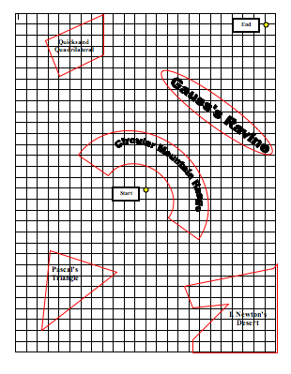

Steps | Directions given | Action taken
1
2
3
4
5
6
7

Understanding Learning (Robot Cartography)

Summary:
Have students write an essay on the Cartesian coordinate system and on how the system works. As another possible assessment, present various points and have students graph them or give students a graph to label.

Outline:
- Formative assessment of Cartesian coordinates.
- Summative assessment of Cartesian coordinates.

Activity:
Formative Assessment
As students are engaged in the lesson ask these or similar questions:
1. Are students able to explain and apply the rules for Cartesian coordinates?
2. Can students explain the concept of an origin?
3. Can students identify the x-axis, y-axis, positive/negative directions?

Summative Assessment
Students will be asked to write a formal lab write-up explaining the “game” that they played and describing the experimental process that they carried out to learn the Cartesian coordinate system. Next, the students will be given a group of points and asked to graph the points and will be given a graph and asked to label the points on the graph. Finally, students will be asked to drive the robot to a random location to identify the location using (x, y) coordinate and then to drive the robot to specific points.

Students will answer the following writing prompt:
1. Explain why there needs to be a standard method for graphing points and explain how that standard method works.

