SPIRIT 2.0 Lesson:
How Are We Related?

===============================Lesson Header ==============================
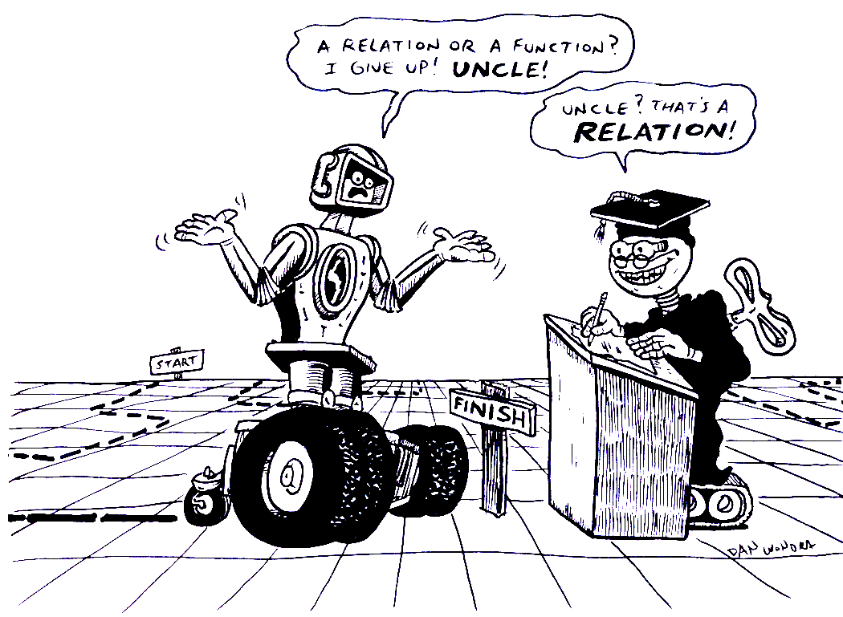
Lesson Title: How Are We Related?
Draft Date: July 17, 2008
1st Author (Writer): Neil Hammond
Algebra Topic: Functions and Relations
Grade Level: Algebra I – 8th/9th Grade

Content (what is taught):
- Determine what a Function is
- Determine what a Relation is
- Be able to tell the difference between the two
Context (how it is taught):
- Have students drive a robot on the coordinate plane so that it makes a relation.
- Instruct students to drive around the plane so that they can make relations and functions.
- Discuss how to determine the difference between a function and a relation.

Activity Description:
Lay a coordinate grid out on a flat surface such as a table or floor. The students will take turns driving the robot around the grid so that the path it travels is in the form of a relation. The students will then draw that path onto graph paper. After the students have drawn a few of these graphs, they will determine which graphs are functions and which graphs are not. Students will use the vertical line test to find the difference.

Standards: (At least one standard each for Math, Science, and Technology - use standards provided)
- Math—A1, B1, B2
- Science—B2
- A1

Materials List:
- Classroom Robot
- Coordinate Grid
- Graph Paper
ASKING Questions (How Are We Related?)

Summary:
Students examine a coordinate plane and discuss functions and relations.

Outline
- Have the coordinate plane drawn on the table or floor.
- Ask students about functions and relations.
- Help the students determine the difference between functions and relations.

Activity:
Start by asking these questions to see if students understand functions and relations:

Questions | Answers
What is a relation? What are some real world examples of relations? | A relation is something that relates one object to another. Some examples of relations are dating, batting average, and points per game.
What is a function? What are some real world examples of functions? | A function is something that relates one object to another, but is also a working relationship. An example of a function is something that has one ‘x’ and one ‘y’
How can we determine the difference between functions and relations? | A relation is a function if it passes the vertical line test. Also, for any function, there is exactly one ‘y’ value for each ‘x’ value.

Resources Search: Cool Math Algebra

Are we related?
I’m not sure…what’s your function?

EXPLORING Concepts (How Are We Related?)

Summary:
Students use a robot to determine the difference between a relation and a function.

Outline:
- The students will be given the opportunity to drive the robot wherever they would like.
- Students will be given a beginning point and an ending point.
- Students will drive the robot from the beginning point to the ending point in any manner that they choose.
- Students will then determine if the path the robot drove is a function or a relation.

Activity:
The students will be split up into four or five groups and each group will have a robot and a coordinate grid. The students will choose the start point and the end point. After the students have selected these two points, they will connect the two points in any manner they chose (straight line, curved line, or a combination of the two).

After the students have driven the path from the start point to the end point, they will then use graph paper to copy the path. NOTE: The graph will not be perfect but they need to try to do the best they can. Once the students have drawn approximately four graphs, they will need to determine if they have drawn a function or only a relation. If the graph is a relation, it only needs to be connected from the start point to the end point. If the graph is a function, then for every ‘x’ value there is only one ‘y’ value associated with it. Remember a function is always a relation, but a relation is not always a function.

Student Worksheet

END
START
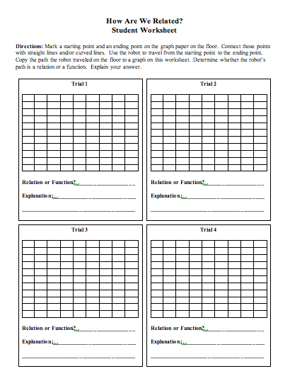
INSTRUCTING Concepts (How Are We Related?)

Functions
Putting “Functions” in Recognizable terms: Functions are a set of related ordered pairs that when graphed a vertical line will pass through the graph only one time no matter where the vertical line is drawn.

Putting “Functions” in Conceptual terms: A function is a relation where each element in the domain (the x value) is paired with only one value in the range (the y value). This means that that an element in the domain is not allowed to repeat.

Putting “Functions” in Mathematical terms: A function is a set of related ordered pairs that can be used to model real world situations. It can be solved explicitly so that y can be written in terms of x for all cases. The advantage of a function versus a relation is that if you plug in an element in the domain (x value) to the function you will always get the same value in the range (y value). This is not true for relations.

Functions take many forms. Some of the most common are polynomials in the form $f(x)=a_{n}x^{n}+a_{n−1}x^{n−1}+⋅+a_{1}x^{1}+a_{0}x^{0}$ where n is an integer. Other functions are absolute values in the form $f(x)=a|x−h|+k$ or radicals in the form $f(x)=a\sqrt[n]{x−h}+k$ where n is an integer. This list is far from inclusive.

Putting “Functions” in Process terms: Thus, for any function, when you plug in a specific x value, you can compute the corresponding y value. These ordered pairs if graphed will be a visual representation of the function.

Putting “Functions” in Applicable terms: Functions are often used to model the real world. Some situations are: 1) linear relationships, 2) quadratics including projectile motion, 3) trigonometric equations and periodic motion, 4) parametric equations and numerous others. A function can be used to model any situation in which every value of x in the domain is paired with only one y in the range.

ORGANIZING Learning (How Are We Related?)

Summary:
Students will have graphs of relations and they will determine if the relations are functions. Students will also using mappings to show how relations and functions are related.

Outline:
- Instruct students to examine graphs of relations using the vertical line test.
- Provide students with a set of ordered pairs. Have students draw a mapping of the ordered pairs and have them determine if the set of ordered pairs is a function.

Activity:
Give students four or five coordinate plane graphs of relations. Students will need to determine if the relation is a function. To determine if it is a function, the students will use the vertical line test. The way to use the vertical line test is as follows:
1. Look at the graph and draw a vertical line anywhere on the graph. If the vertical line passes through two points, the graph IS NOT a function.
2. If the vertical line passes through one point, try another vertical line. If all vertical lines created
only pass through one point, the graph IS a function.
- If ANY vertical line that you draw passes through two points, then the graph IS NOT a function.

All vertical lines pass through only one point. This relation IS a function.
One of the vertical lines passes through two points. This relation IS NOT a function.

Once the students have finished the coordinate graphs, give them some groups of ordered pairs. The students will need to draw a mapping of these ordered pairs to determine if the set of ordered pairs is a function. For example: {(1,2) (2, 5) (1,7) (3, 5) (4, -6)}. This is not a function since the 1 goes to 2 different values.
1
2
3
4
-6
2
5
7

UNDERSTANDING Learning (How are we Related?)

Summary:
Students will work through the assessment of relations and functions.

Outline:
- Formative assessment of relations and functions
- Summative assessment of relations and functions

Activity:
Formative Assessment
As students are engaged in learning activities ask yourself or your students these types of questions:
1. Were the students using the correct vocabulary (relation, function, vertical line test)?
2. Can students explain the difference between relations and functions?

Summative Assessment
Students will be asked to answer four questions and then explain why they answered the questions a certain way.
1. Draw a graph of a function and explain why it is a function.
2. Draw a graph that is not a function and explain why it is not a function.
3. Draw a mapping that is a function and explain why it is a function.
4. Draw a mapping that is not a function and explain why it is not a function.

