SPIRIT 2.0 Lesson:
“The Power Steering Is Out?!”

=============================== Lesson Header==============================
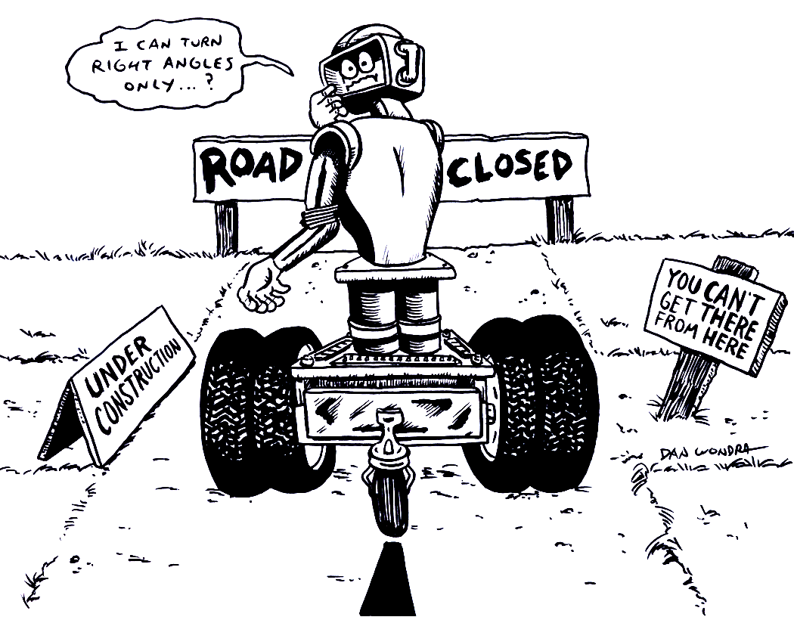
Lesson Title: The Power Steering Is Out?!
Draft Date: July 17, 2008, 2008
Author (Writer): Derrick A. Nero
Algebra Topic: Slope
m = rise / run and m = (y₂ – y₁) / (x₂ – x₁)
Grade Level: Middle

Content (what is taught):
- Use of coordinate planes and points
- Application of the mathematical formula m = (y₂ – y₁) / (x₂ – x₁) or m = rise / run
- Measurement
Context (how it is taught):
- Coordinate points are identified and recorded
- The CEENBot is driven from one coordinate point to another by traveling only horizontally, vertically, and making only one 90º turn (“driving criteria” – in relation to coordinate grid).

Activity Description:
In this lesson, students investigate how the slope of a line connecting two coordinate points is calculated. Students will select “locations” on a coordinate plane marked on the floor. Each student will record his/her “location” as a coordinate point. Pairs of students will be randomly selected to “travel” to one another’s “location” using the CEENBot and driving criteria. All students will record the horizontal and vertical distances traveled by the CEENBot. The student pair will then travel in a straight path from one “location” to the other, and will measure the path using a meter stick. Finally, students will calculate the slope of each pairing using the formula m = rise / run or m = (y₂ – y₁) / (x₂ – x₁).

Standards:
- Math—A1, A3, D1, D2, E1, E3
- Science—A1, A2
- Technology—A3

Materials List:
- CEENBot
- Masking tape
- Data Sheet
- Meter sticks
- Notebook
ASKING Questions (The Power Steering Is Out?!)

Summary:
Students determine the best route to travel from one location to another.

Outline:
- Demonstrate the CEENBot traveling on the coordinate plane that is marked on the floor.
- Drive the CEENBot from one location to the other using many 90º turns.
- Drive the CEENBot from one location to the other using only one 90º turn.

Activity:
The teacher will demonstrate driving the CEENBot on the coordinate plane from one location to another.

Questions | Answers
How many routes can be used to travel to either location? | Numerous routes (with no constraints) can be used to travel to either location.
How many routes can be used to travel to either location, using the driving criteria? | Two routes (with the second being the opposite of the first) can be used to travel to either location using the driving criteria.
What is the quickest route from one location to the other? | A straight path is the quickest route from one location to the other.

EXPLORING Concepts (The Power Steering Is Out?!)

Summary:
Students explore the relationship between the horizontal and vertical distances traveled from one point to another.

Outline:
- Student pairs will drive the CEENBot from one location to another using one 90-degree turn.
- Students will predict the number of units from the starting location to the 90-degree turn (Run).
- Students will predict the number of units from the 90-degree turn to the ending location (Rise).
- Students will predict the straight path distance from one location to the other (Slope).
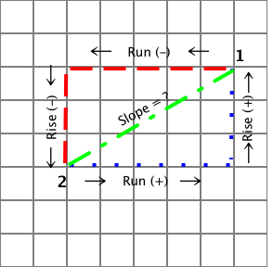
Location 1
Location 2

Activity:
In this lesson, students investigate how the slope of a line connecting two coordinate points is calculated. Students will select “locations” on a coordinate plane marked on the floor. Each student will record his/her “location” as a coordinate point. Pairs of students will be randomly selected to “travel” to one another’s “location” using the CEENBot and driving criteria. All students will record the horizontal and vertical distances traveled by the CEENBot. The student pair will then travel in a straight path from one “location” to the other, and will measure the distance of the path using a meter stick.

To provide formative assessments as students are exploring these concepts ask yourself or your students these questions:
- Did students consider the direction, therefore the value of the units (negative or positive) traveled from one location to the other?
- Did students predict the distances traveled to be identical between locations? both directions?
- How did students predict the straight path distance from one location to the other (i.e., math computation or estimate)?
INSTRUCTING Concepts (The Power Steering Is Out?!)

Putting Slope in recognizable terms: Other words for slope are: steepness, pitch, grade, angle of elevation, angle of inclination/declination, and rise over run.
Putting Slope in Conceptual terms: Slope is a relationship between two rates (related rates) or a comparison of two distances (remember that rate is just a distance divided by a measure of time, r = d/t): the distance the bot travels in the y direction varies (or changes) as a factor (m) of the distance the bot travels in the x direction. So, some number (m) times x gives us y. Therefore, m (dist. Of x) = (dist. Of y). If we solve for the variable m by dividing both sides of the equation by (dist. Of x), we get a related rate (slope). This is also called rise over run.
Putting Slope in Mathematical terms: We could also call the distance traveled in the y direction the change in distance of y or the difference in the y-coordinate values of two points. We could call the distance traveled in the x direction the change in distance of x or the difference in the x-coordinate values of the same two points. This gives us a formula: $M=\frac{Δy}{Δx}$ (difference in y values over the difference in x values or, delta y divided by delta x). When we get to calculus, we simplify by saying, $m=\frac{\text{dy}}{\text{dx}}$ .
Putting Slope in Process terms: Algebraic computation of slope: $m=\frac{y_{2}−y_{1}}{x_{2}−x_{1}}$. Provide examples of calculating slope between points. Be sure to include examples and explanation of negative value slopes.
Putting Slope in Applicable terms: Randomly angle the bot, drive it for three seconds from a given point, measure the vertical and horizontal components, and define the slope.
ORGANIZING Learning (The Power Steering Is Out?!)

Summary:
Students use data tables that record the ramp angle, distance, time, and ramp surface to calculate the rate of motion (speed) of their classroom robot up a ramp.

Outline:
- Collect data as student pairs travel to one another’s locations
- Data includes horizontal (run) and vertical (rise) distances and coordinate points
- Fractions should be expressed in reduced form

Activity:
Students collect data on the distances traveled by student pairs to arrive at one another’s location. Also, students collect information on the coordinate location of each student pairs’ locations. In this lesson, students investigate how the slope of a line connecting two coordinate points is calculated. Students will select “locations” on a coordinate plane marked on the floor. Each student will record his/her “location” as a coordinate point. Pairs of students will be randomly selected to “travel” to one another’s “location” using the CEENBot and driving criteria. All students will record the horizontal and vertical distances traveled by the CEENBot. The student pair will then travel in a straight path from one “location” to the other, and measure the path using a meter stick. Finally, students will calculate the slope of each pairing using the formula m = rise / run or m = (y₂ – y₁) / (x₂ – x₁).

Student Worksheet
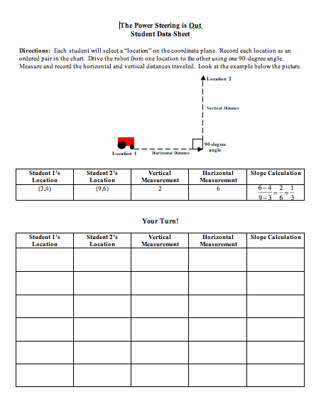

UNDERSTANDING Learning (The Power Steering Is Out?!)

Summary:
Students write essays about the application of m = rise / run or m = (y₂ – y₁) / (x₂ – x₁).

Outline:
- Formative assessment of m = rise / run or m = (y₂ – y₁) / (x₂ – x₁)
- Summative assessment of m = rise / run or m = (y₂ – y₁) / (x₂ – x₁)

Activity:
Formative Assessment
As students are engaged in learning activities ask yourself or your students these types of questions:
1. Were the students able to apply either formula for slope?
2. Can students explain the meaning of slope?

Summative Assessment
Students will complete the following essay questions about the distance-rate-time formula:
- Calculate the slope of the line formed by the student’s home and the Crossroads Mall.
- Write a story involving the path of a rogue robot determined to find its creator and how detectives found it based on its known locations.
- Describe how you can tell the positive or negative value of slope by looking at the location of two points on a coordinate plane.

