SPIRIT 2.0 Lesson:
One Revolution for Robot, One Circumvolution for Robot-kind (D= RT)

==========================Lesson Header ==========================
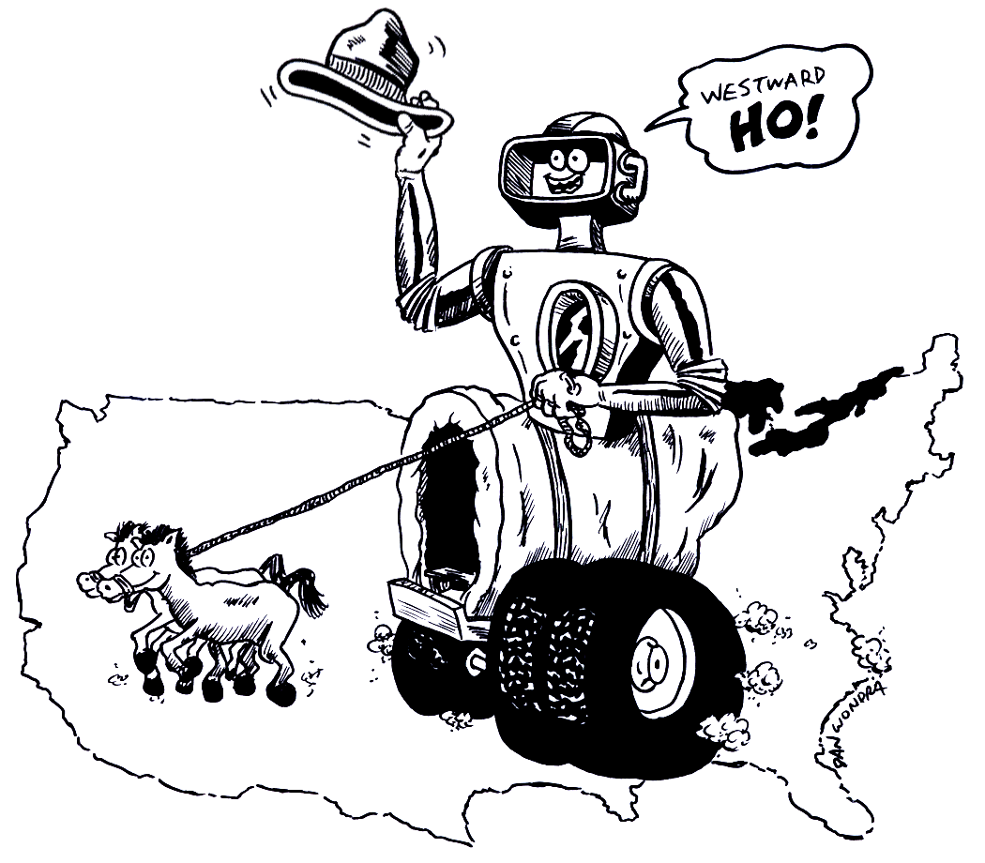
Lesson Title: One Revolution for Robot, One Circumvolution for Robot-kind
Draft Date: July 17, 2008
1st Author (Writer): Colin Boyle
Algebra Topic: Speed and Circumference Formulas
Grade Level: Middle School
Cartoon Illustration Idea: A robot traveling over a map of the United States

Outline of Lesson

Content (what is taught):
- Formulas (rate = distance × time, 2π radius)
- Real-life applications
Context (how it is taught):
- The class must use distance and circumference formulas to determine the amount of time and revolutions needed to travel one mile

Activity Description:
In this lesson students must determine the amount of revolutions a CEENbot wheel needs to travel to any specific location (your own creativeness is the limit). Also the students must figure out the amount of time needed for the CEENbot to travel to that same destination.

Standards:

Math
D1, D2, E1, E3

Science
A1, A2, B1, F5

Technology
D1, D2, E2, F2

Materials List:
Classroom Robot
Stopwatch
Recording Notebook
Tape and Ruler
ASKING Questions (One Revolution for Robot, One Circumvolution for Robot-kind)

Summary: Students will look at wheels and decide how their size is related to the number of revolutions it will make while driving a given distance.

Outline:
- Students will evaluate sample wheels and determine how the radius and circumference are related
- Students will estimate how long it will take the robot to travel certain distances

Activity:
Bring in toy cars (or show pictures of cars) with various wheel sizes. Talk about wheel size how it’s related to the number of revolutions it would make while traveling a given distance. Introduce vocabulary that will be used (i.e. distance, rate, time, circumference of tire, radius of tire, etc.) Talk about the rate formula (r = d/t) and circumference formula (2πr).

Questions | Possible Answers
- How much time do you think the CEENbot will need to travel to the moon? | Answers will vary
- How many wheel revolutions do you think the CEENbot would need to reach the moon? | Answers will vary
- What do you notice about the 3 wheels below? | As the wheel’s radius gets bigger, the circumference increases.
- Consider the 3 wheels below and how many times they would turn (revolutions) while traveling 10 feet. Put them in order from the wheel with the most revolutions to the wheel with the least. | Wheel 2 would make the most revolutions followed by Wheel 1. Wheel 3 would make the least number of revolutions.
- How will an increase in radius of the tires effect the number of revolutions needed? Why? | As the radius of the tires increases, the number of revolutions needed decreases. As the radius increases in size, the wheel itself is larger which makes the circumference larger. A larger circumference means more surface area covered per revolution.
- How would an increase in the revolutions per minute (rpm) of the wheels affect the r=d/t (speed) formula for the CEENbot? Why? | By increasing the rpm of the wheels, the speed of the robot will increase, thereby making it travel further in less time.
Wheel 1
Wheel 2
Wheel 3
Radius = 2 cm
C = 2πr
C = 2π2
C = 12.56 cm
Radius = 1 cm
C = 2πr
C = 2π1
C = 6.38 cm
Radius = 5 cm
C = 2πr
C = 2π5
C = 31.4 cm

EXPLORING Concepts (One Revolution for Robot, One Circumvolution for Robot-kind)

Summary: Students will explore different sized tires from electronic devices (i.e. remote control cars, robots, etc.) and calculate each wheel’s circumference.

Outline:
- Give each student a wheel data sheet and a ruler
- Have students measure the wheel’s radius and calculate its circumference using C= 2πr
- Have students compare their calculations and talk about the number of revolutions and how it compares to the wheel’s radius.
- Students will order the wheels from the least number of revolutions to the greatest number of revolutions.

Activity:
Ideally, several robots and/or remote control cars would be available for students to use. The idea is to provide as many different sized tires as possible. Each student will measure the radius of the tire and calculate its circumference using C= 2πr. NOTE: It may be necessary to “prove” that the circumference formula really works by using a string to go around the outside of a tire and then measuring the string with a ruler. After measuring different sized tires, students will evaluate the data and decide which wheel would make the least number of revolutions while traveling a 5 foot path to the wheel that would make the most revolutions.

Worksheet: Wheel_Data.doc

1
2
3
4
Measure the wheel’s radius
Calculate the circumference using C =2πr
Radius = 3.5 cm
C = 2πr
C = 2π(3.5)
C = 21.98 cm

INSTRUCTING Concepts (One Revolution for Robot, One Circumvolution for Robot-kind)

Distance = rate * time
Putting “Distance = rate * time” in Recognizable terms: Distance = Rate * Time is a formula that is prevalent in algebraic settings. The formula is a linear equation with the rate serving as slope.
Putting “Distance = rate * time” in Conceptual terms: Distance = Rate * time is a formula that shows the relationship between three variables distance, rate, and time. If two are known the third can be calculated. The formula is linear and an example of direct variation.
Putting “Distance = rate * time” in Mathematical terms: The formula give distance as either a function of rate or time with the other serving as a constant of variation. What this means is if the rate is held constant the distance will increase as the time increases (distance as a function of time) or is the time is held constant the distance will increase as the rate increases (distance is a function of rate).
Putting “Distance = rate * time” in Process terms: Thus if you know the rate and the time of the object you can calculate the distance. If you know the distance traveled and either the rate or time you can calculate the one. The ordered pairs (rate, distance) or (time, distance) are infinite and if graphed will form a straight line.
Of note, is that this modeling situation can be used by students to make predictions about future events and is a concrete way of developing a linear equation that students can apply in other settings.
Putting “Distance = rate * time” in Applicable terms: The formula models the real world. It can apply anytime that an object is in motion at a constant rate or for a constant time. If you drive a robot faster it will go farther in the same amount of time or if you maintain a constant speed the robot will go farther in a longer time. To create a situation that models the real world, drive the robot at a constant speed for a determinable length of time and measure both the speed and time. The distance will be equal to the rate driven times the length of time driven.

ORGANIZING Learning (One Revolution for Robot, One Circumvolution for Robot-kind)

Summary: Students will calculate the speed of a robot and use that information to predict how long it would take the robot to travel to different locations.

Outline:
- Put a strip of duct tape on the floor and have students measure its length
- Record the time it takes the robot to travel the distance of the tape
- Determine the rate of the robot r=d/t
- Use the speed to determine how long it would take for the robot to travel 1 mile

Activity:
Depending on how many robots are available, assign students to groups of four. Each student in the group will have a job: timer, operator, measurer, and recorder. The students will drive their CEENbot over the line several times measuring the time it takes to travel the pre-set distance. Using the formula r=d/t, students will calculate the rate of the robot and record it in a data table. Next, students will find the average (mean) of the times recorded. Finally, students will set up a proportion and solve for how long it will take the robot to travel 1 mile.

Sample Data Table:

Length of Duct Tape (d) | Time (t) | Rate (r = d/t) | Proportion
4 ft | 15 seconds | .27 ft/sec | 19555 sec  326 min  5 ½ hours

Student Worksheet: Traveling Robot.doc
UNDERSTANDING Learning (One Revolution for Robot, One Circumvolution for Robot-kind)

Summary: Students fill out a homework assignment using different variables for the formulas and written answers

Outline:
- Formative assessment of d = rt and speed
- Summative assessment of d = rt
- Summative assessment of tables and graphs

Formative Assessment
As students are engaged in learning activities ask yourself or your students these types of questions:
1. Were the students able to apply the d = rt formula and solve for speed?
2. Were the students able to apply the C= 2πr formula and solve for circumference?
3. Can students explain the meaning of speed?

Summative Assessment
Students will complete the following essay questions about the distance-rate-time formula:
- Write a story involving the motion of a classroom robot where the distance can be calculated using the distance-rate-time formula.
- Create a data table of the motion of a classroom robot that would show a constant rate of motion and make a graph of your data table.
- Describe how you can tell the rate of motion is constant by looking at your data table and graph.

Students could answer these quiz questions as follows:
- The classroom robot travels across the floor from Leo to Gina in 5 seconds. The robot's rate of motion (speed) across the floor is 12 centimeters per second. The distance between Leo and Gina can be found using the distance-rate-time formula: d = rt = (12 cm/s)(5 s) = 60 cm.
- The data table for the motion between Leo and Gina would be
Time (s) Distance (cm)
1 12
2 24
3 36
4 48
5 60
To graph this data table put time on the x-axis and distance on the y-axis.
- In a data table, when the distance is the same for equal time intervals the rate of motion is constant. For example the first second (0 to 1 s) the distance is 24 cm, and for the last 1 second (4 to 5 s) the distance is 60 cm - 48 cm = 12 cm. The graph of distance verses time makes a straight line when the rate of motion is constant. The rate of motion can be calculated for each row in the data table to show that the rate of motion is constant:
Time (s) Distance (cm) Rate of Motion (cm/s)
1 12 r = d / t = 12 cm / 1 s = 12 cm/s
2 24
3 36 r = d / t = 36 cm / 3 s = 12 cm/s
4 48
5 60 r = d / t = 60 cm / 5 s = 12 cm/s

