SPIRIT 2.0 Lesson:
He Came Out of Nowhere!!! (Formulas, speed=distance/time)
==========================Lesson Header ==========================

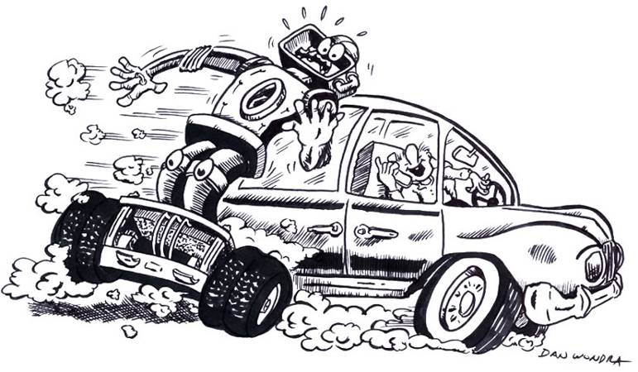
Lesson Title: He Came Out of Nowhere!!!
Draft Date: July 18, 2008
1st Author (Writer): James Earnhardt
Algebra Topic: Formulas and formula manipulation using speed=distance/time
Grade Level: Secondary

Outline of Lesson

Content (what is taught):
- Using speed=distance/time (s=d/t)
- Measurement of time and distance
- Creation of data tables and graphs
- Computation of speed, distance or time given two variables
- Demonstration that various distractions can effect driving ability
Context (how it is taught):
- Robot is “driven” by a student through a course designed by students.
- The distance, time, and number of traffic accidents and/or “infractions” are measured and recorded.
- Several trials are completed as a variety of “distractions” are introduced.
- The average speed for each trial is calculated and the data is graphed.

Activity Description:
This lesson would teach that average speed equals total distance divided by total time. Students use the robot to complete a prescribed driving course to gather the data needed to perform calculations. They navigate the course without any added distractions, and a number of times with one of several common distractions added on each experimental trial. Using the distance from start to finish of each course and the times that they measure for each run, they will use the formula total distance divided by total time to determine their average speed for each run. They will then graph the average speed of each run against accidents and/or traffic infractions.

Standards:
Math A2, D1, D2, E1, E3
Science A1, A2, B2, E1, F1, F3, F4, F5
Technology A3, B2, D1, D2, D3, E1, E2, ,E3, F2

Materials List:
CEENBoTs, stopwatches, notebook, graph paper, metric tape measure, various wood materials to make borders of driving course, walkie-talkies, food, toy cars and trucks, other obstacles or driving hazards selected by students with teacher approval.
ASKING Questions (He Came Out of Nowhere)

Summary: Students are asked, “What is the leading cause of death among teenagers in America?” Discussion is guided to establish that traffic accidents are the leading cause of death and to determine
Some common causes of traffic accidents. “How is motion measured?” Discussion is guided to define the rate of motion as, “speed.”

Outline:
- Demonstrate “driving” a robot around a prescribed course
- Ask students about expected outcomes if a driver is distracted
- Students provide the formula for speed from prior knowledge or research
- Determine variables and measurements

Activity: Answer the questions below from personal knowledge and experience, or by researching on the internet. Demonstrate “driving” a robot around a prescribed course created by the students. Course should include multiple turns and intersections with a variety of common road “hazards.” Either static pedestrians and/or mobile mini-bots should also be included. Other remote controlled vehicles could also be included to provide a more realistic sensation of driving in traffic.

Questions | Possible Answers
- What is the leading cause of death among American teens? | Per the Centers for Disease Control, traffic accidents are the leading cause of death for 16 to 19 year olds.
- What are some common causes for traffic accidents? | Common causes for accidents are impaired driving, excessive speed, lack of experience, lack of driving skill or training, poor driving conditions, mechanical failure, and distracted driving.
- What is distracted driving? | Distracted driving to driving while conducting another activity that draws the driver’s attention away from the actual operation of the vehicle.
- What are some possible causes of distracted driving? | Possible causes of distracted driving include, but are not limited to: using a cell phone to text; using a hand held cell phone to converse; using a hands free cell phone to converse; reading a book, magazine or map; eating or drinking a beverage; other people in the car; listening to music; watching TV or video; personal grooming; being tired and/or drowsy.
- How can you determine the speed of a vehicle by measuring time and distance? | Average speed is defined as the total distance traveled divided by the total time of the journey.



Z _{Z} Z ^{Z}

EXPLORING Concepts (He Came Out of Nowhere)

Summary: Students explore how common driving distractions may influence driving speed and/or number of traffic accidents and infractions of driving rules.

Outline:
- Students design and lay out a driving course
- Students decide on a “standard” list of distractions to be used
- Students assume duties of Monitor, Timer, Friend, Traffic Officer, or Driver
- Changes in drive time can be observed
- Changes in accident and infraction totals can be observed
- Students rotate positions and repeat the process until all students have served as Drivers

Activity:
Students would be supplied with distance and time measuring devices. They will set up a “driving” course in the room complete with multiple turns, intersections, obstacles, hazards, other drivers and pedestrians. The course will be “two-way.” This will allow for two drivers to start from opposite ends of the course simultaneously, and to proceed in opposite directions. A second set of drivers will begin their runs when the first set of drivers reaches the half way point in the course. All students will act as drivers for multiple trials so that they can compare several distractions to determine if they have any effect on speed or safety.
In order to assure that all students are actively engaged during the activity, other students will serve in a list of duty positions. Drivers will navigate the course a number of times with several common distractions. Timers will measure and record the times for each trial. Traffic Officers will monitor for, count, and record any traffic infractions or accidents that may occur. Friends will serve as passengers in the vehicle with the driver, or as the other person involved in the “cell phone conversation.” Monitors will follow the driver’s path to insure that drivers follow the prescribed course, and to record any possible deviations.
Distractions that would be included in each Driver’s set of trials could include, but not be limited to: NO distractions; driving with music of their choice playing; with music not of their choice playing; while talking “hands free” on a simulated cell phone call using headphones with microphone attachment; with “passengers” in their “car”; while eating; while grooming. Each person’s trials will be ordered randomly so that their, “NO distraction,” run is not the first run of everyone’s set. It is further presumed that this is not the student’s first exposure to the CEEN Bot, and that they all have a basic working knowledge of how the robot is driven.
Using the known distance from start to finish of each course and the times that are measured for each run, students will use the formula: total distance divided by total time to determine their average speed for each run. They will then graph the average speed against total number of accidents and/or traffic infractions for each trial in their set of runs.
To provide formative assessments as students are exploring these concepts ask yourself or your students these questions:
- Do distractions appear to be having any effect on number of accidents or driving infractions?
- Do distractions seem to be effecting average speed of the drivers?
- How does the order of implementation seem to affect driving time and speed?
- If a person does not follow the prescribed course, should that effect the calculations for speed of the trial? Why or why not?

INSTRUCTING Concepts (He Came Out of Nowhere)

Distance = rate * time
Putting “Distance = rate * time” in Recognizable terms: Distance = Rate * Time is a formula that is prevalent in algebraic settings. The formula is a linear equation with the rate serving as slope.
Putting “Distance = rate * time” in Conceptual terms: Distance = Rate * time is a formula that shows the relationship between three variables distance, rate, and time. If two are known the third can be calculated. The formula is linear and an example of direct variation.
Putting “Distance = rate * time” in Mathematical terms: The formula give distance as either a function of rate or time with the other serving as a constant of variation. What this means is if the rate is held constant the distance will increase as the time increases (distance as a function of time) or is the time is held constant the distance will increase as the rate increases (distance is a function of rate).
Putting “Distance = rate * time” in Process terms: Thus if you know the rate and the time of the object you can calculate the distance. If you know the distance traveled and either the rate or time you can calculate the one. The ordered pairs (rate, distance) or (time, distance) are infinite and if graphed will form a straight line.
Of note, is that this modeling situation can be used by students to make predictions about future events and is a concrete way of developing a linear equation that students can apply in other settings.
Putting “Distance = rate * time” in Applicable terms: The formula models the real world. It can apply anytime that an object is in motion at a constant rate or for a constant time. If you drive a robot faster it will go farther in the same amount of time or if you maintain a constant speed the robot will go farther in a longer time. To create a situation that models the real world, drive the robot at a constant speed for a determinable length of time and measure both the speed and time. The distance will be equal to the rate driven times the length of time driven.

ORGANIZING Learning (He Came Out of Nowhere)

Summary: Students use data tables that record the distance traveled, time, and number of traffic accidents or infractions. The distances and times will be used to calculate average speed for each run, and average speeds will be graphed against total number of accidents and infractions for each run.

Outline:
- Time and record the data for the driver for each run
- Implement a variety of distractions from a predetermined set
- Data includes distance, time, and number of accidents and infractions
- Calculations would include speed and total number of accidents and infractions
- Graph data, specifically speed verses total number of accidents and infractions

Activity:
Students will arrange the driving courses and measure the distance from start to finish. They will time each “run” in seconds and record this data and the number of any accidents and/or traffic infractions in a data table. After calculating their average speeds for each run, they will graph their speed in relation to the number of accidents they caused and/or traffic “infractions” they may have committed.
Students use the data to calculate the rate of motion (speed) using the formula s=d/t where s is the speed, d is the total distance, and t is the total time. Students were taught how to manipulate the formula to solve for distance with the formula d=st, and to solve for time with the formula t=d/s.
Students will plot graphs of the data. Graphs would plot speed verses accidents and infractions (x, y) = (speed, accidents). Students should find that as speed is increased the number of traffic accidents and/or traffic infractions will increase, especially when distractions are included.

Worksheet:

UNDERSTANDING Learning (He Came Out of Nowhere)

Summary: Students write essays about distance and time, and how it can be used to investigate the rate of motion (speed). Students will manipulate the speed formula to solve for time and distance. Using prior knowledge students will convert between metric and English units to solve problems related to speed, distance and time. Students will write essays related to a common form of distracted driving, using a cell phone, and how it is covered by the laws of Nebraska.

Outline:
- Formative assessment of speed
- Formative assessment of s=d/t
- Summative assessment of s=d/t
- Summative assessment of tables and graphs

Formative Assessment
As students are engaged in learning activities ask yourself or your students these types of questions:
1. Were the students able to apply the s=d/t formula and solve for distance? For time?
2. Can students explain the meaning of speed?
3. Can students give multiple examples of correct speed units? Distance units? Time units?

Summative Assessment: Part A, B, and C

