SPIRIT 2.0 Lesson:
Robots are aMAZEing (mean, median, mode)
==============================Lesson Header===============================

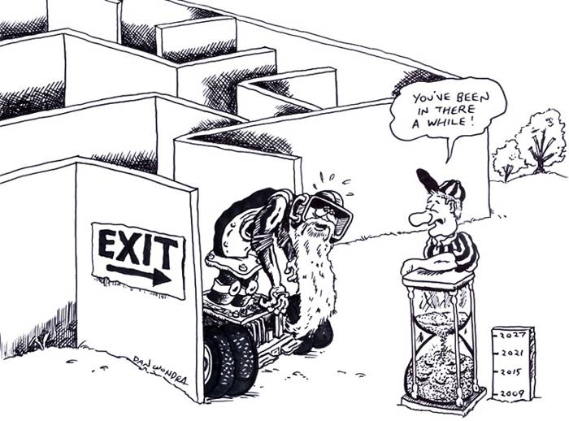
Lesson Title: Robots are aMAZEing
Draft Date: July 17, 2008
1st Author (Writer): Jimmy Johnson
Algebra Topic: Mean, Median, Mode
Grade Level: Upper Elementary and Middle

Content (what is taught):
- Definition of mean, median, and mode
- How to identify and calculate mean, median, and mode
Context (how it is taught):
- The classroom robot will travel through a maze set up with wood or tape on the floor.
- The time it takes each robot to get through the maze will be recorded.
- The mean, median, mode, and range will be calculated for the set of recorded data.

Activity Description:
Each student will run the robot through the maze and each student will be timed on how long it takes to complete the maze. Students will then calculate the mean, median, mode, and range for the class data.

Standards:
- Math—E2
- Science—E1
- Technology—A1

Materials List:
- Classroom Robot
- Stopwatch
- Data Sheet
- Tape
- Wood
- Notebook

ASKING Questions (Robots are aMAZEing)

Summary:
Students will drive the robot through a maze and record the time.

Outline:
- Demonstrate a robot moving through the maze.
- Allow students to maneuver the robot through the maze.
- Record the time it takes each student to move the robot through the maze.

Activity:
Demonstrate how the robot maneuvers through the maze. Then, have each student drive the robot through the maze and record her/his time. Offer a prize for the fastest time.

Questions | Possible Answers
What was the biggest obstacle in the maze? | The biggest obstacles in the maze were turning corners, getting stuck, hitting a block, etc.
Are there any recorded times that seem far away from the other times? | Encourage students to look for a cluster of times and identify any times that are outliers.
What would you estimate is the average time? | The average time estimate will depend on the data. If students are hesitant to offer an answer, provide logical and/or illogical answers and have students use reason to find the best answer.
Let’s say that penalty seconds are added for each time the robot hits a block or touches the tape in the maze. How would the penalty seconds change the average time? | The average time will increase depending on how many penalty seconds each student receives. If a couple students get penalty seconds, those times may be considered outliers. However, if several students get penalty seconds, the average time should increase.
START
FINISH

EXPLORING Concepts (Robots are aMAZEing)

Summary:
Students will calculate the mean, median, mode, and range of the recorded maze times.

Outline:
- Demonstrate a robot moving through the maze.
- Allow students to maneuver the robot through the maze.
- Record the time it takes each student to move the robot through the maze.
- Calculate the mean, median, and mode for the class data.

Activity:
Working with one or more classroom robots, each student will have an opportunity to run the robot through the maze. The class can decide if penalty points will be added (e.g., penalty points may be added if a robot touches a block or tape or if a robot becomes stuck, etc.). Each student will record her/his time.

Once each student has had a chance to drive through the maze, the class will calculate the mean, median, mode, and range. Once the mean, median, mode, and range have been calculated, prompt students to think about the following situations: What would happen to the mean if the slowest time were taken out of the data set? What would happen to the mean if the fastest time were taken out of the data set? What would happen if each time were doubled?

Worksheet: aMAZEing_Data.doc
INSTRUCTING Concepts (Robots are aMAZEing)

Central Tendency
Putting “Central Tendency” in Recognizable terms: Central tendency refers to the “middle” number of a set of data. There are three main measures of central tendency: mean, median, and mode. Which one is best depends on the data.
Putting “Central Tendency” in Conceptual terms: The three measures of central tendency are all slightly different. The most common is the mean or average, the median is the center most value where ½ of the data lies above and ½ lies below, and the mode is the value with the most frequent occurrences in the data set.
Putting “Central Tendency” in Mathematical terms: Each of the measures of central tendency can be found mathematically. By summing the data and dividing by the number of pieces of data in the set, you can calculate the mean or average. The formula for mean is $m=\frac{1}{n}\sum_{i=1}^{n}{x_{i}}$ where $m$ is mean, n is the number of elements of data in the set and $x_{i}$ is the elements of data.
Median is found by placing the data in ascending order and locating the middle value. If there are an odd number of elements in the set, the median is the middle element and will be included in the data set. If there is an even number of elements in the set, the median is found by averaging the middle two elements and this median number will not occur in the original data set.
Mode is found by simply counting the elements in the data set and is the most prevalent element.
Putting “Central Tendency” in Process terms: Central tendency discusses the middle of a set of data. Mean is the most common measure of central tendency but it is affected by outliers or data that deviates radically from the rest of the data in the set. Median is better in situations where data is skewed. Take for instance home prices. If there are 20 houses and 19 of them are worth between $50,000 and $150,000 and the 20th house is worth $2,000,000, the average will be affected by the house with the large value but the median will be much more representative of the data. Mode is useful in situations where data is categorical like what is the most popular type of book in a store or most popular movie.
Putting “Central Tendency” in Applicable terms: There are other ideas relating to central tendency that are important. Range is the space between the smallest and largest values in the data set. Standard deviation is a measure of how far elements will tend to differ from the mean. These ideas together with the measures of central tendency allow us to make comparisons between an element in the data set and the “middle” value. These comparisons allow us to understand trends that are present in the data set.

ORGANIZING Learning (Robots are aMAZEing)

Summary:
Groups of students will create their own robot maze.

Outline:
- Groups of 3-4 students will create a robot maze.
- Other groups will drive a robot through the maze and record their individual times.
- Groups will calculate the mean, median, mode, and range for their maze.

Activity:
Assign groups of 3-4 students. Groups should work together to design and build a robot maze. Groups may decide if penalty points apply to their maze (e.g., adding seconds if a block is knocked down, if the robot becomes stuck, etc.). When all groups have finished building, have each group travel to another maze where each student will drive the robot through the maze and record her/his time. Leave the data for the “building group” to calculate the mean, median, mode, and range of the data. After all groups have finished their calculations, have the class discuss their findings.

Worksheet: aMAZEing_Data.doc

UNDERSTANDING Learning (Robots are aMAZEing)

Summary:
Students show understanding of the complex applications of mean, median, mode, and range.

Outline:
- Formative assessment of mean, median, mode, and range
- Summative assessment of mean, median, mode, and range

Activity:

Formative Assessment
As students are engaged in learning activities ask yourself or your students these types of questions:
1. Were the students able to apply the definitions of mean, median, mode, and range to calculate each of them?
2. Can students explain what the mean is and how central tendency works?

Summative Assessment
1. The following set of numbers is the percent scores from a class test: 77, 88, 68, 70, 90, 95, 89, 88, 99, 100, 65, and 88. Calculate the mean, median, mode, and range for the data.
2. What would happen to the mean, median, mode, and range if a test score of 45 was added to the data?
3. What would happen to the mean, median, mode, and range if the highest score was removed from the original data?
4. Mr. Johnson said he would throw a party if the class average on the test were an 85. One student still needs to take the test. What is the lowest score that student can receive and still ensure that the class will get to have the party?

