The Great Race
Group/Class Data Sheet

Group Data

Name | Trial 1 | Trial 2 | Trial 3 | Average Time

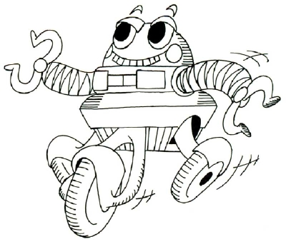
_______________Group Average

_______________Group Median Time

_______________Group Mode

Class Data

Group | Average Time | Median | Mode
1
2
3
4

_______________Class Average

_______________Class Median Time

_______________Class Mode

Questions

- How does your personal data compare to the rest of your group?

- How does your personal data compare to the class?

- How does your group data compare to other group data?

