SPIRIT 2.0 Lesson:
The Great Race

===============================Lesson Header==============================
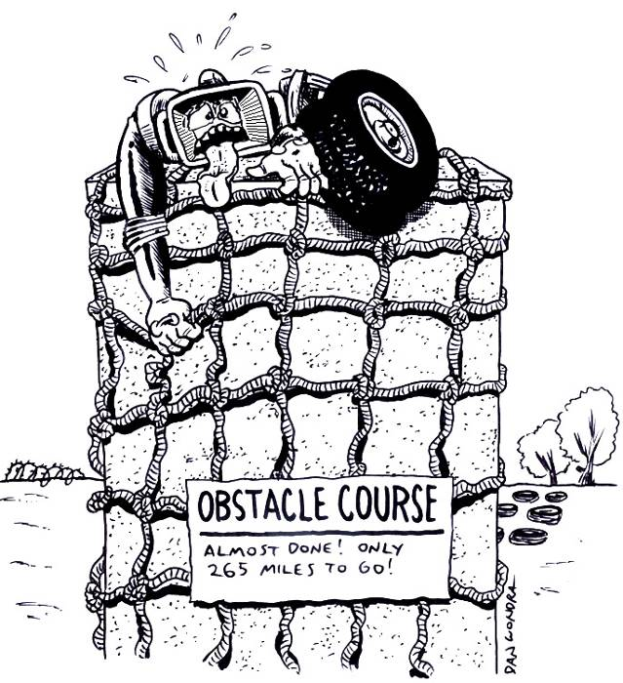
Lesson Title: The Great Race
Draft Date: July 18, 2008
1st Author (Writer): CJ Perry
Topics: Data Gathering, Analysis, & Interpretation
Mean, Median, & Mode, Teamwork
Grade Level: Elementary or Middle

Content (what is taught):
- Data Gathering, Analysis, & Interpretation
- Graphing
- Mean, Median, & Mode
- Teamwork

Context (how it is taught):
- Teams will work once per week (a different team each day) to run the robot through an obstacle course.
- Students will record their predictions, times, and plans to improve their work in a science journal.
- The teacher will collect the journals after each team has completed their work and evaluate the journals.
- Data from the journals will be used to complete lessons that review mean, median, and mode.
- Data from journals will be used to create personal, team, and class graphs to display the data.

Activity Description:
Teams will set up the obstacle course with numbered bricks along a track marked on the classroom floor. Then, teams will take turns running the robot through the course, timing the runs, and recording the times.

Standards:
- Math—A1, A2, A3, D1, E1, E2, E3
- Science—A1, A2, B1, E1, E2, G1
- Technology—A1, A2, A4, B1, B2, B4, C1, C2, C4, D2, D3, D4, E2, E3, E4, F1, F2, F3, F4

Materials List:
- Classroom Robot
- Stopwatch
- Data Sheet
- Graph paper
- Notebook

ASKING Questions (The Great Race)

Summary:
Students are asked how they can improve their time racing a robot through an obstacle course.

Outline:
- Demonstrate setting up an obstacle course.
- Demonstrate a robot going through an obstacle course.
- Discuss the data that could be collected and discuss how this data could be utilized.

Activity:
Demonstrate how the robot climbs a ramp. Increase the ramp angle and show how the robot begins to struggle as it climbs the ramp.

Questions | Possible Answers
What are the fastest times we can get the robot to do our obstacle course? | Various elapsed times
Can we improve our times with practice? How else might we improve our times? | Yes or no  Observing others, discussing techniques, practicing more
What data can we gather? | Elapsed time, average time, mean, median, mode  What works, what doesn’t work  What we might try to do differently  What others are doing
What can we do with the data | Share it  Organize it in a chart  Display it in a graph

EXPLORING Concepts (The Great Race)

Summary:
Students explore how they can improve their time racing a robot through an obstacle course.

Outline:
- Teams will work once per week to run the robot through an obstacle course.
- Students will record their times in a science journal.
- Data from journals will be used to create personal, team, and class graphs to display the data.

Activity:
Students will set up the robot obstacle course. Students will take turns running the stopwatch and recording the data. All students will need to copy the data and their thoughts into their notebooks.
Teams will try to improve their times as they work each week.

To provide formative assessments as students are exploring these concepts, ask yourself or your students these questions:
- What helps you go faster?
- What slows you down?
- What is the data showing us? Are we improving over time?
- What are you learning?

Sample Data Chart & Graph:

Name | Date | Time | Notes
Adam | 3/14 | 55 seconds | Had trouble going up ramp.
Adam | 3/21 | 50 seconds | Did better on ramp, but still had trouble turning first corner in course.
Adam | 3/28 | 40 seconds | The practicing paid off! It’s the best time yet!

INSTRUCTING Concepts (The Great Race)

Central Tendency
Putting “Central Tendency” in Recognizable terms: Central tendency refers to the “middle” number of a set of data. There are three main measures of central tendency: mean, median, and mode. Which one is best depends on the data.
Putting “Central Tendency” in Conceptual terms: The three measures of central tendency are all slightly different. The most common is the mean or average, the median is the center most value where ½ of the data lies above and ½ lies below, and the mode is the value with the most frequent occurrences in the data set.
Putting “Central Tendency” in Mathematical terms: Each of the measures of central tendency can be found mathematically. By summing the data and dividing by the number of pieces of data in the set, you can calculate the mean or average. The formula for mean is $m=\frac{1}{n}\sum_{i=1}^{n}{x_{i}}$ where $m$ is mean, n is the number of elements of data in the set and $x_{i}$ is the elements of data.
Median is found by placing the data in ascending order and locating the middle value. If there are an odd number of elements in the set, the median is the middle element and will be included in the data set. If there is an even number of elements in the set, the median is found by averaging the middle two elements and this median number will not occur in the original data set.
Mode is found by simply counting the elements in the data set and is the most prevalent element.
Putting “Central Tendency” in Process terms: Central tendency discusses the middle of a set of data. Mean is the most common measure of central tendency but it is affected by outliers or data that deviates radically from the rest of the data in the set. Median is better in situations where data is skewed. Take for instance home prices. If there are 20 houses and 19 of them are worth between $50,000 and $150,000 and the 20th house is worth $2,000,000, the average will be affected by the house with the large value but the median will be much more representative of the data. Mode is useful in situations where data is categorical like what is the most popular type of book in a store or most popular movie.
Putting “Central Tendency” in Applicable terms: There are other ideas relating to central tendency that are important. Range is the space between the smallest and largest values in the data set. Standard deviation is a measure of how far elements will tend to differ from the mean. These ideas together with the measures of central tendency allow us to make comparisons between an element in the data set and the “middle” value. These comparisons allow us to understand trends that are present in the data set.
ORGANIZING Learning (The Great Race)

Summary:
Students will calculate mean, median, and mode for the obstacle course data.

Outline:
- Calculate the mean, median, and mode for group data.
- Collect the data from other groups and calculate the mean, median, and mode.
- Compile the class data and calculate the mean, median, and mode.
- Compare individual and group data with the class data.

Activity:
Students will take their group data and calculate the mean, median, and mode. These calculations can be done in a spreadsheet program on the computer using the formulas shown below. Next, students will record the data from other groups in their notebook. Finally, students will calculate the mean, median, and mode for the class data. After all the calculations are complete, students can compare their times with other group times and the class times.

Worksheet: Great_Race_Group_Data.doc

Spreadsheet Formulas:
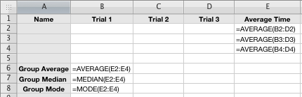
UNDERSTANDING Learning (The Great Race)

Summary:
Students share data by presenting graphs to the whole group and discussing what they have learned.

Outline:
- Formative assessment with journals, notes, and small and whole group discussions
- Summative assessment of graphs
- Summative assessment of group presentations to class and possibly other rooms

Activity:
Formative Assessment
As students are engaged in learning activities, ask yourself or your students these types of questions:
- Did the students keep their data accurate and neat?
- Did students calculate mean, median, and mode correctly?

Summative Assessment
Students will present information to the class about what they did and what they learned. Students should be able to present and explain their graphs.

Possible Extensions:
- Visit other classrooms and share presentations.
- Have the team with the best average time create the next obstacle course.
- Challenge others in the building (principal, other teachers, building engineer, parents, etc.) to run the course and compare their times. How can we help them improve?

