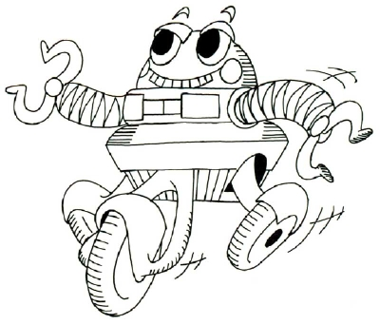
Roller Coaster Robot

Roller Coaster Sketch

Documentation:

