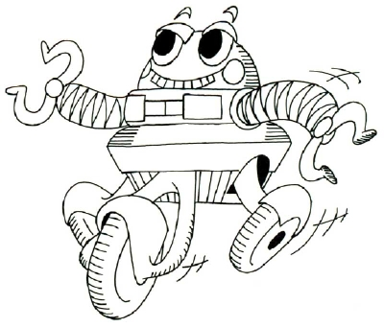
Roller Coaster Robot
Area Under the Curve
Directions: Sketch your roller coaster on the grid below. Then, create a series of rectangles to estimate the area under the curve. Remember that your rectangles can have different widths to create the best estimate.

Number of Rectangles | Area of each rectangle using lower sums | Sum | Area of each rectangle using upper sums | Sum | Estimated Interval : ___ < area < ___

