CEENBoT Stories
Slope Notes

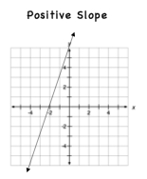 | NOTES  ____________________________________  ____________________________________  ____________________________________  ____________________________________
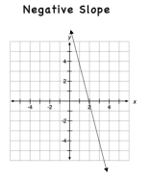 | NOTES ____________________________________  ____________________________________  ____________________________________  ____________________________________
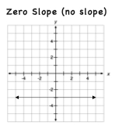 | NOTES ____________________________________  ____________________________________  ____________________________________  ____________________________________
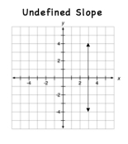 | NOTES ____________________________________  ____________________________________  ____________________________________  ____________________________________

