SPIRIT 2.0 Lesson:
Robot Rounding!
==============================Lesson Header ===============================
Lesson Title: Robot Rounding!
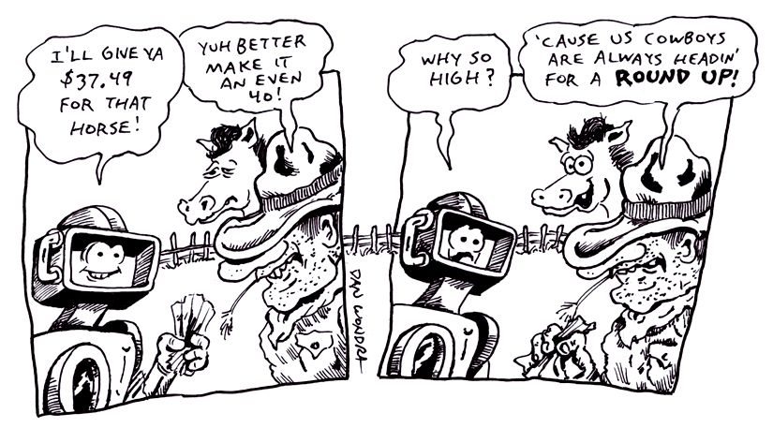
Draft Date: July 15, 2009
1st Author (Writer): Shantelle Suiter
Revised from Brian Sandall – Numbers Numbers Everywhere! (A and I the same)
Algebra Topic: Real Numbers
Grade Level: 4 - 8

Content (what is taught):
- Real numbers
- The concept that there is always a number between two numbers
- Analysis and inference from data

Context (how it is taught):
- The robot is driven on the floor stopping randomly.
- The locations where the robot stops are marked, and recorded to the nearest measurement
- When to round up to the next measurement or not is decided.
- The concept that Real numbers are infinite is explored.
Activity Description:
In this lesson, students drive a robot on the floor marked with a number line. At each robot stop, the point is recorded to the nearest measurement. This is continued for several data points in metric and then again in customary.

Standards:
Math—A1, E1
Science—A1, A2
Technology—A1, B4, C1, C4

Materials List:
- Robot equipped with a vertical pointing device
- Large number line on the floor marked with graduations
- Record sheet
Asking Questions (Robot Rounding!)

Summary: Students will generate a list of numbers. As students state numbers, order them from least to greatest. This list should be extensive to introduce the idea that the set of real numbers is very large.

Outline:
- Students will generate a list of numbers.
- The numbers will be ordered from least to greatest to represent a number line.

Activity: Ask students to start naming numbers that they know. (You want answers like integers, mixed numbers, proper and improper fractions). As the students give answers, put this list on the board and order them from least to greatest. During this time, review the concept of less than and greater than as well as ordering numbers from least to greatest.

Questions | Answers
What are some numbers that you know? | Students will name whole numbers. After listing those numbers from least to greatest on the board, lead students by asking the other questions.
Can you think of other numbers that are not whole? | Students will name mixed numbers and other fractions.
Is there a number between (pick two numbers from the previous answers)? | Yes. Guide students to name a fraction between the two numbers.
How many numbers are there? | Technically, an infinite number.

-5
10

Exploring Concepts (Robot Rounding!)

Summary: Drive the robot along a number line to generate a set of numbers that can be ordered. Stop the robot at a place along the sticks. Estimate the location to the nearest metric and customary unit. Continue driving the robot until a large set of points is generated.

Outline:
- Drive the robot along the number line and stop it randomly.
- When the robot stops, record the position. Estimate the position.
- Place numbers on the chart.
- Repeat the process until a large set of points is created.

Activity: Use two or three each of metric sticks and yard sticks. Tape them to the floor if necessary. Have the major units marked. For example, feet with red marker, yards with yellow, meters with green and decimeters with blue. Attach a ruler to the front of the robot so that when it stops the location can be recorded. Students will drive the robot randomly along the number line and stop at different locations. Students will repeat this process to generate several numbers that are both metric and customary. Students will need to estimate a number at each of these “unknown” locations. Add each estimated number to the chart.

Instructing Concepts (Robot Rounding!)

Real Numbers

Putting “Real Numbers” in Recognizable terms: Real numbers are all of the different kinds of numbers that we use in day-to-day life.

Putting “Real Numbers” in Conceptual terms: Real numbers are all of the numbers that can be represented by points on a number line. We also need to understand the concept of “sets” and “subsets”: A set is a collection of objects, or “elements” (order and/or sequence does not matter). A subset is a set that is a part of another set. The empty set (or null set) is a set with no elements in it. The null set is a subset of every set.

Putting “Real Numbers” in Mathematical terms: Real numbers are a 1-1 mapping of the set of all of the points on a [Real] Number Line to a set of the values that each of these points may represent. A subset of the set of Real Numbers is the set of positive integers, the counting numbers, also known as the natural numbers {1,2,3,…}. Each of the natural numbers has an opposite integer, called a negative integer {-1, -2, -3, …}. A special integer is zero {0}. Zero separates the positive numbers from the negative numbers. Zero is the only number whose opposite is itself. The set of Real numbers may be broken into two mutually exclusive subsets: Rational numbers have values that can be represented by the ratio of two integers, while irrational numbers have values that cannot be represented by the ratio of two integers.

Putting “Real Numbers” in Process terms: Since the Real numbers can be represented by points on a number line, we can describe the relationship of any two real numbers by their relative positions on the line. The two numbers may be equal in which case they occupy the exact same point. One point may be greater than the other point (positioned to the right of the other). Or one point may be less than the other point (positioned to the left of the other).

Putting “Real Numbers” in Applicable terms: As you drive the robot along a straight line, stop it at irregular (random) time intervals and estimate its position by using Real numbers from each of the different subsets of the set of Real numbers.
Organizing Learning (Robot Rounding!)

Summary: Students analyze the list of numbers and are asked to round the numbers on the list.

Outline:
- Given the smaller unit, round it to for the larger unit
- Given the larger unit, list the possible smaller units that round to it.

Activity: Students will generate a list of numbers from 1 to 1,000. Place a number in one category for metric and customary. Now find or estimate the possibilities for the rest of the units. Continue by switching which unit started with. (ie. Place a 3 in the meter/yard and solve the other 4. Then place a 45 in the decimeter/feet unit and solve the other 4 and so on.)

Metric | Meters | Decimeters | Centimeters

Customary | Yards | Feet | Inches
Understanding Learning (Robot Rounding!)

Summary: Give students measurements to round to the nearest unit. They must also show what that measurement could be using alternate units.

Outline:
- Formative assessment of real numbers.
- Summative assessment of real numbers.

Activity:
Formative Assessment
As students are engaged in the lesson, ask these or similar questions:
1. Do students understand that there is always a number between two numbers?
2. Can student find a number between two numbers?
3. Do students understand decimals and how decimals may designate a place between two numbers?

Summative Assessment
Students will write a formal lab write-up of the process that they carried out to arrive at the concept that the number line is made up of an infinite set of real numbers.

Students will answer one of the following writing prompts:
1. Explain why a number would round up or down.
2. Discuss how you can place a number between two numbers.

Students will complete the following quiz questions as follows:
- Round the numbers 17.3 and 738. What place value did you use?
- What would 68 inches round to in feet and yards?
- What would 68 centimeters round to in decimeters and meters?

