SPIRIT 2.0 Lesson:
CEENBoT Putt Putt
==========================Lesson Header ==========================
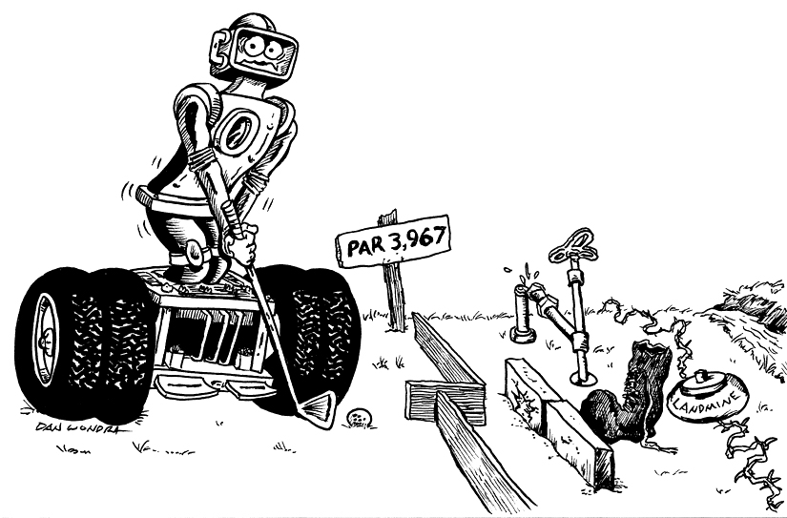
Lesson Title: CEENBoT Putt Putt
Draft Date: 6-23-2009
1st Author (Writer): Jennifer Higgins
Instructional Component Used: Area of Two-Dimensional Shapes
Grade Level: 8-10

Outline of Lesson
The learner will design 2-4 golf holes for a CEENBoT golf course by creating a rough draft, a scale drawing and calculating the area while working in a small group of 2 – 3 people. TLW construct the holes they design based on their scale drawings in order to create an entire course. The learner will analyze the difficulty of each hole by playing a round of CEENBoT Putt-Putt.

Content (what is taught):
- Scale Drawings (needs to have been previously taught)
- Area of Two Dimensional Shapes

Context (how it is taught):
- Students will discuss the features and key terms used to describe golf courses.
- Students will examine the movement of the CEENBoT and discover its limitations.
- Students will design golf holes and create an accurate scale drawing of the holes.
- Students will calculate the area of the entire hole, the area of the cup, and the area of obstacles.
- Students will layout the holes they design based on their scale drawings.
- Students will play the course and evaluate the difficulty of each hole.

Activity Description:
After a class discussion of golf courses, the students will examine the movements of the CEENBoTs and their limitations. Then they will design a golf course while working in small groups.

Standards: Math MC1, MD1, MD2 Science SB1

Technology TA1, TA2 Engineering EA2, ED1

Materials List:
Golf Balls, Stop Watches, Masking Tape, Plain Paper, Rulers, Protractors, Pencils, Colored Pencils, Wood Blocks, Wood Ramps, Cardboard Boxes, Soccer Cones, and other materials students and teachers may want to use. Students may be allowed to bring appropriate materials from home if necessary or desired.
Asking Questions (CEENBoT Putt-Putt)

Summary: The students will understand the key features of a golf course by participating in a class discussion.

Outline:
- Brainstorm the features found on a golf course in a small group of 3-4 people.
- Share brainstorm as a class.

Activity:

Create a Power point with pictures of golf courses including miniature golf courses. Have it playing as students enter the room and continue to let it play for a minute or two after they enter the room. Then ask the following questions:

Questions | Answers
How many of you have golfed on a full-scale golf course? How many of you have played miniature golf? | Answers will vary.
What are the differences between the two types of courses? | Miniature courses are smaller, have different kinds of hazards, lower pars, etc…
What types of hazards are on golf courses? (Have them brainstorm this in small groups and then share as a class.) | Water, roughs, hills, obstacles, moving obstacles, curves, can’t see the hole easily, etc…
What is meant by the word “par”? | The number of strokes it typically takes to get the ball into the cup.

Images of golf courses can be found at http://images.google.com

Exploring Concepts (CEENBoT Putt-Putt)

Summary: Students will explore the movements and limitations of the CEENBoT in order to understand how the CEENBoT affects the miniature golf course design. Then they will work in teams to design 2-3 holes for the CEENBoT to golf as instructed.

Outline:
- Provide a variety of objects like blocks, ramps, golf balls, etc. for the students.
- Provide the students with plenty of room to work in groups.
- Students will create obstacles and challenges for the CEENBoT to drive through. They will record their observations in their engineering notebook.
- The students divide into small teams of 2-3 people in order to create 2-3 golf holes based on given guidelines. (The number of holes each group designs will be dependent on time, class size and space for the course.)
- They will layout their golf holes and play the course.

Activity:
Part 1: Students will work in groups to design obstacles and challenges for the CEENBoT to drive through. Students should be encouraged to push the CEENBoT to its limits. A variety of materials should be provided as well as many CEENBoTs as possible.
They will record their observations in their engineering notebook in an organized manner. They may include sketches. The time will be limited to the life of the battery. They might be best limited to 15 minutes. If students appear to be struggling, provide ideas and guidance as needed. This part of the activity may be skipped if this has been completed earlier in the academic year.
Part 2: The CEENBoT Putt Putt Requirements
- Create holes for a miniature golf course for the CEENBoTs to drive a golf ball into a cup (a two-dimensional shape). The time needed to drive the golf ball into the cup will be the score with the lowest total time being the objective.
- Each hole must incorporate at least 3 different geometric shapes from this list: circles, squares, rectangles, triangles, and regular polygons. One shape will serve as the cup. The cup does not have to be a circle. (The teacher may want to provide an example.)
- A rough draft must be done in the engineering notebook first. Each hole will be drawn to scale on the paper provided. All dimensions will be labeled in such a manner that anyone could construct the hole.
- The play area of the hole and hazards must be calculated. (Teacher may limit due to space. May want to set minimum area.) All work must be shown in the engineering notebook in an organized manner. Students should indicate what formulas are being used.
- The area of the shape serving as the “cup” must be included and these are limited to an area of 15 square inches to 50 square inches. (Teacher must indicate early on what units of measurement will be used for this activity and what scale must be used for the pictures.)
- Students will determine what par will be for their holes. In this activity, par will be the time it takes the CEENBoT to move the golf ball from the tee to the cup. Students must explain the process used to determine the par for their holes in the engineering notebook.

Worksheet: M040_CEENbot_Putt_Putt-E-Holes.doc

Instructing Concept (CEENBoT Putt-Putt)

Area of Polygons
There are two types of polygons concave and convex. Convex polygons have all interior angles less than 180 degrees. Concave polygons have one or more interior angles greater than 180 degrees. To find the area of a concave polygon it is necessary to subdivide the polygon into smaller convex polygons. Since finding the area of concave polygons involve using convex polygons this instructional component will focus on basic convex polygons.

 | Triangle  A 3-sided figure | Area = | b is the base and h is the height at a right angle to the base
 | Parallelogram  A 4-sided figure with both pair of opposite sides parallel | Area = | b is the base and h is the height of the parallelogram at a right angle to the base
 | Rectangle  A parallelogram with at least 1 right angle | Area = | b is the base and h is the height of the rectangle
 | Rhombus  A parallelogram in which at lease 2 consecutive sides are congruent | Area = | d₁ and d₂ are the diagonals of the rhombus
 | Kite  A 4-sided figure in which the  2 disjoint pairs of consecutive sides are congruent | Area = | d₁ and d₂ are the diagonals of the kite
 | Square  A rectangle with 4 congruent sides | Area = | b is the base and h is the height of the square
 |  | Area = | d₁ and d₂ are diagonals of the square
 |  | Area = | s is the side length of the square
 | Trapezoid  A 4-sided figure with exactly  1 pair of parallel sides | Area = | b₁and b₂ are the parallel sides and h is the height at a right angle to the base
 | Regular polygon  A polygon with all sides and interior angles congruent | Area = | a is the apothem (distance from the center perpendicular to a side) and p is the perimeter

If the polygon doesn’t fit into one of the above classifications you can find the area by subdividing it into polygons that do fit into one of these types. The easiest method is to subdivide it into triangles and then add up the area of all the small triangles to find the area of the polygon.

Although a circle is not a polygon I will mention the area formula here: Area circle = where r is the radius of the circle. This formula is an extension of a regular polygon where the side length is approaching zero.
Organizing Learning (CEENBoT Putt-Putt)

Summary: The students will utilize their engineering notebook to record observations and rough drafts of holes design. They will create accurate scale drawings of the holes on white 8.5” by 11” paper with all dimensions accurately labeled and areas included. Par time will be labeled on the drawing. Students will also create a supplies list needed to create the holes.

Outline:
- Students will organize their observation of CEENBoT movement in their engineering notebook.
- Students will create rough drafts of the golf holes in their engineering notebook.
- Students will draw accurate scaled pictures of the holes they created with all dimensions labeled and required areas included.
- They will create an organized list of the supplies needed to construct their holes.

Activity:

Utilizing their engineering notebooks, the students will take notes about how the CEENBoT moves and its limitations (if Part 1 of the Activity is completed). Their notes should be well organized and may include sketches. Students who struggle may want to organize their info as follows:
CEENBot Can Move | CEENBoT Cannot Move
Up low angle ramps | Cannot climb stairs

Each person in the group needs to record these observations in their own book.

When they are working in their smaller groups on the holes, each person should have a sketch of all of the holes in their engineering notebook. One set of final scaled drawings will be completed as well as one list of supplies. The final drawings may be assigned to team members like this:

Number in Group | Number of Holes | Number of people per hole
2 | 2 | 1
3 | 3 | 1
4 | 2 | 2

Understanding Learning (CEENBoT Putt-Putt)

Summary: Students will have completed the following tasks by the end of the project:
1. CEENBoT Movement Notes
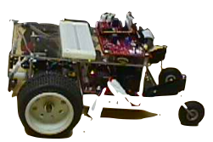
2. Rough drafts in Engineering notebook
- Scale drawings of the golf holes
- Par times set for each hole with an explanation of how this was determined in the engineering notebook.
- Materials list
- The holes constructed on the floor

Formative Assessment:
As students are engaged in the project, ask yourself or the students the following:
- Were students able to work together as teams effectively?
- Were the students able to calculate the area of the different shapes they used?
- Have they labeled the areas with the correct units?

Summative Assessment:
After the project is completed the students will reflect in their engineering notebook on the following:
- How does the design of a golf course use math?
- How effective was your method of determining par for your holes?
- What questions do you still have about area?
- What do you know really well about area?

Worksheet: M040_CEENbot_Putt_Putt-U-rubric.doc

