SPIRIT 2.0 Lesson:
Robot Area
==========================Lesson Header ==========================
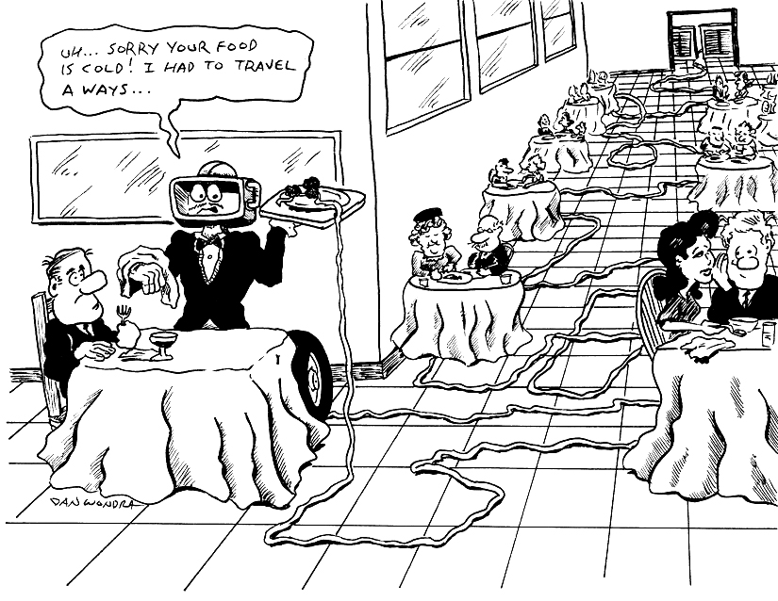
Lesson Title: Robot Rectangle Area
Draft Date: 6-23-09
1st Author (Writer): Lisa Hamling
Instructional Component Used:
Area of Rectangles
Grade Level: 7th

Outline of Lesson

Content (what is taught):
- Area of polygons, square units,
and dimension
- Discover area formula for polygons
and what is needed to find the area.

Context (how it is taught):
Students would use the robot to draw different “rooms” (polygons) on a large grid that is on the floor. Then count how many squares are in each “room” (polygon) and label correctly. Do several trials noting the dimensions of the polygons. Many tiles are 1 square foot so you could use the tiles as your grid or use blue masking tape to create a large grid in the room.

Activity Description:
Students will be divided into groups to create a “room” in the shape of a polygon. They will determine the dimensions of the polygons by measuring the distance traveled by the robot. The area then is the number of squares (tiles on the floor that the robot went around) inside the room. Each group will count how many square feet are in the room they created. NOTE when the polygon is not perfectly aligned to the grid the area will have to be carefully estimated by counting partial squares. The groups will then move around the room to record the dimensions of the polygons created by the other groups. Once all rooms have been recorded, the students will look for patterns to discover the area formula for polygons.

Standards:

Math: MC1, MB1, MA3, MD1

Science: A1, A2

Technology: C1, B1

Materials List:
- Robot
- Marker, Tape
- Large grid, Chart
Asking Questions (Robot Area)

Summary: Students will discuss what area is and what it is used for.

Outline: The teacher would lead discussion on area creating an anticipatory setting of what area is and what it is used for.

Activity: The teacher would ask questions to get the students thinking about what area is and how it is used by using the following questions or ones similar to them.

Questions | Answers
How do we know how much carpet to buy for a room? | Answers will vary. Can be found by calculating the area of the room and knowing the base and height.
How do we know how much siding will go on the triangular gable of a house. | Answers will vary. Can be found by calculating the area of the gable
How do we know how many tiles to buy for our kitchen? | Answers will vary. Can be found by calculating the area of the room
How much paint will it take to paint a wall or room? | Answers will vary. Can be found by calculating the area of the wall(s).
How big is the soccer field/basketball court/ football field? | Answers will vary. Can be found by calculating the area of the playing field.
How much area is there in a stop sign | Answers will vary.
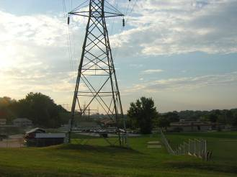
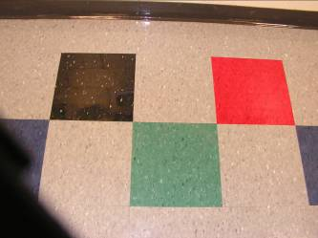
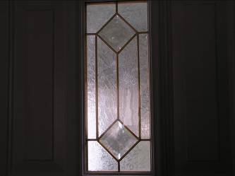

Exploring Concepts (Robot Area)

Summary: Students will explore the area of a rectangle.

Outline:
- Students will create a room (polygon) by driving the robot and determine the dimensions of the polygon measuring the path of the robot.
- Students will count how many squares are in the room (polygon).
- Students will record the appropriate dimensions and number of squares in a chart with headings. Measure in feet or other appropriate unit for your grid.

Activity: The students would use the robot to draw a small room on a large grid. Then count how many square feet would be in the “room” drawn. After counting the squares of several rooms drawn out by other groups, ask the students if a pattern exists to find the area without counting the squares contained in the “room”. With some of the more complex polygons a pattern does exist but is less apparent. The teacher might want to provide guiding questions to get students to thing about relevant information like finding the area by making triangles and using dimensions like perimeter and apothem. If you are talking about a room that is a rectangle the formula would be base times height and a triangle would be one half base times height.

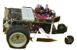

Instructing Concepts (Robot Area)

Area of Polygons

There are two types of polygons concave and convex. Convex polygons have all interior angles less than 180 degrees. Concave polygons have one or more interior angles greater than 180 degrees. To find the area of a concave polygon it is necessary to subdivide the polygon into smaller convex polygons. Since finding the area of concave polygons involve using convex polygons this instructional component will focus on basic convex polygons.

 | Triangle  A 3-sided figure | Area = | b is the base and h is the height at a right angle to the base
 | Parallelogram  A 4-sided figure with both pair of opposite sides parallel | Area = | b is the base and h is the height of the parallelogram at a right angle to the base
 | Rectangle  A parallelogram with at least  1 right angle | Area = | b is the base and h is the height of the rectangle
 | Rhombus  A parallelogram in which at least  2 consecutive sides are congruent | Area = | d₁ and d₂ are the diagonals of the rhombus
 | Kite  A 4-sided figure in which the  2 disjoint pairs of consecutive sides are congruent | Area = | d₁ and d₂ are the diagonals of the kite
 | Square  A rectangle with 4 congruent sides | Area = | b is the base and h is the height of the square
 |  | Area = | d₁ and d₂ are diagonals of the square
 |  | Area = | s is the side length of the square
 | Trapezoid  A 4-sided figure with exactly  1 pair of parallel sides | Area = | b₁and b₂ are the parallel sides and h is the height at a right angle to the base
 | Regular polygon  A polygon with all sides and interior angles congruent | Area = | a is the apothem (distance from the center perpendicular to a side) and p is the perimeter

If the polygon doesn’t fit into one of the above classifications you can find the area by subdividing it into polygons that do fit into one of these types. The easiest method is to subdivide it into triangles and then add up the area of all the small triangles to find the area of the polygon.

Although a circle is not a polygon I will mention the area formula here: Area circle = where r is the radius of the circle. This formula is an extension of a regular polygon where the side length is approaching zero.
Organizing Learning (Robot Area)

Summary: Students will record the dimensions of each room created by 3 groups. The dimensions will be put in a chart.

Outline:
1) Students will create a room (polygon) with appropriate dimensions.
2) Students will count how many squares are in the room (polygon) for nonrectangular rooms the students must estimate the area.
3) Students will record the base, height and number of squares in a chart with the appropriate headings. Measure in feet (or other appropriate unit) for your grid.

Activity:
Record information in the following chart:
Polygon Formed | Perimeter | Apothem | Side Length | Base  (if applicable) | Height  (if applicable) | Area  (include label)

Understanding Learning (Robot Area)

Summary: Students will create a house with different sized rooms to show their understanding of area of a polygon and the formulas to find it. The students will show the necessary measurement of each room and calculate the area of each room.

Outline:
- While students are involved in the activity, the teacher should ask questions such as:
In this room, what is the perimeter of the polygon?
Where is the apothem?
What is the area of the polygon?
- The students will create, on paper, different rooms in a house. The students will identity the required dimensions/measurements and show calculations for finding the area.

Activity:

Formative Assessment

As students are engaged in the lesson ask these or similar questions:
- What is the perimeter of the polygon?
- What is the apothem of the polygon?
- What is the area of the polygon
- Are students able to estimate the area correctly?

Summative Assessment

Students can answer the following writing prompt:
Describe how to find the area of any polygon and state what you must measure to find the area.

Students can create a “house” with at least 3 different polygons for rooms. They must list the measurements required to find the area and then calculate the area of each room. A proper scale should be used to draw the room accurately. An extension of the activity could be to find cost amounts for four different floor coverings and then use those costs to find the price associated with putting each type of flooring down in each room.

