SPIRIT 2.0 Lesson: Speedy Area
Speedy Area
==========================Lesson Header ==========================
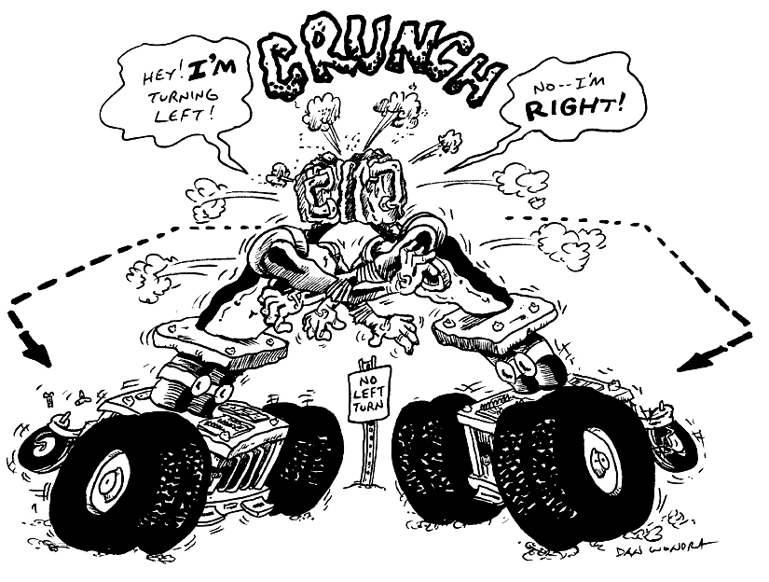
Lesson Title: Speedy Area
Draft Date: 6/22/09
1st Author (Writer): Lisa Hamling
Instructional Component Used: Formulas for Area and Perimeter
Grade Level: High School Geometry

Outline of Lesson

Content (what is taught):
- Perimeter and area of a square
- Measurement
- Distance = rate X time
- Maximum value

Context (how it is taught):
- Students will drive the robot for 30 seconds creating a rectangle. The path of the robot will represent the perimeter of a rectangle and the enclosed figure will represent the area of the rectangle.
- The students will then measure the distance traveled, the perimeter, and use that value to find the sides of the rectangle and then calculate the area.
- The students will also be given the relationship of distance equals rate times time (d = rt) to see if other methods could be used to figure out ways to maximize the area of a rectangle besides trial and error.

Activity Description:
Students will explore how far the CEENBoT can drive in 30 seconds making a rectangle. Students need to realize that the CEENBoT needs to make 3 turns to create the rectangle, which will take more time than just going in one straight line. They will use a marker attached to the CEENBoT to draw a rectangle on a freezer paper covered floor. The objective is to make the rectangle have the most area possible. The students may consider the rate of the CEENBoT and how long it takes to create 3 turns to calculate the maximum perimeter, which in turn will maximize the area of the rectangle.
Standards:

Math
MC1, MD1, MD2
Science
SA1

Technology
EB1
Engineering
TD1

Materials List:

Classroom robot, Stopwatch, Recording Notebook, Freezer Paper, Meter Stick / Tape measure
Markers, 3 different colors for each group, Tape or clip to attach marker.
Asking Questions (Speedy Areas)

Summary: Students will investigate how far the robot will travel in 30 seconds creating a rectangle.

Outline:
- Students will drive the robot and calculate the area given the distance the robot traveled in 30 seconds with 3 right turns (or 3 left turns).

Activity:
Drive the robot creating a rectangle while timing for 30 seconds. Then measure the distance the marker created on the paper to find the side of the rectangle and the area of the rectangle.

Questions | Answers
How do you find the perimeter of a rectangle? | P = add up the sides or 2l + 2w
How do you find the area of a rectangle? | A = bh
How do you find the area of a rectangle if you know the perimeter? | You must know the length or the width at least.
Where do we use area? | Answers may vary i.e. carpet a floor, paint a room.
Where do we use perimeter? | Answers may vary i.e. frame around a window,

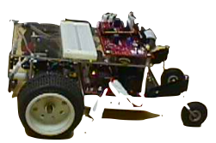
Perimeter = 2l + 2w

Exploring Concepts (Speedy Area)

Summary: Students will explore the areas of different rectangles given a fixed perimter.

Outline:
- Have students draw many rectangles with a perimeter of 16 units. They can either use a pencil and ruler or the robot to do this.
- Students calculate the area of the rectangles with fixed perimeter.
- Students make generalizations about the rectangle with the largest area.

Activity: Give students a fixed perimeter of 16 units and have them draw as many rectangles with that perimeter as possible in 5 minutes. This can be done with pencil and paper or by utilizing the robot. Careful measurements should be taken and recorded. After five minutes students should calculate the area of all the rectangles that were drawn and record the area in the chart. Finally ask if there are any generalizations that can be made based on the data. The hope here is that they realize that a square is the rectangle with the maximum area given a fixed perimeter.

2 x 8
1 x 16
4 x 4

Instructing Concepts (Speedy Areas)
Area of Polygons

There are two types of polygons concave and convex. Convex polygons have all interior angles less than 180 degrees. Concave polygons have one or more interior angles greater than 180 degrees. To find the area of a concave polygon it is necessary to subdivide the polygon into smaller convex polygons. Since finding the area of concave polygons involve using convex polygons this instructional component will focus on basic convex polygons.

 | Triangle  A 3-sided figure | Area = | b is the base and h is the height at a right angle to the base
 | Parallelogram  A 4-sided figure with both pair of opposite sides parallel | Area = | b is the base and h is the height of the parallelogram at a right angle to the base
 | Rectangle  A parallelogram with at least  1 right angle | Area = | b is the base and h is the height of the rectangle
 | Rhombus  A parallelogram in which at least  2 consecutive sides are congruent | Area = | d₁ and d₂ are the diagonals of the rhombus
 | Kite  A 4-sided figure in which the  2 disjoint pairs of consecutive sides are congruent | Area = | d₁ and d₂ are the diagonals of the kite
 | Square  A rectangle with 4 congruent sides | Area = | b is the base and h is the height of the square
 |  | Area = | d₁ and d₂ are diagonals of the square
 |  | Area = | s is the side length of the square
 | Trapezoid  A 4-sided figure with exactly  1 pair of parallel sides | Area = | b₁and b₂ are the parallel sides and h is the height at a right angle to the base
 | Regular polygon  A polygon with all sides and interior angles congruent | Area = | a is the apothem (distance from the center perpendicular to a side) and p is the perimeter

If the polygon doesn’t fit into one of the above classifications you can find the area by subdividing it into polygons that do fit into one of these types. The easiest method is to subdivide it into triangles and then add up the area of all the small triangles to find the area of the polygon.

Although a circle is not a polygon I will mention the area formula here: Area circle = where r is the radius of the circle. This formula is an extension of a regular polygon where the side length is approaching zero.
Organizing Learning (Speedy Areas)

Summary: Students will organize the perimeter, sides, and areas for their rectangles in a chart. They will also show the work for the calculations below the chart.

Outline:
- Divide the students into 3 groups and give them the materials needed.
- The students need to put the paper on the floor and attach the marker to create the rectangle.
- Have students drive the robot creating a rectangle.
- Be sure the students are timing only to 30 seconds.
- Remind the students they need to make 3 turns to create the rectangle. It is not a straight line distance. The students could drive the CEENBoT straight, make a right turn, drive straight, make a right turn, drive straight, make a right turn, drive straight and continue until the 30 seconds are done. The picture may not look like a completed a rectangle but they should have enough data to find the possible perimeter of the rectangle and in turn find the side and calculate the possible maximum area.
- The students should do at least 3 trials, changing the color of the marker for each trial.

Activity:
The students will experiment driving the robot straight and making 3 turns. The students will time for 30 seconds. The students will measure how far their robot traveled which is the perimeter of the rectangle. They will record the distance in the chart. Then, calculate the side of the possible rectangle using the chart and either the length or width. Using the side values, the students will calculate the area of the rectangle writing the value in the chart. The students should continue to experiment to see if they can increase the distance traveled and actually drive the rectangle that has the maximum area. All information should be recorded on the chart. The students should show their calculations in the chart below. Record the distance traveled in 30 seconds for each trial of rectangle driven.

Distance Traveled = Perimeter | Side (Length) | Side (Width) | Area rectangle

Understanding Learning (Speedy Areas)

Summary: Students will complete a homework assignment using different values for distance traveled. The students will calculate the sides of the rectangle from the perimeter given a length or width and then calculate the area.

Outline:
- Formative assessment of perimeter and area of a rectangle.
- Summative assessment of perimeter and area of a rectangle.

Activity:
Formative Assessment
As students are engaged in the lesson ask these or similar questions:
- How is the distance traveled used to calculate the side of the rectangle?
- Do you need to draw a perfect rectangle with the CEENBoT in order to know what the perimeter of the rectangle is?
- What formula do we use to calculate the area of a rectangle?
- Given the area of the square, can you find its side?
- Given the area of the square, can you find its perimeter?

Summative Assessment
Students can answer the following writing prompt:
Describe how to find the area of a rectangle and what is the minimum amount of information required to do so. In addition discuss how the area of the rectangle changes when the side length changes.

Find the missing values given the information in the chart for any given square:
Perimeter | Length | Width | Area
1. 20 meters |  | 2
2. 24 meters | 6
3. 28 meters | 10
4. 30 meters |  | 10
5. 40 meters | 8 meters
6. | 12 meters | 30 meters
7. | 15 meters |  | 60 meters squared
8. |  | 10 meters | 400 meters squared
9. | 100 meters |  | 1600 meters squared
10 | 200 meters |  | 2000 meters squared

Extension: How would you change the activity if you were to draw a pentagon instead of a square?
How would the formula for perimeter change if you wanted to draw a pentagon instead of a square?
Where would you find the area formula for a pentagon?
What is the area formula for a regular pentagon?

