Robot Ratios

Directions: Using a humanoid robot, measure the following lengths and widths plus five additional lengths and widths not listed. Then, use the measurements to form ratios and answer the questions.
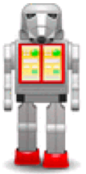
http://www.pdclipart.org

Lengths and Widths to Measure | Measurement (in mm)
Eye Width
Head Width
Leg Length
Distance from Hip to Knee
Distance from Elbow to Fingertip
Body Width
Head Length

Form different ratios using the measurements from the humanoid robot. List the ratios on the back of this worksheet.

Are any of the humanoid robot ratios close to the ratios from your face?

If you measured the same lengths and widths on your body, would the ratios be the same as the humanoid robot ratios?

