Project SHINE / SPIRIT2.0 Lesson:
This Teacher was mentored by:


www.bd.com

In partnership with Project SHINE grant funded through the

National Science Foundation

Can You Canula?
==========================Lesson Header ==========================
Lesson Title: Can You Canula?
Draft Date: 6-14-10
1st Author (Writer): Cherrie Cummings & Terri Jelinek
2nd Author (Editor/Resource Finder): BD
Instructional Component Used: Circumference
Grade Level: 7-10

Content (what is taught):
- Circumference
- Pi

Context (how it is taught):
- Students measuring circumference and diameters with micrometers or calipers
- Students developing the formula for circumference based on measurements found.

Activity Description:
This lesson would teach circumference by having students involved in measuring diameter and circumference of various sized circles. Students will build a chart of their measurements and look for the relationship between diameter and circumference. Students will then use the circumference formula to solve problems with one missing variable.

Standards:

Science: A1, A2 Technology: TD3

Engineering: ED1, ED2 Math: MC1, MD1

Materials List:
- Circular objects such as cans, paper towel roll, circular mouse pad, etc.
- Meter sticks and meter tapes.
Asking Questions: (Can You Canula?)

Summary: Students will determine if the distance across a circle affects the distance around a circle. BD-West Manufacturing in Columbus, NE produces medical needles. Before the points are ground onto the needles they are called canula. Medical institutions need various sizes of needles for different types of injections. Diameter and circumference are continuously used in this process.

Outline:
- Teacher holds up different circles and asks which one has the greatest distance around the exterior
- Teacher asks if there is relationship between the distance across the circle and the distance around it

Activity: The teacher will question students about circles and the properties of circles. Students will “learn” about diameter and circumference and how they are related.

Questions | Answers
Does the distance across the straw (diameter) affect the distance around the straw (circumference)? | Yes, the greater the distance across the greater the distance around.
Would it be possible to find the distance around the straw (circumference) knowing the distance across the straw (diameter)? | There is a constant ratio between distance around and distance across.
^{diameter}
^{radius}
^{circumference}

Exploring Concepts: (Can You Canula?)

Summary: Student will work in groups to determine methods of measuring diameter and circumference of various circles (i.e. cans, paper towel roll, circular mouse pad, etc.). Meter sticks and tapes will be available.

Outline:
- Students work in groups to determine how to find the distance across a circle.
- Students work in groups to determine how to find the distance around a circle.

Activity: In this lesson, students investigate how the distance around a circle (circumference) compares to the distance across a circle (diameter). They use the items available to come up with a plan for measuring the largest distance across the circle and the distance around the circle.
^{diameter}
^{radius}
^{circumference}

Instructing Concepts: (Can You Canula?)

Circles

A circle is defined to be the set of all points in a plane equidistant from a point called the center. Thus to define a circle you must have a point (center) and a distance from the center (radius).

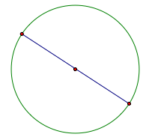 | Diameter – A chord of a circle that contains the center. Note a diameter is the longest chord.
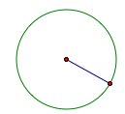 | Radius – distance from the center to the circle. Note: Diameter = 2 radii
Distance “around” the circle | Circumference =
Portion of the circumference  with a central angle of m degrees | Arc length =
 | Area =
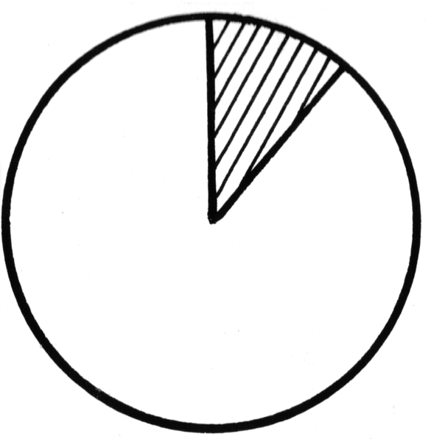 | A_{sector} =
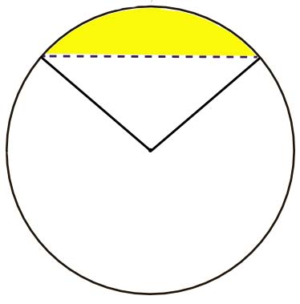 | A_{segment} = A_{sector} – Area Triangle
 | Measure central angle = measure subtended arc.
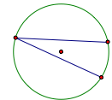 | m(inscribed angle) =
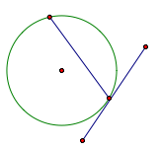 | m(tangent/chord angle) =
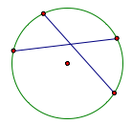 | m(chord/chord angle) = (sum of the intercepted arcs)
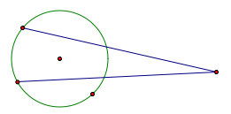 | m(secant/secant) = (difference of the intercepted arcs)
Organizing Learning: (Can You Canula?)

Summary: Students will investigate the relationship between diameter of a circle and its circumference.

Outline:
- Students are given plastic straws of varying diameters
- Students measure the diameter of the straw and record it on their charts
- Students cut the straw open and measure the width to find the circumference and record it on their charts
- Students analyze the relationship between the circumference and the diameter of the straws

Activity: In this lesson, students will investigate the relationship between the circumference of a circle and its diameter. Students work in groups to measure the diameter and circumference of straws of varying diameters. They will use a chart to organize their measurements and then use the chart to look for relationships. Students may need guidance in finding the relationship by using the question “how many times greater is the circumference?”

Cylinder | Diameter | Circumference | Relationship
1
2
3
4
5
Understanding Learning: (Can You Canula?)

Summary: Students will write an explanation of the relationship between the circumference and the diameter of a circle. Students will solve problems involving circumference given one variable.

Outline:
- Formative assessment questions asked during the activity about the relationship between circumference and diameter
- Students will identify the ratio between circumference and diameter is pi

Activity:

Formative Assessment
As students are engaged in the lesson ask these or similar questions:
- What is the relationship between circumference and diameter of a circle?
- Is the ratio between circumference and diameter of a circle always the same?
- What is the ratio called?

Summative Assessment

See Attachment:

Attachment: M047_Shine_circles.doc-U-assesment.doc

