Project SHINE / SPIRIT2.0 Lesson:
This Teacher was mentored by:


www.behlenmfg.com

In partnership with Project SHINE grant funded through the

National Science Foundation

Don’t Lose Your Load!
==========================Lesson Header ==========================
Lesson Title: Don’t lose your load!
Draft Date: June 14, 2010
1st Author (Writer): Megan DeWispelare
Instructional Component Used: Technology and
Making and Interpreting Graphs
Grade Level: Elementary School
Business Partner: Behlen Mfg. Co.

Content (what is taught):
- Use of Excel to graph
- Way to change spreadsheet into usable graphs

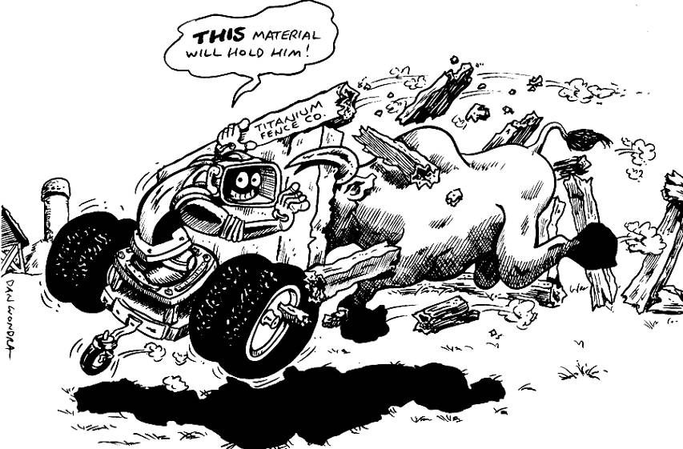
Context (how it is taught):
- Material strength is determined
- Construction of fence to test material strength

Activity Description:
The student will experiment with different materials to determine their strength. After strength is determined, the student will construct a fence to test the holding strength. After the strength is determined from the different materials of fence, the student will chart and graph the results.

Standards:

Science: SA1, SE1 Technology: TA1, TB2, TD2

Engineering: EA1, EA2 Math: ME2

Materials List:
- Different materials to construct a fence (plastic straws, toilet paper roll, popsicle sticks, wooden dowel, plastic knife, etc.)
- Glue
- Weights to measure the strength of fence (books could also work)
Asking Questions: (Don’t lose your load!)

Summary: The students will brainstorm what materials will hold the heaviest load.

Outline:
- Determine what materials are strong materials
- Come up with ideas as to why these materials are strong
- Ask if shape or size matter for strength of material

Activity: The teacher will ask the students to brainstorm a list of materials they believe are strong and why they think the material is strong.

Questions | Answers
What do you think a strong material is? | Steel, brick, etc.
What makes a material strong? | Answers vary
Does the shape of the material make a difference in the strength? | Yes, certain shapes make a material stronger
Do you think wood is stronger than plastic? | Can vary
Do you think wood is stronger than brick? | Can vary
Do you think aluminum is stronger than glass? | Answers vary
Exploring Concepts: (Don’t lose your load!)

Summary: Students will investigate the strength of different materials.

Outline:
- Students will test the strength of given materials
- To test the strength, use different weights

Activity: The students will be given different materials and will explore their strength. Some example materials include plastic straws, toilet paper rolls, popsicle sticks, wooden dowels, and plastic knives. The students should check how easily they can break each material. Students can also experiment with trying to create something to break, or create a stronger item by stacking them.
Instructing Concepts: (Don’t lose your load!)

Data Analysis/Modeling Data by Best-Fit Curves

The process of modeling data is essential for any field of study where data has been collected over time and predictions are desired about future behavior. The process involves identifying a trend that is present and making a prediction based on that trend. This process consists of four parts: 1) graphing a scatterplot of the data, 2) analyzing the data for a trend, 3) creating a function model that fits the trend, and 4) making credible predictions based on the model, assuming the trend continues.

Scatterplots
The first step is to graph a scatterplot of the data. This can be done by hand or by using a graphing utility. If you are doing it by hand, scales for the x (independent) variable and the y (dependent) variable will need to be chosen so that the data is spread out enough to make the trend recognizable.

Analyzing the Data for a Trend
After creating the scatterplot it is necessary to analyze the data for trends that are present. These trends can be as simple as a line (linear regression) or more complex such as a polynomial (quadratic, cubic, etc.), sinusoidal, power or any other function that looks like the trend present. The closer the data resembles the function you want to use to model it the better your predictions should be. The measure of how closely the function will model the data is called the correlation coefficient (r). Correlation is a number that ranges between – 1 and + 1. The closer r is to +1 or – 1, the more closely the variables are related. If r = 0 then there is no relation present between the variables. If r is positive, it means that as one variable increases the other increases. If r is negative, it means that as one variable increases the other decreases. Correlation is very hard to calculate by hand and is usually found using the aide of a graphing utility.

Creating a Function Model
After deciding on a function that models the trend present it is necessary to create an equation that can be used to make future predictions. The easiest model to create is a linear regression if the trend present is linear. To do this you first draw a line that comes as close to splitting the data while at the same time having all the data points are as close to the line you are drawing as possible. There will be a kind of balance to the line within that data plot that should split the data evenly and follow the same linear trend. If the trend that is present in the data is stronger, then it will be easier to draw your line. After drawing the line, you can calculate the equation by estimating two points on the line. Using these two points, calculate slope and the y-intercept and write the equation. Regression models can be found more precisely using graphing utilities. Anything other than a linear regression is very difficult to find by hand.

Making Predictions Using the Model
After the model is found it is easy to use it to make predictions about future events assuming the trend continues. You can simply plug in for either the x or y variable and solve for the other. This will create a predicted data point that can be used to base future decisions on. If the correlation is high, meaning the trend is strong; the predictions should be fairly accurate.

Organizing Learning: (Don’t lose your load!)

Summary: Students will investigate the strength of different materials using a chart.

Outline:
- Students will create a fence using the materials supplied
- Students will test the materials and record how each material held up for each weight

Activity: The students will use the given materials to create a fence. All fences will be constructed in the same manner so most fences will look the same. After the fence is constructed, students will hang weights or put books on top of the fence to see how much weight the fence will hold. NOTE: Hang the weights from the fence and gradually add more until the fence breaks or sags. After this information is found and charted, the students will create a bar graph to show what material held the most weight and what material held the least.

The students will test the process a certain way after the teacher determines the best way available. This could change because of the material used to check the weight will change from classroom to classroom.

The activity could also be done letting the kids construct their own fence. From their own construction, students could conclude the way the fence is constructed also plays a part in the weight each fence can hold.

Extensions: Students could be provided with different materials and/or construct different types of fences (picket, slate, etc.)

Resources: Sample Chart
X=fence held weight O=fence did not hold
Number of books | Wood Fence | Plastic Fence | Paper Fence
1 book | x | x | x
2 books | x | x | o
3 books | x | o | o
Understanding Learning: (Don’t lose your load!)

Summary: The students will graph the given data and interpret their results in essay format.

Outline:
- Formative assessment of data analysis
- Summative assessment of data analysis

Activity: Students will answer a writing prompt about data analysis or complete a performance assessment.

Formative Assessment
As students are engaged in the lesson ask these or similar questions:
- Were the students able to tell what material held the most weight?
- Can the students predict other materials that could possibly hold more weight? Can they predict materials that will hold less weight?

Summative Assessment
Students can answer the following writing prompt:
- Explain the data analysis procedure and how you used it in this lesson.
- Explain why some materials that might be considered weak can actually hold a lot of weight. Justify your answer by using data.
- Describe the best design for a fence. Justify your answer by using data.

Students can do the following Performance Assessment:
Complete the process below, chart the data, graph the collected data, and analyze it to make decisions.
Number of books | Aluminum Fence | Plastic Fence | Paper Fence
3 book | X | O | X
7 books | X | O | O
9 books | X | O | O

- From the following data chart, create a bar graph to show how each material handled the weight.
- After the graph is completed, answer the question, “What fence material held the most weight and why?” Was it because of the way the fence was made? Was it because the paper fence ripped?
- Create a sales pitch from the data to sell the fence type that held the most weight.
- Extended Thinking: Are there stronger fences out in the world? What determines the strength? Does location in the world, or type of animal enclosed make a different in the strength of the fence?

