Project SHINE / SPIRIT2.0 Lesson:
This Teacher was mentored by:


www.nppd.com

In partnership with Project SHINE grant funded through the

National Science Foundation

Splitting the Penstock
==========================Lesson Header ==========================
Lesson Title: “Splitting the Penstock”
Draft Date: June 17, 2010
1st Author (Writer): Tom J. Price
2nd Author (Editor/Resource Finder):
Instructional Component Used:
Calculating the Area of a Circle
(Cross-Section of a Cylinder)
Grade Level: 7th or 8th Grade

Content (what is taught):
- The rough equivalency of the area of one large circle split into two smaller congruent circles.

Context (how it is taught):
- Groups of students will explore the diameter of PVC pipe to gain information
on splitting one large pipe (the penstock) into two smaller pipes (intakes for the generating turbines).

Activity Description: A discussion on electrical energy generated from hydroelectric sources, or other sources, takes place first. The teacher will demonstrate a model of a penstock and intake turbines for the class (or the teacher may make individual kits for groups of students). Students will be able to see from the model (PVC pipe) and from pictures from the Internet how the size of a penstock for a hydroelectric power plant is related to the size of the intake pipes for the generating turbines.

Standards:

Science: SA1, SB3 Technology: TA1, TA3

Engineering: EA1, EC1, EE1 Math: MC1, MD1, ME1

Materials List:
- One piece of 1.5 inch diameter PVC plumbing pipe (about one foot in length)
- One 3-Y connecting piece (one connector splits pipe into three ways) with reducers (down to 1 inch diameter PVC pipe)
- Three pieces of 1 inch diameter PVC plumbing pipe to represent the intake pipes at a hydroelectric facility (lengths that will make the ends collinear)
- A source of water (faucet, beaker, or drinking cooler) would provide a reenactment of lake water flowing down to the generating turbines. Three beakers could collect the water for measurement.
Asking Questions: (Splitting the Penstock)

Summary: Energy is produced from a variety of sources, but all of them except solar involve some kind of turbine (generator). Groups of two or three students will answer the questions on the handout (left side of the chart shown below).

Outline:
- Students are guided into thinking about sources of energy for electrical production, especially water (hydro)
- Questions are funneled down to specific measurements for penstock and intake turbines

Activity: The teacher will demonstrate a simple model of a penstock (large PVC pipe) that splits into three intakes (smaller PVC pipes). Two pictures from the Internet will show examples of a typical hydroelectric system. The teacher can either write the questions on the marker board or cut/paste on to a sheet of paper.

Questions | Answers
How is water used to produce energy? | Elevated water, like a lake, is used to flow down through a penstock to generating turbines.
Why is water a useful source for generating power? | Depending on the location, water is cheap, renewable, clean, and usually dependable.
How do engineers calculate the specific way to transfer a large volume of water (penstock) into several smaller volumes of water (the intakes for the turbines)? | Knowing the amount of water available in a given area, engineers calculate the length and size of the penstock to transfer the water to several corresponding generating turbines.
Why is one penstock split into several smaller pipes, why not just have three penstocks that feed three turbine intakes? | Having only one penstock saves on money as the cost of several long pipes into a water source requires more resources. Once the water is delivered to the power station, it is split into the corresponding intakes for the turbines.

Resources:
Wikipedia (penstock): http://en.wikipedia.org/wiki/Penstock shows a picture of several penstocks bringing water down to the turbines.

US Department of Energy (types of hydropower plants): http://www1.eere.energy.gov/windandhydro/hydro_plant_types.html

How Stuff Works (Really Big Things: Hydroelectric Power) http://videos.howstuffworks.com/discovery/30198-really-big-things-hydroelectric-power-video.htm
Exploring Concepts: (Splitting the Penstock)

Summary: Students will be given many different circles and explore the area of each. Students will then look at how the area changes when the radius changes.

Outline:

- Students will measure the diameter and radii of many circles
- Students will figure the area of the circles
- Students will compare the radius to area and see what the relationship is between area and radius as the radius changes

Activity: The teacher will provide a number of different circles to students who will measure the radius and diameter and record them. Next, the area of each circle will be calculated and recorded. Finally, students will compare the radius of circles to the area and see how the area changes as the radius changes. In the chart students should use the first circle as the benchmark for the comparisons of radii change per area change. The goal is that students recognize that the area to radius is not linear it is squared.

Circle # | Radius | Diameter | Area | Change in area per radius change
1
2
3
4
5
^{diameter}
^{radius}

Instructing Concepts: (Splitting the Penstock)

Circles

A circle is defined to be the set of all points in a plane equidistant from a point called the center. Thus to define a circle you must have a point (center) and a distance from the center (radius).

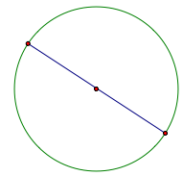 | Diameter – A chord of a circle that contains the center. Note a diameter is the longest chord.
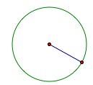 | Radius – distance from the center to the circle. Note: Diameter = 2 radii
Distance “around” the circle | Circumference =
Portion of the circumference  with a central angle of m degrees | Arc length =
 | Area =
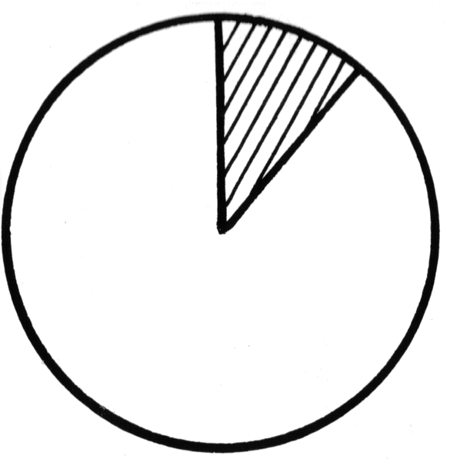 | A_{sector} =
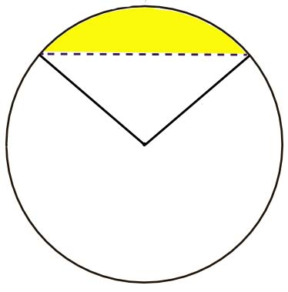 | A_{segment} = A_{sector} – Area Triangle
 | Measure central angle = measure subtended arc.
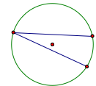 | m(inscribed angle) =
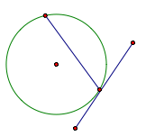 | m(tangent/chord angle) =
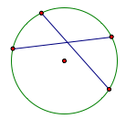 | m(chord/chord angle) = (sum of the intercepted arcs)
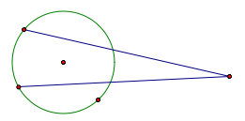 | m(secant/secant) = (difference of the intercepted arcs)

Organizing Learning: (Splitting the Penstock)

Summary: Hydroelectric power is electrical power gained by transforming mechanical energy (water flow) to electrical energy. The students will be given a brief overview of what a penstock is and how intake pipes for generating turbines are related.

Outline:
- On a sheet of paper handed out by the teacher, students will record their efforts, starting with the largest pipe (diameter), the diameter of the intake pipes, the amount of initial water, and the amount of collected water.

Activity: To begin with, a discussion on electrical energy generated from hydroelectric sources will take place. The teacher will then demonstrate a model of a penstock (1.5 inch PVC pipe) and intake turbines (three attached 1 inch pipes) for the class. As an extension, with a source of water (predetermined amount or not), the teacher can demonstrate how the downward flow of water from a source is mechanical energy that can be transformed into electrical energy. With a source of water (predetermined amount or not), the teacher can demonstrate how the downward flow of water from a source is mechanical energy that can be transformed into electrical energy. Holding the three intake pipes level, the students can view how the size of the penstock should be related to the size of the intake pipes. Water is then poured down the penstock and collected into three beakers. Students can then measure the diameter of the penstock, the diameter of the intake pipes, and the amount of water (beginning and end). The data can be organized in the attached file: M051_SHINE_Splitting_Penstock-circles-O.doc

Note: the teacher could split this activity into groups of 3 students where they could actually build their own penstock and intake pipes with smaller PVC pipes, but that would take much more material, time and money.

Resources:
Wikipedia (Penstock): http://en.wikipedia.org/wiki/Penstock shows a picture of several penstocks bringing water down to the turbines

US Department of Energy (types of hydropower plants): http://www1.eere.energy.gov/windandhydro/hydro_plant_types.html

How Stuff Works (Really Big Things: Hydroelectric Power) http://videos.howstuffworks.com/discovery/30198-really-big-things-hydroelectric-power-video.htm

Attachments: M051_SHINE_Splitting_Penstock-circles-O.doc

Understanding Learning: (Splitting the Penstock)

Summary: Students will explain their knowledge of circles.

Outline:
- Formative assessment on area of circles.
- Summative assessment on area of circles.

Activity: Students will answer a variety of summative questions relating to circles (specifically the area of circles)

Formative Assessment
As students are engaged in the lesson ask these or similar questions:

- How do engineers calculate the size of the intake pipes that fit a corresponding penstock?
- Why are cylinders used to transport the water?
- Why is water an efficient way to produce electricity?
- What are the drawbacks to hydroelectric power?
- What happens if the intake pipes inadvertently carry something
other than water (branches, newspapers, pollution, etc.)?

Summative Assessment
Students can answer the following writing prompt:
- Describe the following concepts: 1) what measurements you must know to find the area of a circle, 2) how you calculate the area of a circle, and 3) what happens to the area of a circle as the radius changes (be specific).

Students can do the following questions relating circles to penstock.

- How is the diameter of the penstock related to the diameters of the intake pipes? Be specific and justify your answer.

- Why does the penstock at the North Platte, Nebraska hydroelectric plant have a diameter of 13 feet with two intake pipes that have a diameter of 9 feet? Justify your answer.

- If a penstock with a diameter of 15 feet is going to be split into four intake pipes,
what is the largest diameter that the intake pipes should be? Justify your answer.

- Why is hydroelectric power an efficient way to create electrical energy?

