SPIRIT 2.0 Lesson:
Get Geared Up
==========================Lesson Header ==========================
Lesson Title: Get Geared Up
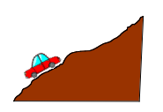
Draft Date: June 4, 2010
1st Author (Writer): Brandon Thoene
Instructional Component Used: Ratios and Proportions
Grade Level: 9th -12th

Content (what is taught):
- Students will calculate gear ratios
- Students will determine which situations each gear ratio could be used

Context (how it is taught):
- An example will be done by the instructor explaining how a ten-speed bike works
- What type of gear ratio is used for a rock crawling or a towing vehicle and why?
- What type of gear ratio does a drag vehicle or a land speed race vehicle use and why? Talk about different track lengths 1/4 mile and 1/8 mile.
Activity Description:
In this lesson, students will build a solar car and test the car with three different gears to drive the car. Students will chart the results found corresponding to the time the car traveled a specific distance (25ft.). For each set of gear ratios, the student will record the time it took the car to travel down the test track (3 times). Students will come up with an average and record the results in a chart. Finally, students will calculate the gear ratios of all of their sets of gears and estimate results of other given gear ratios. Formula: Drive Gear / Motor Gear = Gear Ratio

Standards:

Science: SB1, SB3 Tech: TA1, TA4, TB1, TC2, TC4, TD1, TD3, TF4

Engineering: EA1, EA2, EA3, EA4, EB5, EC1 Math: MA1 MA2 MB1 MD1 MD2 ME1 ME 3 ME 4

Materials List:
- Test Track
- Solar Cars
- Stop Watch
- Variety of Gears
Asking Questions: (Get Geared Up)

Summary: Students will think about different gear ratios and experience they might have with them.

Outline:
- Ask students if they have ever used different gear ratios
- What is the result from using different gear ratios?
- Think about reasons for utilizing different gear ratios

Activity: Students will be exposed to different gear ratios. Most likely, they are familiar with them even if they don’t know that they are. Applications where gear ratios are relevant to them include bicycles with gears, cars with overdrive, gears in steering columns, etc. They will be asked about how different gear ratios work and why different gear ratios are used.

Questions | Answers
What is a gear ratio? | The ratio between the amount of revolutions the device rotates with relation to the drive shaft
What can different gear ratios do? | Applications: High Torque/Low Speed or Low Torque/High Speed
What purpose do gear ratios serve? | Reduce stress on the engine/motor, produce more torque and produce higher or lower speeds
What types of things have multiple gears? | Bicycles, cars, trucks, transmissions, differentials or mixers
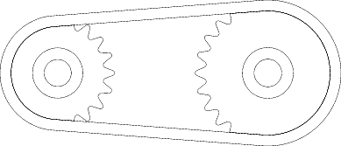
Public Domain Clip Art
pdclipart.com

Exploring Concepts: (Get Geared Up)

Summary: Students will investigate the relationships between different gear ratios and how they make a solar car travel differently on a flat track.

Outline:
- Demonstrate solar cars with different gear ratios
- Students will test different gear ratios on a solar car on a flat track
- Discuss how gear systems work in relation to speed and torque and graph the different sets of gears in relation to time it took the car to complete the test track

Activity: Students will build solar cars and record the time it took the car to travel down a flat, 15-foot test track. The data will be recorded and charted. The gear ratio will be changed and the process repeated several times to generate data. A class discussion will take place about what was observed in the trials with different gear ratios.

Gear Ratio | Time | Comments
Instructing Concepts: (Get Geared Up)

Ratios and Proportions

Putting “Ratios and Proportions” in Recognizable terms: Ratios are a way to compare two things. Ratios are often called rates when one of the quantities being compared is time. Proportions are two equal ratios.

Putting “Ratios and Proportions” in Conceptual terms: Ratios compare two different quantities. Those quantities can have the same units in which case the ratio has no units or the quantities can have different units in which case the ratio will have units. Proportions are two equivalent ratios and are found in many geometric and trigonometric applications.

Putting “Ratios and Proportions” in Mathematical terms: Ratios express the magnitudes of quantities relative to one another. They are a means of comparison and can be represented many different ways: Fractions, decimals, using a colon, and using the word to. For instance , , 4:5, and 4 to 5 all represent the same thing. Ratios should be given in lowest terms. If the ratio is 10 boys to 14 girls, the ratio should be given as 5 to 7. Proportions look like this and compare two equal ratios using four variables representing means and extremes. The means are b and c and the extremes are a and d. You can find any one of the variables given the other three using algebra.

Putting “Ratios and Proportions” in Process terms: Since the ratios can be represented in numerous ways the situation should dictate the form of the ratio. In sports like batting averages etc. ratios are given as decimals or percentages (.300), in recipes, ratios are given as fractions (3/4 cup), or on maps ratios are given as one scale to another scale 1 in : 100 miles. Proportions can be used to find one missing quantity from two equal ratios. They are solved using cross-multiplication (algebra) or the means-extremes product theorem (geometry).

Putting “Ratios and Proportions” in Applicable terms: Ratios can be used to compare different things. For instance you can use them to compare the size of one town to another (the first is twice the size of the second, 2:1). Ratios can be used to compare efficiency of a vehicle like 32 mpg for a car and 18 mpg for a pickup truck. Proportions can be used to find a missing quantity of two equal ratios. You can use proportions any time similar figures are present in geometry, drafting, cartography or architecture. The proportions will easily allow you to find an unknown measurement or length.
Organizing Learning: (Get Geared Up)

Summary: Students will investigate the relationships between different gear ratios. Students will also discover applications that would best suit each type of gear ratio.

Outline:
- Students will apply gear ratios to different situations and record results
- Students will calculate gear ratios (in decimal form) and record them

Activity: In this activity, students will be given problems involving different gears and they will need to solve for the gear ratio. Students will also determine what gear ratio would be appropriate for certain driving conditions. The formula for gear ratio is: Drive Gear / Motor Gear = Gear Ratio. Below are the conditions that students will decide which gear ratio best and record it.
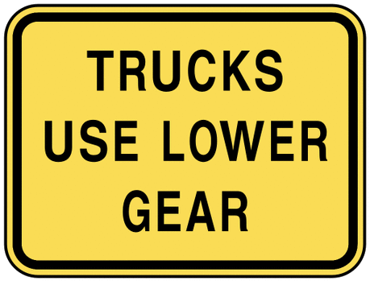
Public Domain Clip Art
pdclipart.com

- Various conditions up and down hills
- Steep conditions
- Land speed racing
- Fuel mileage
- Towing
- Rock climbing

They will change the gear ratio of the car and the track will be modified to fit the conditions to test their prediction. The results should be recorded.

Track condition | Gear Ratio | Time | Comments (result)
Understanding Learning: (Get Geared Up)

Summary: Students will take a summative test by answering short answer questions and essay questions based on what they built and their test results. The will also practice using the formula: Drive Gear / Motor Gear = Gear Ratio

Outline:
- Formative assessment of ratios and proportions
- Summative assessment of ratios and proportions

Activity:
Formative Assessment
As students are engaged in learning activities, ask yourself or your students these types of questions:
- How do you calculate gear ratio?
- What types of application require which type of gear ratio, high or low ratio?

Summative Assessment
Students will complete a short answer and essay question.
- How do you calculate gear ratio?
- What types of applications require gear ratios? High or low ratios?

