Project SHINE / SPIRIT2.0 Lesson:
Down the Line
==========================Lesson Header ==========================
Lesson Title: Down the Line
This Teacher was mentored by:


www.bd.com

In partnership with Project SHINE grant funded through the

National Science Foundation

Draft Date: 6-14-10
1st Author (Writer): Cherrie Cummings and Terri Jelinek
2nd Author (Editor/Resource Finder): BD West – Columbus, NE
Instructional Component Used: Volume of Cylinders
Grade Level: 9-11

Content (what is taught):
- Volume of a Cylinder

Context (how it is taught):
- Dimensions of various cylinders are identified and recorded.
- Water is used to find the volume of the cylinder in mL and that is converted to cubic centimeters.
- Students hypothesize how to calculate volume using the dimensions of the cylinder.
Activity Description: Students will measure the height and diameter of a cylinder. They will then fill the cylinder with water and predict how much water is in the cylinder. Next, they will pour the water into a graduated cylinder to measure the volume in mL. They will convert this measurement to cubic centimeters. Students will hypothesize and test methods using cylinder measurements to determine the volume.

Standards:

Science Technology
SA1 TD3

Engineering Math
ED1, ED2 MC1, MD1

Materials List:

Graduated cylinders
Asking Questions (Down the Line)

Summary:
Students will determine what affects how much liquid can be held in a tube. BD-West Manufacturing in Columbus, NE produces saline solution. They fill syringes with the saline solution so that it is ready to be used by medical facilities. In order to calculate the amount of solution in various sizes of syringes it is necessary to calculate volume of cylinders.

Outline:
- Have students compare two different sized tubes and explain which tube they believe will have more water and why, without actually filling them with water.

Activity: The teacher will distribute different sized tubes to groups of students and as they begin discussing which tube could hold the most liquid, ask these questions:

Questions | Answers
What affects the amount of water that can be transported in a tube? | Length of the tube, diameter of the tube
How could you measure how much water is in a tube? | Fill it up with water and then pour water into a graduated cylinder.

Exploring Concepts (Down the Line)

Summary:
Students investigate the amount of water that each cylinder can hold by filling them up with water.

Outline:
- Students will decide which tube they believe is larger and fill it with water.
- Students will pour the water from the larger tube into the smaller tube and see if their prediction was right.

Activity: In this lesson, students investigate the volume of a cylinder by filling tubes with water. Each group will be given two tubes with varying heights and diameters. They will predict as group which cylinder they believe has a larger volume. Students will then fill the cylinder with water and try pouring it into the smaller one. If they were correct, they should have water left over. If they were incorrect, all of the water should fit into the smaller tube and still have room for more.

To provide formative assessment, ask students these questions:

Were you correct on your prediction?
What things did you look at when making your prediction?

Instructing Concepts (Down the Line)

Surface Area and Volume of right solids with regular bases
Surface Area: The measure of how much exposed area a solid object has, expressed in square units.
Volume: How much three-dimensional space a shape occupies or contains, expressed in cubic units.

These formulas apply to right solids. If the solid is oblique it is much more difficult to find the SA and V. If the base is not regular these formulas apply but the LA is more difficult to find. You have to find the area of each face separately and add them together.
Right prism with base  regular polygon  Surface Area = LA + 2 BA  Volume = BA * h | 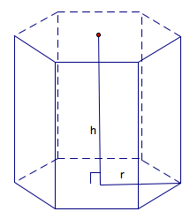 | BA = base area  LA = lateral area = perimeter base*h  h = height
Note: If the prism is rectangular then:
V =
Note: If the prism is a cube then:
SA = and V =
Right Pyramid with base regular polygon  SA = LA + BA  Volume = BA * h | 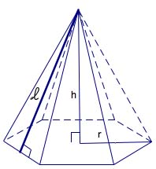 | BA = base area  LA=lateral area =  h = height  = slant height
Right Cylinder  Surface Area = 2 BA + LA  Volume = | 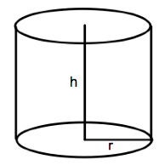 | BA = base area =  LA = lateral area =  r = radius of base  h = height
Right Cone  Surface Area = LA + BA  Volume = | 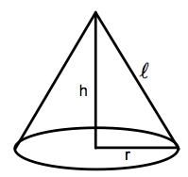 | BA = base area =  LA= lateral area =  r = radius  = slant height  h = height
Sphere  Surface Area =  Volume = | 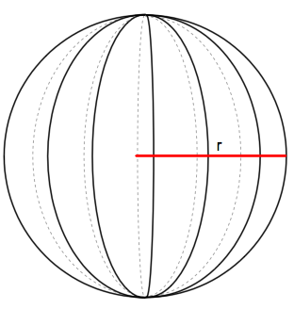 | r = radius
Organizing Learning (Down the Line)

Summary:
Students will investigate how the height and diameter of a cylinder affect the volume of the cylinder and develop the formula for finding the volume of a cylinder.

Outline:
- Students will measure height and diameter of each cylinder with a ruler (in cm) and record.
- Students will measure the amount of liquid each cylinder can hold using a graduated cylinder and record.
- Students will convert the volume in mL to the volume in cube centimeters.
- Knowing the volume of each cylinder, students will hypothesize how to calculate volume given the measurements for height and diameter.

Activity: Students will measure the height, diameter and radius of a cylinder. They will then fill the cylinder with water and predict how much water is in the cylinder. Next, they will pour the water into a graduated cylinder to measure the volume in mL. They will convert this measurement to cubic centimeters. Students will hypothesize and test methods using cylinder measurements to determine the volume.

Cylinder | Height | Diameter | Radius | Volume in mL | Calculated Volume
1
2
3
4
5

Understanding Learning (Down the Line)

Summary:
Students will write explanations of different methods of finding volumes of cylinder. Students will solve problems involving volume of cylinders given different parameters.

Outline:
- Formative assessment of volume of cylinders.
- Summative assessment of volume of cylinders.

Activity:

Formative Assessment
As students are engaged in the lesson ask these or similar questions:
- Were the students able to develop different methods for measuring volume of a cylinder?
- Can students explain the effects height and diameter of a cylinder have on it’s volume?
- Do students understand that 5 cubic centimeters = 5 ml?

Summative Assessment
Students can answer the following writing prompt:
Describe 2 different ways you can find the volume of a cylinder and how to use each method.

Students can answer problems finding the volume of a cylinder and real world applications for the volume of a cylinder relating to BD Medical. See attached file: M055_SHINE_Down_the_Line-U-assessment.doc

Attachments: M055_SHINE_Down_the_Line-U-assessment.doc

