Project SHINE / SPIRIT2.0 Lesson:
Surface Area…Who Needs It?
==========================Lesson Header ==========================
Lesson Title: Surface Area…Who Needs It?
This Teacher was mentored by:


www.behlenmfg.com

In partnership with Project SHINE grant funded through the

National Science Foundation

Draft Date: June 11, 2010
1st Author (Writer): Kay Strecker
Instructional Component Used: Surface Area and Volume
Grade Level: 7-8

Content (what is taught):
- Surface area of cylinder
- Volume of cylinder
- Volume conversion (cubic feet to gallons)

Context (how it is taught):
- Make a model of a round livestock tank
- Find surface area and volume of tank
- Change dimensions to maximize volume and minimize surface area
Activity Description:
Part of the cost of manufacturing an item is the cost of raw materials. The surface area of steel livestock tanks determines the amount of steel required for making the tank. Students will make a model of a small round livestock tank and calculate its surface area and volume (convert volume to gallons). Students will then determine the dimensions of a tank that has the lowest possible surface area for the given volume.

Standards:

Math: MC, MC4 (NE Math Standard 8.2.5.b)

Materials List:
- Farm supply catalogs
- Graph paper
- Tape
- Scissors
- Rulers
Asking Questions (Surface Area…Who Needs It?)

Summary: Determine parts (geometric shapes) needed to build a round livestock tank.

Outline:
- Students will consider what is needed to build a round livestock tank
- Students will consider non-traditional uses for a livestock tank

Activity: In small groups, students will discuss the questions below. Summarize the answers as an entire class.

Questions | Answers
How many pieces of steel would be needed to make a round livestock tank? | 2
What shape are the pieces? | Circular (bottom), rectangular (side)
What factors affect the cost of building the tank? | The amount of steel needed (surface area), the price of steel sheets, labor costs, etc.
How could you use a small livestock tank if you don’t have livestock? | Storage device in your garage, tub for ice and sodas for a picnic, bathtub for your dog, etc.
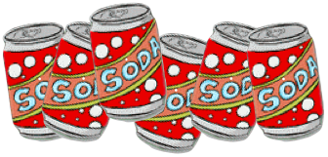

Exploring Concepts (Surface Area…Who Needs It?)

Summary: Students will build a scale model of a round livestock tank and calculate the surface area and volume of their tank.

Outline:
- Find the dimensions of a small round livestock tank in a farm supply catalog
- Identify shapes of steel pieces needed to create the tank
- Using graph paper, scissors, tape, rulers, make a model of the tank
- Calculate the surface area and volume of the tank

Activity: Students will use farm supply catalogs to determine the dimensions of a small round livestock tank. Students will draw a picture of the tank and label all necessary measurements. Then they will make a scale model of the tank using graph paper. Using formulas for area and volume, students should calculate the area and volume of their tank. Convert the volume from cubic feet to gallons (multiply by 7.48) to compare with gallons listed in the catalog.

Materials Needed:
- Farm supply catalogs
- Graph paper
- Scissors
- Tape
- Rulers

Instructing Concepts (Surface Area…Who Needs It?)

Surface Area and Volume of right solids with regular bases
Surface Area: The measure of how much exposed area a solid object has, expressed in square units.
Volume: How much three-dimensional space a shape occupies or contains, expressed in cubic units.

These formulas apply to right solids. If the solid is oblique it is much more difficult to find the SA and V. If the base is not regular these formulas apply but the LA is more difficult to find. You have to find the area of each face separately and add them together.
Right prism with base  regular polygon  Surface Area = LA + 2 BA  Volume = BA * h | 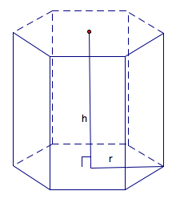 | BA = base area  LA = lateral area = perimeter base*h  h = height
Note: If the prism is rectangular then:
V =
Note: If the prism is a cube then:
SA = and V =
Right Pyramid with base regular polygon  SA = LA + BA  Volume = BA * h | 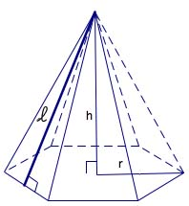 | BA = base area  LA=lateral area =  h = height  = slant height
Right Cylinder  Surface Area = 2 BA + LA  Volume = | 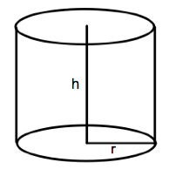 | BA = base area =  LA = lateral area =  r = radius of base  h = height
Right Cone  Surface Area = LA + BA  Volume = | 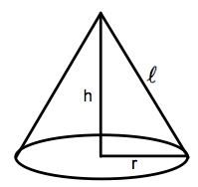 | BA = base area =  LA= lateral area =  r = radius  = slant height  h = height
Sphere  Surface Area =  Volume = | 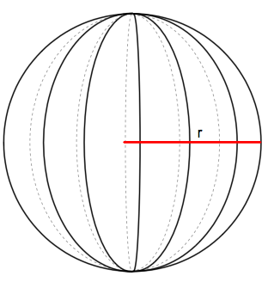 | r = radius
Organizing Learning (Surface Area…Who Needs It?)

Summary: The cost of building a livestock tank can be kept low by using the least amount of steel possible. Students will determine the dimensions of a round tank with the lowest possible surface area for a given volume.

Outline:
- Determine dimensions of a small round livestock tank.
- Sketch the tank, then calculate the surface area and volume of the tank. (to convert cubic feet to gallons, multiply by 7.48)
- Making a table to record results, change the dimensions of the tank, calculate the new surface area and volume.
- Determine which dimensions give the lowest surface area for the original volume of the tank.

Activity: Students will use farm supply catalogs to determine the dimensions of a small round livestock tank. Students will calculate the surface area and volume of the tank, then convert the volume to gallons. Next, students will organize the information in a table. Students will then change the diameter and/or height of the tank and recalculate the surface area and volume. Students should continue to change the diameter and/or height many times (approximately 10) until a reasonable sample of tanks have had the surface area and volume calculated. Finally, a determination will be made about which dimensions will give the lowest surface area without changing the volume.

Resources:
Farm supply catalogs and data table

DATA TABLE

Diameter | Height | Surface area | Volume (cubic units) | Volume (gallons)
Understanding Learning (Surface Area…Who Needs It?)

Summary: Students will complete a homework assignment where they will design a cylindrical container with the lowest possible surface area for a given volume.

Outline:
- Formative assessment of surface area and volume of cylinders
- Summative assessment of surface area and volume of cylinders

Activity:
Formative Assessment
As students are engaged in the lesson ask these or similar questions:
- What happens to the surface area and volume if you increase the height of the cylinder?
- What happens to the surface area and volume if you increase the radius of the cylinder?
- Are students able to make a model of a tank and find the surface area and volume?

Summative Assessment
Students can answer the following writing prompt:
Write a paragraph to describe how changing the diameter and height of a cylinder affects the cylinder’s surface area and volume.

Students will complete a homework assignment with questions similar to the following:
- Given pictures of cylinders, calculate the volume of the cylinders.
- Given pictures of cylinders, calculate the surface area of the cylinders.
- A wholesale food distributor needs to create 1-gallon cans for ketchup. They want to keep the cost of the can as low as possible. Determine the dimensions of a cylinder-shaped can that will hold one gallon (231 cubic inches) with the lowest possible surface area.
- If you decrease the diameter 1 foot (inch, cm) and increase the height 1 foot (inch, cm), what is the new surface area and volume?

