Project SHINE / SPIRIT2.0 Lesson:
This Teacher was mentored by:


www.behlenmfg.com

In partnership with Project SHINE grant funded through the

National Science Foundation

Cut It Out!
==========================Lesson Header ==========================
Lesson Title: Cut It Out!
Draft Date: June 14, 2010
1st Author (Writer): Kay Strecker
Instructional Component Used: Surface Area and Percent
Grade Level: 7-8

Content (what is taught):
- Surface Area of a complex solid
- Spatial relationships
- Percent of a number

Context (how it is taught):
- Calculate the surface area of an oblong round-end cattle tank
- Determine placement of the tank’s pieces on steel sheets to cut out the most pieces possible
- Determine what percent of the steel sheets are wasted
Activity Description:
Students will determine the shapes needed to make an oblong cattle tank. They will calculate the surface area of the tank. They will then determine how many tanks can be cut from sheets or rolls of steel and calculate the percent of steel that is wasted.

Standards:

Math: MC1, MC4, MA3

Materials List:
Polygon shaped tiles
Graph paper
Rulers
Farm supply catalogs
Play dough or cookie dough
Rolling pins or dowels
Cookie cutters

Asking Questions (Cut It Out!)

Summary: Students consider shapes that fit together with or without wasted space between them.

Outline:
- Students discuss in pairs
- Share answers with entire class

Activity: Students will be divided into groups and given a pile of polygon shaped tiles. They will work together to find what shapes will tile exactly without any space left between the tiles. They will also note what shapes don’t fit together exactly.

Questions | Answers
If you make a pan of brownies, what shape do you cut them in? Why? | Squares or rectangles because there would not be any wasted space between them.
What would happen if you cut the brownies into heart shapes for Valentines Day? | There would be wasted space between the hearts.
What shape would you use to get the most brownies per pan? Squares or hearts? | Squares
How could you figure out what percent of the brownies would be wasted if you cut them into heart shapes? | Estimate the area of the heart cookie (maybe draw it on graph paper and count squares) and multiply by the number of hearts that fit; find the area of the brownie pan; make a ratio of area of cookies to area of brownie pan then change to a percent.
Which shapes form a tessellation? Squares or hearts? | squares

Resources: Show students some pictures of repeating shapes like checkerboards, quilts, tessellations, etc. You can search for images at http://www.google.com/imghp?hl=en&tab=wi
Exploring Concepts (Cut It Out!)

Summary: Students explore filling a region with repeating shapes efficiently by cutting out cookies with cookie cutters.

Outline:
- Roll out cookie dough (or play dough) to a given thickness
- Cut out as many cookies as possible with one cookie cutter

Activity: Each student is given the same amount of cookie dough or play dough and a cookie cutter (all students should have the same size/shape cookie cutter). They are to roll the dough out into a given thickness (1/4 inch). Students then cut out as many cookies from their dough as possible. Determine the greatest number of cookies that were cut out. Discuss how the shape of the rolled dough affected the number of cookies. NOTE: A faster, less messy way to do this would be to see how many “cookies” students can trace on a sheet of paper.

Resources:
Materials list:
cookie dough or play dough
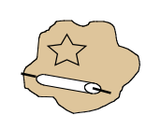
rolling pins or dowels
rulers
cookie cutters

Instructing Concepts (Cut It Out!)

Surface Area and Volume of right solids with regular bases
Surface Area: The measure of how much exposed area a solid object has, expressed in square units.
Volume: How much three-dimensional space a shape occupies or contains, expressed in cubic units.

These formulas apply to right solids. If the solid is oblique it is much more difficult to find the SA and V. If the base is not regular these formulas apply but the LA is more difficult to find. You have to find the area of each face separately and add them together.
Right prism with base  regular polygon  Surface Area = LA + 2 BA  Volume = BA * h | 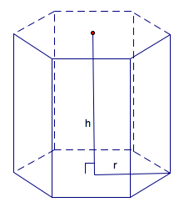 | BA = base area  LA = lateral area = perimeter base*h  h = height
Note: If the prism is rectangular then:
V =
Note: If the prism is a cube then:
SA = and V =
Right Pyramid with base regular polygon  SA = LA + BA  Volume = BA * h | 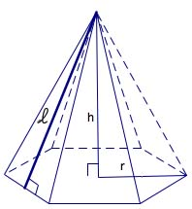 | BA = base area  LA=lateral area =  h = height  = slant height
Right Cylinder  Surface Area =  Volume = | 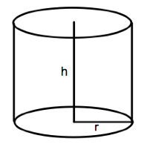 | r = radius of base  h = height
Right Cone  Surface Area =  Volume = | 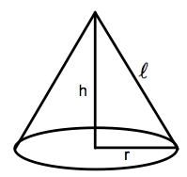 | r = radius  = slant height  h = height
Sphere  Surface Area =  Volume = | 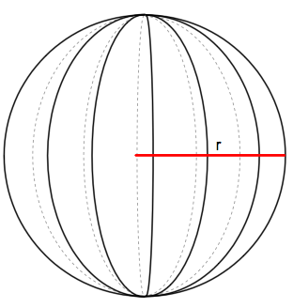 | r = radius
Organizing Learning (Cut It Out!)

Summary: Students will determine the most cost effective way to arrange the parts of a cattle tank on a sheet of steel.

Outline:
- Sketch the parts of the cattle tank
- Find the surface area of the cattle tank
- Using paper and pencil or technology, determine the arrangement of the parts on two different types of steel: 4’ by 8’ sheets and 2’ rolls
- Calculate the percent of the steel that would be wasted

Activity: Students will be given a picture of a cattle tank from a farm supply catalog. Using dimensions given in the catalog, students will sketch a scale drawing of the steel pieces needed to build the tank. Students will then calculate the surface area of the tank. Then students will sketch out how the pieces could be arranged on 4’ by 8’ sheets and on rolls of 2’ steel. For each arrangement, students will calculate the percent of wasted steel. To do this students will need to find the total surface area that students started with and then use the formula:

Percent waste

Resources:
Materials List:
Farm supply catalogs
Rulers
Graph paper

Understanding Learning (Cut It Out!)

Summary: Students will complete a homework assignment where they determine the surface area and percent waste created when making a log-cabin shaped aluminum can for maple syrup.

Outline:
- Formative assessment of surface area.
- Summative assessment of surface area.

Activity:

Formative Assessment
As students are engaged in the lesson ask these or similar questions:
- Could you arrange the pieces differently to use the material more efficiently?
- If the size or shape of the pieces was changed slightly, would they fit better?
- How can you change a ratio to a percent?

Summative Assessment
Students can answer the following writing prompt:
- Given a shape like a tank or a log cabin explain how you can find the surface area.
- If you are making a tank out of a flat sheet metal, how can you minimize the amount of waste? Your explanation must include surface area.

Students will complete a worksheet with a picture of a log-cabin shaped can for maple syrup. Detailed instructions and questions can be found in the attached file:
M057_SHINE_Cut_It_out-U-Assessment.doc

- Draw a picture of each face (side) of the can, labeling the measurements.
- Find the surface area of the can.
- Sketch out how to fit the pieces on a 1’ wide roll of aluminum.
- Calculate the percent of wasted aluminum for each can.
- Sketch out a different arrangement of the pieces and calculate the percent of waste. Which arrangement is a more efficient use of aluminum?

Resources:
Rulers
Graph paper

Attachments: M057_SHINE_Cut_It_out-U-Assessment.doc

