Project SHINE / SPIRIT2.0 Lesson:
This Teacher was mentored by:


www.nppd.com

In partnership with Project SHINE grant funded through the

National Science Foundation

From Playing with Electronics to Data Analysis
==========================Lesson Header ==========================
Lesson Title: From Playing with Electronics to Data Analysis
Draft Date: June 14, 2010
1st Author (Writer): Merlin Lahm
Associated Business: NPPD
Instructional Component Used: Best-Fit Curves
Grade Level: 9-12

Content (what is taught):
- Data collection
- Data analysis
- Creation of a direct square mathematical model

Context (how it is taught):
- Data collection from an electronic circuit
- Create a stat plot on a graphing calculator
- Algebraic manipulation of the data points, resulting in a mathematical model
- Perform quadratic regression on a graphing calculator
Activity Description:
In this lesson, small groups of students will be supplied a breadboard, a DC power supply that can contain one to four batteries, and a resistor. All groups will have a resistor rated at the same number of Ohms. The students will create a simple circuit containing one resistor. Students will use a multimeter to measure the current in the circuit when the battery supply contains one, two, three, and four batteries. Students will record the reading, find the product of voltage and current (this is power, P = VI), and record their findings with the current as the independent variable and power as the dependent variable. Each student in the group will store the data points in the stat mode of a graphing calculator, change the window as needed, and plot the data on the calculator. Students should recognize the resulting graph as one that may occur from a direct square variation. Groups will create a direct square model from their data and groups will compare their results. The constant of variation students have found should be equal to the Ohm rating of the resistor in the circuit. Each student will then perform a quadratic regression with the original data points and compare the result to the model they have developed. The instructor will explain how, with substitution, V = IR and P = IV combine to yield P = I²R, a direct square variation.

Standards:

Science: SE2 Technology: TA3, TB4, TC2, TC4, TF1, TF2, TF4

Engineering: EA1, EA2, EB1, EB5, EC1 Math: MA3, MB1, MB2, MB3, MC2, MD1, MD2,

ME1, ME2, ME3
Materials List:
Breadboard Batteries Battery connection
Resistors Multimeter Calculator
Asking Questions: (From Playing with Electronics to Data Analysis)

Summary: Students identify the quantity a multimeter displays when determining current in a circuit. Students have a very basic understanding of how the current exists.

Outline:
- Create a simple circuit
- Measure the current with a multimeter

Activity: The teacher demonstrates how to insert battery supply wires and resistors into a breadboard and how to measure current with a multimeter. Ask the following questions:

Questions | Answers
What do you know about electricity? | Electrons move over a conductor establishing a current
How is current measured? | amps
How is potential difference measured? | volts
What is resistance, and how is it measured? | ohms
How do all these measurements relate? | V = IR and P = VI. We will discover the relationship P = I²R in this activity.

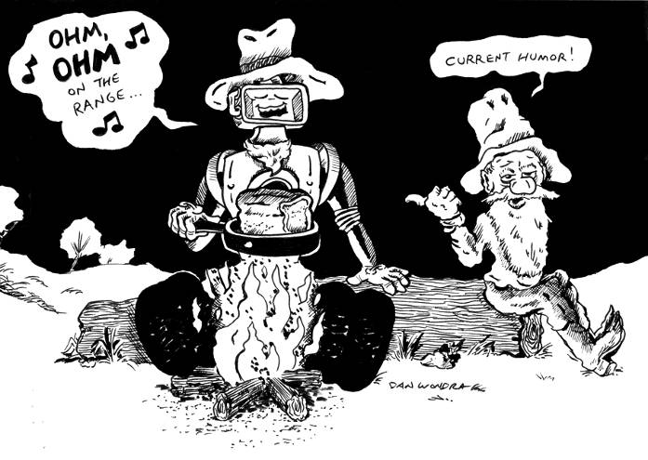
000
Exploring Concepts: (From Playing with Electronics to Data Analysis)

Summary: Students will create a simple circuit containing one resistor and measure the current in the circuit with a power supply of 1.5, 3, 4.5, and 6 volts. Students will record current for each voltage and multiply voltage and current to fill a third column. The result will be a table with current as the independent variable and power as the dependent variable.

Outline:
- Create a simple circuit containing one resistor and a battery supply with one to four 1.5 V batteries
- Measure and record several data points with current as the independent variable and power as the dependent variable

Activity: Students will create a circuit with voltage supply that can be changed from one to four 1.5 V batteries, insert a resistor, record the resulting current, multiply voltage and current, and record current as the independent variable and the resulting power as the dependent variable.

V  Voltage  (V) | I  Current  (A) | P = VI
1.5
3
4.5
6
Instructing Concepts: (From Playing with Electronics to Data Analysis)

Data Analysis/Modeling Data by Best-Fit Curves

The process of modeling data is essential for any field of study where data has been collected over time and predictions are desired about future behavior. The process involves identifying a trend that is present and making a prediction based on that trend. This process consists of four parts: 1) graphing a scatterplot of the data, 2) analyzing the data for a trend, 3) creating a function model that fits the trend, and 4) making credible predictions based on the model, assuming the trend continues.

Scatterplots
The first step is to graph a scatterplot of the data. This can be done by hand or by using a graphing utility. If you are doing it by hand, scales for the x (independent) variable and the y (dependent) variable will need to be chosen so that the data is spread out enough to make the trend recognizable.

Analyzing the data for a trend
After creating the scatterplot it is necessary to analyze the data for trends that are present. These trends can be as simple as a line (linear regression) or more complex such as a polynomial (quadratic, cubic, etc.), sinusoidal, power or any other function that looks like the trend present. The closer the data resembles the function you want to use to model it the better your predictions should be. The measure of how closely the function will model the data is called the correlation coefficient (r). Correlation is a number that ranges between – 1 and + 1. The closer r is to +1 or – 1, the more closely the variables are related. If r = 0 then there is no relation present between the variables. If r is positive, it means that as one variable increases the other increases. If r is negative, it means that as one variable increases the other decreases. Correlation is very hard to calculate by hand and is usually found using the aide of a graphing utility.

Creating a function model
After deciding on a function that models the trend present it is necessary to create an equation that can be used to make future predictions. The easiest model to create is a linear regression if the trend present is linear. To do this you first draw a line that comes as close to splitting the data while at the same time having all the data points are as close to the line you are drawing as possible. There will be a kind of balance to the line within that data plot that should split the data evenly and follow the same linear trend. If the trend that is present in the data is stronger, then it will be easier to draw your line. After drawing the line, you can calculate the equation by estimating two points on the line. Using these two points, calculate slope and the y-intercept and write the equation. Regression models can be found more precisely using graphing utilities. Anything other than a linear regression is very difficult to find by hand.

Making predictions using the model
After the model is found it is easy to use it to make predictions about future events assuming the trend continues. You can simply plug in for either the x or y variable and solve for the other. This will create a predicted data point that can be used to base future decisions on. If the correlation is high, meaning the trend is strong; the predictions should be fairly accurate.
Organizing Learning: (From Playing with Electronics to Data Analysis)

Summary: Students will record in an x-y table the current (x) and the corresponding power (y). Students will plot the data points on a graphing calculator. NOTE: Be sure to have some mechanism for students to describe direct square variation as part of the organizing, particularly as it relates to P = I²R. Students will identify the relationship between current and power as a direct square variation and calculate the constant of variation. The constant of variation should be the Ohm rating of the resistor used in the circuit. Students will perform quadratic regression on the calculator and compare the resulting equation to the model P = I²R they had calculated by hand.

Outline:
- Record the data points in a table with current as the independent variable and power as the dependent variable.
- Store and graph the data points on a graphing calculator.
- Identify the relationship as a direct square variation based on the shape of the graph.
- Create a direct square model by calculating the constant of variation (resistance) and test the model on all four data points.
- Perform a quadratic regression on the four data points and compare it to the direct square model found earlier.
- As a group, conclude that P = I²R.

Activity: Previously, small groups of students have been supplied a resistor and the materials with which to create a simple circuit with a power supply that contains from one to four 1.5 V batteries. They created a circuit containing one resistor, a variable power supply of different voltages and used a multimeter to measure the current in the circuit. The data was recorded with the current as the independent variable and the product of voltage and current (power) as the dependent variable.

Each student in the group will store the data in a graphing calculator and create a scatterplot. From the graph students have created, they will identify the relationship between current and power as a direct square variation. Students will develop a model for the data and test it on all data points. Groups will compare their results. The constant of variation should be the Ohm rating of the resistor in the circuit. Each student will perform a quadratic regression and compare the result to the direct square model produced earlier. Students will predict the outcome for a new resistance, and test their prediction with a new resistor. The instructor will explain that, with substitution, V = IR and P = IV can be combined to P = I²R.
Understanding Learning: (From Playing with Electronics to Data Analysis)

Summary: Students are able to store data in the stat mode of a graphing calculator, change the window as needed, and create a scatterplot of the data on the calculator. Students are able to perform regressions on stored data points to develop models.

Outline:
- Formative assessment of data analysis/modeling data by best-fit curves
- Summative assessment of data analysis/modeling data by best-fit curves

Activity:
Formative Assessment
As students are engaged in the lesson ask these or similar questions:
- How do you store data on the calculator?
- What window would be appropriate for this data set?
- How does one select a stat plot? Which one produces a scatterplot of data?
- What button sequence produces a quadratic regression?

Summative Assessment
Students will write a short summary of the lab and what they have learned. Students will also answer assessment questions.
- Store the following data (given by teacher) on a graphing calculator, produce a scatterplot on the calculator, and sketch the result.
- Store the following data (given by teacher) on a graphing calculator and create a quadratic model.
- Identify the relationship described by the graph as direct or inverse.

Performance Assessment
Using the same resistor setup, students will predict what a 7.5 V or 9 V batteries power should be using the calculated model. NOTE: Students will have to use the equation V = IR to calculate the current (I) which the can then plug into the model. After doing the calculation, students can test their prediction by actually changing the voltage.

