Project SHINE / SPIRIT2.0 Lesson:
This Teacher was mentored by:

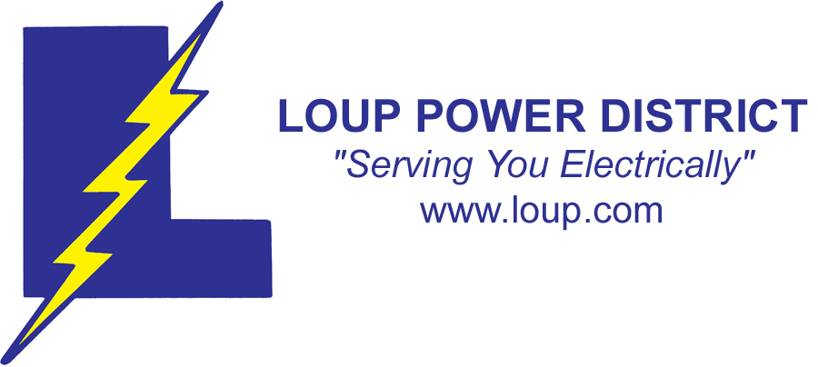
www.loup.com

and


www.nppd.com

In partnership with Project SHINE grant funded through the

National Science Foundation

String of Lights
==========================Lesson Header ==========================
Lesson Title: String of Lights
Draft Date: June 17, 2010
1st Author (Writer): Trina Hellbusch
Associated Business: Loup Power District & NPPD
Instructional Component Used: Data Analysis
Grade Level: 7th and 8th grade

Content (what is taught):
- Analyzing Data
- Comparing Data

Context (how it is taught):
- Identify holiday light sets and types of bulbs used in them
- Identify the affect the use of lights has on a monthly electrical bill
- Compare and record the watts used by LED and incandescent light sets
- Use the information gathered to determine the cost to display holiday lights on a home
Activity Description:
This lesson would teach data analysis by involving students in the activity of thinking about electricity and the cost related to an electrical bill for hanging holiday lights. The students would then identify types of bulbs used for light sets and compare a set of LED and incandescent string of lights recording the data. They would then calculate the cost in KWh to hang the lights and decided how they would hang the lights in/on their home and what it would cost to display them based upon their data and number of light sets used.

Standards:

Engineering: E1, E2, E3

Materials List:
- Kill A Watt Meter
- LED light set
- Incandescent light set
- Camera (optional)
Asking Questions: String of Lights

Summary: Students will think about the cost of electricity and how holiday lights affect the electric bill.

Outline:
- Students will identify that you pay for Kilowatt-hours in a home and added usage of holiday lights affect the usage.
- Students will understand that there are a variety of types of bulbs used in holiday lights and some may be more efficient.

Activity: The teacher will help students understand that most homes use and pay for electricity. Holiday lights affect the usage of electricity based upon the types and amount of lights that are displayed. Thoughts about different types of lighting possibilities will be discussed.

Questions | Answers
How many of you hang up holiday lights? | Most students home will have holiday lights indoors or outdoors.
How do holiday lights and electrical bills relate? | Your electrical bills would increase when lights are plugged in.
Is there a difference in the types of holiday lights and bulbs displayed? | Most students would have knowledge of a variety of types of bulbs in holiday light sets. They may identify LED, fluorescent, neon and incandescent bulbs.
When using a specific type of bulb, would this impact your electrical bill differently? | Students would say that it may or may not.

Attachments:
Sample NPPD Statement: http://www.nppd.com/My_Account/Additional_Files/read_bill.asp
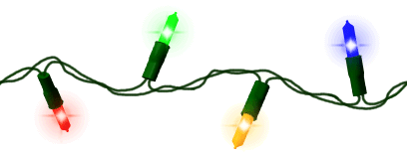

Exploring Concepts: String of Lights

Summary: Students will research efficiency of different types of holiday light bulbs. They will select two strings with different types (LED and incandescent) of bulbs and test and compare the watts used each by each string. With this data, students will decide which type of light that they will use in a display they are going to design.

Outline:
- Students will research the types of bulbs and decide as a groups two types of common holiday light sets to test for efficiency.
- Students will record the watt usage of two different bulb sets of holiday lights using a kilowatt meter.
- With this information, students will decide which type of lights to use for display based on efficiency.

Activity: In this lesson, students will research the cost associated with different types of holiday lights (LED and incandescent). Next, they will then calculate the watts used by each string of lights using a kilowatt meter. Finally, using the efficiency of each light set, students will determine which type they would use at their home in a design that they are going to create. Students will research the types of bulbs used in Holiday light bulbs on Wikipedia http://www.wikipedia.org/ to gain a better understanding of each bulb type.

Resources:
Wikipedia: http://www.wikipedia.org/

Sample NPPD Statement: http://www.nppd.com/My_Account/Additional_Files/read_bill.asp
Instructing Concepts: String of Lights

Data Analysis

Data analysis is the process of collecting, analyzing, modeling data, and making predictions. The reasons for this process are many but typically the most important are: 1) to find useful information, 2) to make predictions about possible outcomes, and 3) to support and provide evidence for the decision making process.

Data Collection
The process can start with the collection of data using any number of strategies. The data collection might take the form of an experiment where you conduct trials in which you measure the effect of one variable on another by controlling all other possible variables. The collection might be a survey of something by sampling to gather information. It is important that the survey be unbiased, random, and representative of the group you are sampling. Data can be present without going out to collect something new. In the business world it could be historic sales, production, or costs. In academia it can be test scores. In engineering, data is collected on production processes, historical usage or environmental factors, and stress or strength measurements. Data is everywhere and often the problem is not finding data but limiting it to what you are looking to study.

Data Analysis
The analysis of the data that was collected is a critical step. Here you are carefully looking at the data that was collected. It could be in a spreadsheet or other computer application that can organize the data. You probably will want to graph the data because trends are easier to see from a picture. This step is really about identifying trends that might be present. It is possible that there isn’t a strong trend present in the data. If there is not a trend it is not necessarily bad. It just means that the variables are not related.

Mathematical Modeling
Modeling the data that was collected and analyzed is where the mathematics occurs in this process. You can use a graphing calculator, computer spreadsheet or other specialized computer application to generate an equation that represents the data. These uses of technology will also provide statistical measurements like variance and correlation that can help you understand the effectiveness of your equation (model).

Reporting
The final step in this process is to report the data and model that represent it and to make predictions using the model to support decisions. If you have a model that statistically represents the data accurately it should be possible to make fairly reliable predictions. You can present the results in printed form, graphically, or a combination of both. You can show your prediction by showing an extrapolation using your model and present that information as support for a decision. You need to be cautioned that any predictions that are made are only that, a prediction. If the trend changes, your prediction will not be correct. The process of data analysis is a tool to make an educated guess about the future not a guarantee that your prediction will come true.
Organizing Learning: String of Lights

Summary: Students will design a lighting display for their home and will figure out how many strings they will need. Next, they will calculate the cost to power the display they designed for one hour. Students will calculate the total cost to purchase the light sets and display them for the holiday season. They could bring in a drawing of picture of their light display.

Outline:
- As a class, identify how many days and hours per day that the display will be used.
- Students will design a display for their home calculating how many light sets will be needed to create the display.
- Students will identify the rate used in their area for electrical use and determine the cost to display each set of lights for an hour.
- Students will calculate the total cost to purchase the lights needed and the cost to power their lights for the decided amount of time/days based on the rates for KWh.
- Students will draw or photograph their display.

Activity: In this lesson, students will design a lighting scheme for their home and will record the type of light, the cost of the lights and the number of strings that their design will require. The class will decide as a group how many hours/days the lights will be turned on. After the design is completed, the cost associated with running the display for one hour will be calculated. A resource for the cost of electricity is your local power company. Next, students will calculate and record the cost associated with running the display (including the cost of the actual strings of lights) for the time determined by the class. Finally, students will turn in a picture/drawing of their design along with the data.

Type  of  Light | Cost  of  Light | Number  of  Strings | Electricity Used  (1 hour) | Cost of Electricity (per hour) | Cost Associated With Display

Resources:
Sample NPPD Statement: http://www.nppd.com/My_Account/Additional_Files/read_bill.asp
Understanding Learning: String of Lights

Summary: Students will complete a formative and summative assessment on data analysis.

Outline:
- Formative assessment of data analysis
- Summative assessment of data analysis

Activity: Students will write about their experience relating it to data analysis.

Formative Assessment
As students are engaged in the lesson ask these or similar questions:
- Were the students able to calculate watts used and cost per KWh for a string of lights?
- Were the students able to design a display for their home and keep track of light sets used based on measurement?
- Are students able to calculate the total cost to purchase the lights for their home display?
- Are students able to calculate the cost to power their display for a determined amount of hours and days?
- Are students able understand and explain the change seen in an electrical bill during this said time?

Summative Assessment
Students can answer the following writing prompt:
Explain the data you collected, how it was collected, and the decision you arrived at based on the analysis of the data.

Students will complete one of the following assessments to apply their knowledge further.
- Students could take a photo or sketch of a light display in their area and estimate the usage cost using data analysis.
- Students could calculate the cost for their display if they would have used the less efficient bulb set or combination of both.
- Students could investigate how to limit the time their display is on and recalculate the cost identifying the advantage to the overall usage/billing of KWh, comparing this with the initial.
- Write a summary of each aspect of the activity and identify the impact the activity has on lighting decisions during the holiday season for yourself and when viewing displays of others. You must justify using the data and decisions that you arrived at using the data.

