Project SHINE / SPIRIT2.0 Lesson:
Troublesome Towers
==========================Lesson Header ==========================
Lesson Title: Troublesome Towers
These Teachers were mentored by:

www.katana-summit.com

In partnership with Project SHINE grant funded through the

National Science Foundation

Draft Date: 6-15-10
1st Author (Writer): Cherrie Cummings and Terri Jelinek
2nd Author (Editor/Resource Finder): Katana Summit
Instructional Component Used: Surface Area of a Cone
Grade Level: 9-11

Content (what is taught):
- Surface Area of a Cone

Context (how it is taught):
- Review sector area formula
- Dimensions of a cone are identified and recorded
- Cone is cut and flattened to form a sector
- Students hypothesize how to calculate the lateral surface area of a cone
Activity Description:
Students will measure the radius and slant height of a conical object (paper cone). They will then cut the cone along its slant height and flatten it to form a sector. Next, they will calculate the area of the sector and use their method to hypothesize the formula for the lateral surface area of a cone.

Standards:

Science: SA1 Technology: TD3

Engineering: ED1, ED2 Math: MC1, MD1

Materials List:
- Rulers
- Scissors
- Paper cones
Asking Questions: (Troublesome Towers)

Summary: Students determine what properties make a cone unique. Katana Summit in Columbus, Nebraska, produces large towers used for wind turbines. In order to calculate the amount of paint and protective coating needed, they would need to know the surface area of the conical shaped tower.

Outline:
- Have students compare a cone to a pyramid and cylinder
- The similarities and differences will be recorded in a Venn diagram

Activity: The teacher will distribute models of pyramids, cones, and cylinders. Students can make a Venn diagram comparing the three figures. As students begin to compare and contrast these figures, ask the following questions:

Questions | Answers
What properties do all three have in common? | They all have height, all are 3-D, all have at least one base
What do cones and cylinders have in common? | At least one circular base, 3-D, both have a height
What do pyramids and cones have in common? | Each have one base, 3-D, both have a height and slant height, both have a vertex

Pyramid
Cylinder
Cone

Exploring Concepts: (Troublesome Towers)

Summary: Students will investigate ways of finding the lateral surface area of a cone.

Outline:
- Students will be given different sized conical party hats and paper cups.
- Students will work in small groups to discuss ways they could find the lateral surface area of each cone.

Activity: In this lesson, students will be given different sized conical party hats and paper cups. They will work in small groups to discuss ways they could find the lateral surface area of each cone. Guiding questions the teacher could ask are:
  - What are parts of a cone that could be measured?
  - What parts would affect the lateral surface area of a cone?
  - How do you think these cones were made?
  - Did the cones start out three-dimensional?
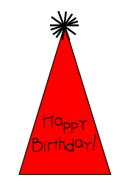

Instructing Concepts: (Troublesome Towers)

Surface Area and Volume of Right Solids with Regular Bases
Surface Area: The measure of how much exposed area a solid object has, expressed in square units.
Volume: How much three-dimensional space a shape occupies or contains, expressed in cubic units.

These formulas apply to right solids. If the solid is oblique it is much more difficult to find the SA and V. If the base is not regular these formulas apply but the LA is more difficult to find. You have to find the area of each face separately and add them together.
Right prism with base  regular polygon  Surface Area = LA + 2 BA  Volume = BA * h | 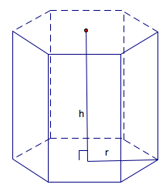 | BA = base area  LA = lateral area = perimeter base*h  h = height
Note: If the prism is rectangular then:
V =
Note: If the prism is a cube then:
SA = and V =
Right Pyramid with base regular polygon  SA = LA + BA  Volume = BA * h | 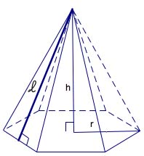 | BA = base area  LA=lateral area =  h = height  = slant height
Right Cylinder  Surface Area = 2 BA + LA  Volume = | 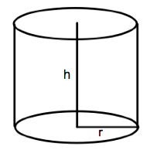 | BA = base area =  LA = lateral area =  r = radius of base  h = height
Right Cone  Surface Area = LA + BA  Volume = | 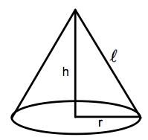 | BA = base area =  LA= lateral area =  r = radius  = slant height  h = height
Sphere  Surface Area =  Volume = | 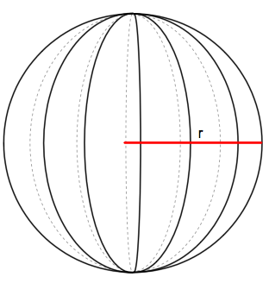 | r = radius
Organizing Learning: (Troublesome Towers)

Summary: Students will investigate how the formula for the area of a sector can be used to create the formula for surface area of a cone.

Outline:
- Students will draw and measure the slant height of a cone.
- Students will trace the base on a piece of paper and use folds to find the center.
- Students will measure the radius of the base and find the circumference.
- Students will cut the cone along the slant height and lay it flat to form a sector.
- Students will lay the sector on a larger piece of paper and use a compass to complete the circle using the slant height as the radius of the circle.
- Students will use the area of the circle formula and determine what fraction of the circle makes up the sector by using circumference of the entire circle and circumference of the original cone.

Activity: Students will draw and measure the slant height of a paper cone. They will trace the base on a piece of paper and use folds to find the center (patty paper would work well). Using this traced circle, students can measure the radius and find the circumference of the base of the cone. Next, students will cut the cone along the slant height and lay it flat to form a sector. They will then lay the sector on a larger piece of paper and use a compass to complete the circle using the slant height of the cone as a the radius of the circle. Students will calculate the area of the large circle. The teacher will review that you find area of a sector by finding the area of a circle and multiplying it by the fraction of the circle that the sector occupies. This fraction will be found by using the circumference of the large circle as the denominator and the circumference of the base of the cone as the numerator (arc length of the sector). Students will then calculate the area of the sector. Students will analyze the process to hypothesize the formula for lateral surface area of a cone. Guiding questions for the teacher:
  - What is the area of the large circle?
Answer: l²π (slant height squared times π)
  - What is the circumference of the large circle?
Answer: 2lπ
  - What is the circumference of the base of the cone?
Answer: 2rπ
  - What could we compare to find what fraction of the circle the sector occupies?
Answer: Circumference of each circle
  - How would you calculate the fraction?
Answer: Circumference of base divided by circumference of the large circle
  - Once you know the fraction of the circle, how do you calculate the area of the sector?
Answer:
  - Can we simplify this expression?
Answer: πrl
Understanding Learning: (Troublesome Towers)

Summary: Students will write an explanation of the process used to develop the formula for the lateral surface area of a cone. Students will also solve problems involving lateral and total surface area of a cone.

Outline:
- Formative assessment surface area (cone)
- Summative assessment surface area (cone)

Activity: Students will write about finding the surface area of a cone and perform calculations related to surface area of a cone and its applications.

Formative Assessment
As students are engaged in the lesson ask these or similar questions:
- Were students able to transfer their understanding of sector area to find the surface area of a cone?
- Can students explain the fractional part of the large circle used in developing the formula?

Summative Assessment
Students can answer the following writing prompt:
Explain how you can find the surface area of a cone. Be sure to include what measurements must be known and how you found the formula for the lateral area.

Students can answer problems finding the surface area of a cone and real world applications for the surface area of a cone relating to BD Medical. See attached file:
M062_SHINE_Troublesome_Towers.doc-U-Assess.doc

Attachments:
M062_SHINE_Troublesome_Towers.doc-U-Assess.doc
