Project SHINE / SPIRIT2.0 Lesson:
These Teachers were mentored by:


www.bd.com

In partnership with Project SHINE grant funded through the

National Science Foundation

Box It Up
==========================Lesson Header ==========================
Lesson Title: Box It Up
Draft Date: 6-14-10
1st Author (Writer): Cherrie Cummings and Terri Jelinek
2nd Author (Business Partner): BD Medical Surgical Systems
Instructional Component Used: Surface Area of Rectangular Prisms
Grade Level: 7-10

Content (what is taught):
- Surface area of a rectangular prism

Context (how it is taught):
- Dimensions of various rectangular prisms are identified and recorded
- Students develop ways to calculate surface area of a rectangular prism
- Students hypothesize how to calculate surface area using dimensions of rectangular prism
Activity Description:
Students will measure the length, height, and width of various sizes of boxes of facial tissue and cereal. They will then unfold or cut the box to lay it flat. Students will draw on previous knowledge of finding the surface area of a two-dimensional figure to find the area of the “net” of the box of tissue or cereal. Students will then hypothesize and test methods using the prism measurements to determine the formula for surface area.

Standards:

Science: SA1 Technology: TD3

Engineering: ED1, ED2 Math: MC1, MD1

Materials List:
- Boxes of facial tissue
- Boxes of cereal
- Ruler
- Meter stick
Asking Questions: (Box It Up)

Summary: Students discuss how much cardboard is needed to make boxes. BD Medical Surgical Systems in Columbus, Nebraska, produces medical supplies that are shipped across the world. These products are packaged in cardboard boxes. Due to the variety of products they produce, various sizes of cardboard boxes are needed. This requires an understanding of how boxes are assembled and how this affects surface area of the cardboard needed to create the box.

Outline:
- Teacher holds up different boxes and have students discuss which box would require the most cardboard

Activity:
The teacher will hold up different sizes of boxes and ask the following questions:

Questions | Answers
Which box would require the most cardboard to make? | Answers vary depending on box sizes
What factors would impact how much cardboard you need? | The length, height, and width of the rectangular prism.
What do companies consider when they are determining the dimensions of the boxes? | Cabinet space, ease of use, volume of product inside, etc.

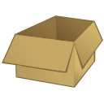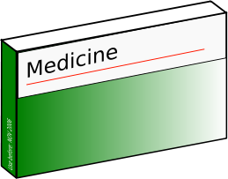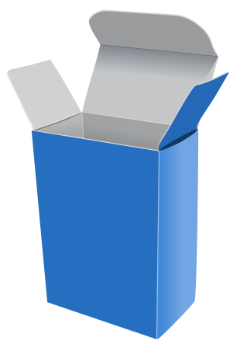

Exploring Concepts: (Box It Up)

Summary: Students will work in small groups to determine methods of calculating the surface area of various rectangular prisms. For example: facial tissue box, cereal box, etc.

Outline:
- Students list various ways of finding surface area of a rectangular prism
- Students will share ideas on their list
- The concept of a net will be introduced

Activity:
In this lesson students will work in groups to discuss various ways of finding surface area of a rectangular prism. They will share their ideas as a class and make a class list. The teacher may want to guide the students into the idea of a “net” and explain what a net is.

Instructing Concepts: (Box It Up)

Surface Area and Volume of Right Solids with Regular Bases

Surface Area: The measure of how much exposed area a solid object has, expressed in square units.
Volume: How much three-dimensional space a shape occupies or contains, expressed in cubic units.

These formulas apply to right solids. If the solid is oblique it is much more difficult to find the SA and V. If the base is not regular these formulas apply but the LA is more difficult to find. You have to find the area of each face separately and add them together.
Right prism with base  regular polygon  Surface Area = LA + 2 BA  Volume = BA * h | 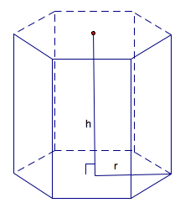 | BA = base area  LA = lateral area = perimeter base*h  h = height
Note: If the prism is rectangular then:
V =
Note: If the prism is a cube then:
SA = and V =
Right Pyramid with base regular polygon  SA = LA + BA  Volume = BA * h | 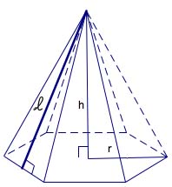 | BA = base area  LA=lateral area =  h = height  = slant height
Right Cylinder  Surface Area = 2 BA + LA  Volume = | 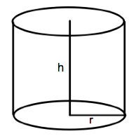 | BA = base area =  LA = lateral area =  r = radius of base  h = height
Right Cone  Surface Area = LA + BA  Volume = | 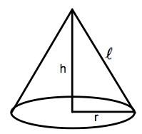 | BA = base area =  LA= lateral area =  r = radius  = slant height  h = height
Sphere  Surface Area =  Volume = | 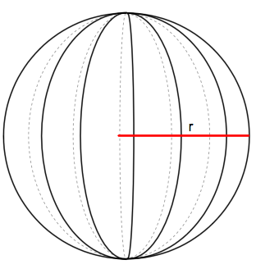 | r = radius
Organizing Learning: (Box It Up)

Summary: Students will investigate how the length, width, and height of a rectangular prism affect the surface area of the prism and develop the formula for find the surface area.

Outline:
- Students will measure the length, width, and height of each rectangular prism and record
- Students will unfold, or cut each box to make a “net” of the prism
- Students will use prior knowledge of calculating area of rectangles to find the area of the net
- Students will hypothesize how to calculate the surface area given the measurements of length, width, and height

Activity: Teacher will split students into groups of four. Each student should have a rectangular prism, therefore the group will measure a total of four prisms. Students will measure the length, width, and height of various rectangular prisms. They will then cut or unfold the prisms and use formulas for calculating area of rectangles to find the area of the net of each prism. Next, they will hypothesize and test methods using the dimensions of the prism to calculate the total surface area.

Prism | Sketch | Length | Width | Height | Net Area
1

2

3

4

Understanding Learning: (Box It Up)

Summary: Students will write an explanation of why the formula for surface area of a prism works. Students will solve problems involving surface area of rectangular prism given different parameters.

Outline:
- Formative assessment of surface area (prisms)
- Summative assessment of surface area (prisms)

Activity: Students will write about finding the surface area of a right prism and perform calculations related to surface area of a right prism and its applications.

Formative Assessment
As students are engaged in the lesson ask these or similar questions:
- Were the students able to use the formulas for finding area of two-dimensional figures to help them find the area of a three-dimensional figure?
- Were students able to explain the relationship between the area of the net and the surface area of the prism?
- Can students explain the effects of length, width, and height on surface area?

Summative Assessment
Students can answer the following writing prompt:
Explain how you can find the surface area of a right prism and what the “net” of a prism looks like.
Students can answer problems finding the surface area of a right prism and real world applications for the surface area of a right prism relating to BD Medical. See attached file:
M063_SHINE_Box_It_Up-U-assess.doc

Attachments:
Box It Up Assessment: M063_SHINE_Box_It_Up-U-assess.doc
