Project SHINE / SPIRIT2.0 Lesson:
Katana Summit – Towers of Steel
==========================Lesson Header ==========================
Lesson Title: Katana Summit – Towers of Steel
These Teachers were mentored by:

www.katana-summit.com

In partnership with Project SHINE grant funded through the

National Science Foundation

Draft Date: 7-7-10
1st Author (Writer): Cherrie Cummings and Terri Jelinek
2nd Author (Editor/Resource Finder): Katana Summit
Instructional Component Used: Volume of Cones & Pyramids
Grade Level: 9-11

Content (what is taught):
- Volume of a Cone & Pyramid

Context (how it is taught):
- Review volume of prism and cylinder
- Dimensions of a cone are identified and recorded
- Cones, cylinders, prisms and pyramids are filled and analyzed
- Students hypothesize how to calculate the volume of a cones & pyramids
Activity Description:
Students will measure the radius and height of cylinders and cones and the sides and height of pyramids and prisms. They will then calculate the volume of the cylinders and prisms in cubic centimeters. Students will fill a cone with the same radius and height with water and measure its volume in milliliters. Students will do the same with prisms and pyramids with the same base area and heights and compare them. They will use their data to hypothesize how to calculate volume of cones and pyramids. NOTE: It is essential for cones-cylinders and pyramids-prisms to have congruent bases and equal heights.

Standards:

Science: SA1 Technology: TD3

Engineering: ED1, ED2 Math: MC1, MD1

Materials List:
- Rulers
- Plastic models of cylinders, cones, prisms and pyramids
- Water
Asking Questions: (Katana Summit – Towers of Steel)

Summary: Students compare cones to cylinders and pyramids to prisms. Katana Summit in Columbus, Nebraska, produces large towers used for wind turbines. Once the towers are produced, trucks transport them to the wind farm. Due to the unusually large size and weight of the towers, special accommodations must be made. Weight of the towers is calculated based on the volume of the tower.

Outline:
- Have students compare cones to cylinders and pyramids to prisms
- Similarities and differences will be recorded

Activity: The teacher will distribute models of pyramids, cones, cylinders and prisms. Students will compare and contrast pyramids and prisms and cones and cylinders.

Questions | Answers
How are cones and cylinders alike? | They both have circular bases and height, both are 3-D
How are cones and cylinders different? | Cones come to a point at the top, cones have one base and cylinders have two
How are prisms and pyramids alike? | Both have a polygon base, both are 3-D, both have a height
How are prisms and pyramids different? | Pyramids have one base and prisms have two, pyramids come to a point at the top
How are cones and pyramids alike? | Both have one base and come to a point at the top, both are 3-D, both have a slant height and an altitude
How are cones and pyramids different? | Cones have a circular base and pyramids have a polygonal base
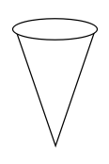

Exploring Concepts: (Katana Summit – Towers of Steel)

Summary: Students will investigate ways of finding the volume of a cone and predict the relationship between the volume of cone and a cylinder with the same base area and height. They will also predict the relationship between the volume of prisms and pyramids with the same base area and height.

Outline:
- Students will be given plastic models of cones, cylinders, prisms and pyramids and work in groups to discuss ways to find the volume of the cones and pyramids.
- Students will hypothesize how they might use the volume of a prism or cylinder to find the volume of a cone or pyramid with the same base area and height.

Activity: In this lesson, students will be given different sized cylinders, cones, prisms and pyramids and asked to hypothesize methods of finding volume of cones and pyramids. Students should also hypothesize about how the volume of a cone and cylinder of the same radius and height are related and how the volume of a pyramid and prism with the same base and height related.
Guiding questions the teacher could ask are:
- What are parts of a cone that could be measured?
- What parts of a pyramid can be measured?
- What could you do to find the volume of a cone?
- What could you do to find the volume of a pyramid?
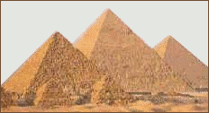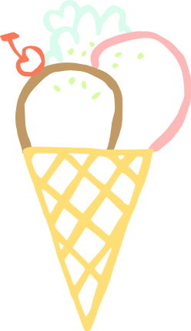
Instructing Concepts: (Katana Summit – Towers of Steel)

Surface Area and Volume of Right Solids with Regular Bases
Surface Area: The measure of how much exposed area a solid object has, expressed in square units.
Volume: How much three-dimensional space a shape occupies or contains, expressed in cubic units.

These formulas apply to right solids. If the solid is oblique it is much more difficult to find the SA and V. If the base is not regular these formulas apply but the LA is more difficult to find. You have to find the area of each face separately and add them together.
Right prism with base  regular polygon  Surface Area = LA + 2 BA  Volume = BA * h | 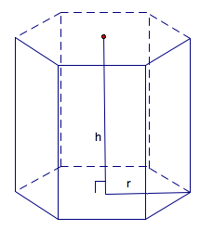 | BA = base area  LA = lateral area = perimeter base*h  h = height
Note: If the prism is rectangular then:
V =
Note: If the prism is a cube then:
SA = and V =
Right Pyramid with base regular polygon  SA = LA + BA  Volume = BA * h | 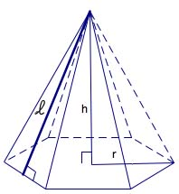 | BA = base area  LA=lateral area =  h = height  = slant height
Right Cylinder  Surface Area = 2 BA + LA  Volume = | 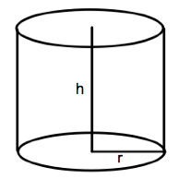 | BA = base area =  LA = lateral area =  r = radius of base  h = height
Right Cone  Surface Area = LA + BA  Volume = | 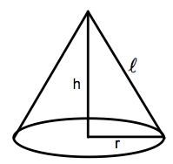 | BA = base area =  LA= lateral area =  r = radius  = slant height  h = height
Sphere  Surface Area =  Volume = | 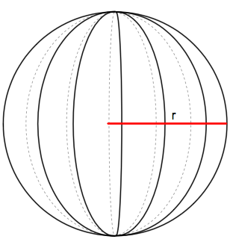 | r = radius
Organizing Learning: (Katana Summit – Towers of Steel)

Summary: Students will investigate how the formula for the volume of a cylinder or prism could be used to find the volume of a cone or pyramid with the same base area and height.

Outline:
- Students will complete necessary measurements on the base of cylinders and prisms to find base area and then will measure the height to calculate the volume in cubic centimeters.
- Students will fill the cylinder or prism with water and measure the milliliters of water using a graduated cylinder.
- Students will compare the volume in cubic centimeters to the volume in milliliters.
- Students will fill a cone with the same base and height measurements as the cylinder with water and measure the number of milliliters using a graduated cylinder.
- Students will fill a pyramid with the same base area and height as one of the prisms and measure the number of milliliters using a graduated cylinder.
- Students will compare the volume of the cones to the cylinders and the volume of the pyramids to the prisms.

Activity: Students will work in groups and move to stations where they will measure the radius and height of a cylinder and calculate its volume. They will then fill it with water and measure the volume of the water in milliliters using a graduated cylinder. They will then fill a cone with the same base area and height as the cylinder with water and will measure the water in milliliters using the graduated cylinder. They will record their measurements and move to the next station. Other stations will have cylinders and cones with the same base area and height but different from the first. Some stations will have prisms and pyramids with the same base area and height. These may be triangular, rectangular, trapezoidal, or regular polygon based prisms and pyramids. After students have completed the chart they should hypothesize a method of using measurements to find the volume of a cone or pyramid.

Type of Base | Volume of Cylinder or Prism in cm³ | Volume in Cylinder or Prism in ml | Volume of Cone or Pyramid in ml

Guiding questions for the teacher:
  - What is the relationship between cm³ and ml?
  - What could you do to the cylinder or prism volume to get the cone or pyramid volume?
  - What is the ratio between the cylinder or prism volume and the cone or pyramid volume?
Understanding Learning: (Katana Summit – Towers of Steel)

Summary: Students will write an explanation of the process used to develop the formula for the volume of cones or pyramids based on the volume of the cylinder or prism. Students will also solve problems involving volume of cones and pyramids.

Outline:
- Formative assessment of volume of cones and pyramids
- Summative assessment of volume of cones and pyramids

Activity:
Students will write about finding the volume of cones and pyramids and perform calculations related to volume of cones and pyramids and their applications.

Formative Assessment
As students are engaged in the lesson ask these or similar questions:
- Were students able to transfer their understanding of volume of prisms or cylinders to volume of pyramids and cones?
- Can students explain the relationship between volume of prisms or cylinders and volume of pyramids or cones?

Summative Assessment
Students can answer the following writing prompt:
Explain how you can find the volume of a right cone or right pyramid. Be sure to state the measurements that must be known to calculate the volume.

Students can answer problems finding the volume of a right cone or a right pyramid and real world applications for the volume of a right cone or a right pyramid relating to Katana Towers. See attached file: M064_SHINE_Towers_of_Steel-U-Assess.doc

Attachments:
M064_SHINE_Towers_of_Steel-U-Assess.doc
