Project SHINE / SPIRIT2.0 Lesson:
Tricky Traps
==========================Lesson Header ==========================
Lesson Title: Tricky Traps
Draft Date: 7/11/10
1st Author (Writer): Cherrie Cummings and Terri Jelinek
2nd Author (Business Partner): Valmont Industries
These Teachers were mentored by:


www.valmont.com

In partnership with Project SHINE grant funded through the

National Science Foundation

Instructional Component Used: Area of a trapezoid
Grade Level: 7-10

Content (what is taught):
- Area of a trapezoid

Context (how it is taught):
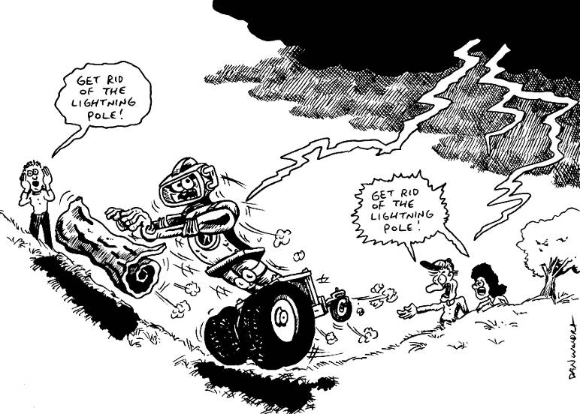
- Review parallelogram area formula
- Parts of a trapezoid are identified
- Two identical trapezoids are drawn
- Students hypothesize how to calculate the area of a trapezoid utilizing the formula for area of a parallelogram

Activity Description:
Students will draw two congruent trapezoids labeling one set of corresponding bases in one color, the other set of corresponding bases in another color and the corresponding heights in a third color. Students will cut out the trapezoids and arrange them to form a parallelogram. Students will then use their knowledge of finding the area of a parallelogram to help them hypothesize the formula for area of a trapezoid.

Standards:

Science: SA1 Technology: TD3

Engineering: ED1, ED2 Math: MC1, MD1

Materials List:
- Rulers
- Scissors
- Dot paper
- Colored pencils
Asking Questions: (Tricky Traps)

Summary: Determine what parts of a trapezoid are unique. What parts do other shapes have?
Valmont Industries in Valley, Nebraska, produces a variety of poles for lighting and electricity. In order to create the poles each sheet of steel is cut into a trapezoid. This trapezoid is then rolled to create the pole. The area of the original trapezoid determines the surface area of the pole.

Outline:
- Have students compare and contrast trapezoids to other shapes with which they have worked
- Students will record what they think are “properties” of trapezoids

Activity: The teacher will draw various polygons on the board and ask the questions like the ones below. As the questioning is going on, students should be thinking about a trapezoid and what the properties of a trapezoid are. Students or the teacher should write down what is in common and what is different between the shapes.

Questions | Answers
What shapes are similar to trapezoids? | All quadrilaterals because they have four sides.  Triangles have a base.  Parallelograms because they have parallel sides.
How are trapezoids different from other shapes? | Trapezoids have two bases and only one set of parallel sides.
What area formulas could be useful in finding the area of a trapezoid? | Triangle, parallelogram, square or rectangle

Exploring Concepts: (Tricky Traps)

Summary: Students will work in groups to determine methods of calculating area of a trapezoid.

Outline:
- Students will draw trapezoids.
- Students will work in small groups to discuss ways they could find the area of their trapezoid.

Activity: In this lesson students will investigate various methods for finding area of trapezoids. They will draw trapezoids with varying bases and heights and work in groups to come up with a plan to find the area of each trapezoid. After awhile the students should come together and discuss the ideas that they have about finding the area of a trapezoid.

Instructing Concepts: (Tricky Traps)

Area of Polygons

There are two types of polygons concave and convex. Convex polygons have all interior angles less than 180 degrees. Concave polygons have one or more interior angles greater than 180 degrees. To find the area of a concave polygon it is necessary to subdivide the polygon into smaller convex polygons. Since finding the area of concave polygons involve using convex polygons this instructional component will focus on basic convex polygons.

 | Triangle  A 3-sided figure | Area = | b is the base and h is the height at a right angle to the base
 | Parallelogram  A 4-sided figure with both pair of opposite sides parallel | Area = | b is the base and h is the height of the parallelogram at a right angle to the base
 | Rectangle  A parallelogram with at least  1 right angle | Area = | b is the base and h is the height of the rectangle
 | Rhombus  A parallelogram in which at least  2 consecutive sides are congruent | Area = | d₁ and d₂ are the diagonals of the rhombus
 | Kite  A 4-sided figure in which the  2 disjoint pairs of consecutive sides are congruent | Area = | d₁ and d₂ are the diagonals of the kite
 | Square  A rectangle with 4 congruent sides | Area = | b is the base and h is the height of the square
 |  | Area = | d₁ and d₂ are diagonals of the square
 |  | Area = | s is the side length of the square
 | Trapezoid  A 4-sided figure with exactly  1 pair of parallel sides | Area = | b₁and b₂ are the parallel sides and h is the height at a right angle to the base
 | Regular polygon  A polygon with all sides and interior angles congruent | Area = | a is the apothem (distance from the center perpendicular to a side) and p is the perimeter

If the polygon doesn’t fit into one of the above classifications you can find the area by subdividing it into polygons that do fit into one of these types. The easiest method is to subdivide it into triangles and then add up the area of all the small triangles to find the area of the polygon.

Although a circle is not a polygon I will mention the area formula here: Area circle = where r is the radius of the circle. This formula is an extension of a regular polygon where the side length is approaching zero.
Organizing Learning: (Tricky Traps)

Summary: Students will investigate the relationship between the area of a parallelogram and the area of a trapezoid.

Outline:
- Students are given dot paper, colored pencils, rulers and scissors
- Students will draw two congruent trapezoids labeling one set of corresponding bases in one color, the other set of corresponding bases in another color and the corresponding heights in a third color.
- Students will cut out the trapezoids and arrange them to form a parallelogram.
- Students will then use their knowledge of finding the area of a parallelogram to help them hypothesize the formula for area of a trapezoid.

Activity: Students will draw two congruent trapezoids labeling one set of corresponding bases in one color, the other set of corresponding bases in another color, and the corresponding heights in a third color. Students will cut out the trapezoids and arrange them to form a parallelogram. Students will then use their knowledge of finding the area of a parallelogram to help them hypothesize the formula for area of a trapezoid.

Guiding questions for the teacher:
- What is the base of the parallelogram formed by the two trapezoids? Base₁ + Base ₂
- What is the height of the parallelogram? The same as the trapezoid height.
- What is the formula for finding the area of a parallelogram? Base x height
- What is would you calculate the area of the parallelogram using the terms we used to label our trapezoid? (Base₁ + Base ₂) x height
- How does the area of one trapezoid compare to the area of the parallelogram? It is half.
- How do we adjust the formula of the area of the parallelogram to find the area of one trapezoid? Divide by two.
- What is the formula for area of a trapezoid? (Base₁ + Base ₂) x height ÷2

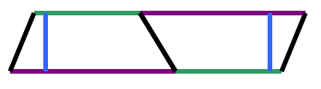
Understanding Learning: (Tricky Traps)

Summary: Students will write an explanation of the process used to develop the formula for the area of a trapezoid. Students will solve problems involving area of a trapezoid.

Outline:
- Formative assessment polygons (area of trapezoid)
- Summative assessment polygons (area of trapezoid)

Activity: Students will write about finding the area of trapezoids and perform calculations related to area of trapezoids and its application.

Formative Assessment
As students are engaged in the lesson ask these or similar questions:
- Were students able to transfer their understanding of parallelogram area to find the area of trapezoid?
- Can students explain the process used to develop the formula for area of a trapezoid?

Summative Assessment
Students can answer the following writing prompt:
Explain the method you learned to find the area of a trapezoid and how it relates to a parallelogram. Be sure to cite any measurements that you need to know to apply the formula.

Students can answer problems finding the area of a trapezoid and real world applications for the area of a trapezoid relating to Valmont Industries.

Attachments:
See attached file: M065_SHINE_Tricky_Traps-U-Assess.doc
