Project SHINE / SPIRIT2.0 Lesson:
Pushing Pivots
==========================Lesson Header ==========================
Lesson Title: Pushing Pivots
Draft Date: 7/9/10
1st Author (Writer): Cherrie Cummings and Terri Jelinek
2nd Author (Business Partner): Valmont Industries
These Teachers were mentored by:


www.valmont.com

In partnership with Project SHINE grant funded through the

National Science Foundation

Instructional Component Used: Area of a Circle
Grade Level: 8-10

Content (what is taught):
- Area of a Circle

Context (how it is taught):
- Review parts of a circle
- Review area of a parallelogram
- Students draw a large circle using a compass and cut it out
- Students fold the circle in half four times without unfolding between folds. They will end up with 16 sectors.
- Students draw lines on the folds using a colored pencil.
- Students cut out the sections and arrange them in a row with the curved part on top next to a section with the curved part on the bottom. When finished they should form a shape similar to a parallelogram
- Students hypothesize how to calculate the area of a circle utilizing the formula for area of a parallelogram

Activity Description:
Students will use a compass to draw a large circle on a piece of plain white paper. They will then cut out the circle. Students will fold their circle in half and, without unfolding, fold it in half again. They will repeat this process until they have 16 equal sectors on their circle. They will then unfold their circle and use a colored pencil and ruler to draw the fold lines. Students will then cut along the lines and arrange their sectors with the edges touching and each going opposite directions so the point of one sector is up and the next one has the point down. When they are finished their arrangement should resemble a parallelogram. Students will use their knowledge of the parts of a circle and the area formula for parallelograms to hypothesize the formula for area of a circle.

Standards:

Science: SA1 Technology: TD3

Engineering: ED1, ED2 Math: MC1, MD1

Materials List:
- Rulers
- Scissors
- Compass
- Colored pencils
- Paper
Asking Questions: (Pushing Pivots)

Summary: Students will hypothesize which shape encloses the largest area. Valmont Industries in Valley, Nebraska produces center pivot irrigation systems. In order to calculate the number of acres being irrigated by a particular system it is necessary to calculate the area of the circular region the system will cover.

Outline:
- Have students discuss shapes that could be made with a given length of string or rope
- Teacher will use the rope or string to form different shapes. Students discuss what shape encloses the largest amount of area.
- Record hypotheses about the shape and largest area

Activity: The teacher will use the rope or string to create shapes suggested by the students. Students will hypothesize which shape with the same perimeter has the largest area. On a board, rank the group’s thoughts about which shape has the largest area.

Questions | Answers
What are some shapes I could make with this rope? | Triangle, square, pentagon, hexagon… circle
How does the area of a triangle compare to the area of a square using the same rope? | Triangle is smaller.
Which shape is going to give you the greatest area? | circle
Exploring Concepts: (Pushing Pivots)

Summary: Students will work in groups to determine methods of calculating area of a circle.

Outline:
- Students will draw circles
- Students will work in small groups to discuss ways they could find the area of their circle

Activity: Give students paper and graph paper and have them work in groups to come up with a way to estimate the area of a circle. After awhile, the groups should come back together and share their ideas about how to calculate the area of a circle without using the well-known formula.

Guiding Questions:
- How could you use the graph paper to estimate the area of the circle?
- Why is this considered an estimate and not the actual area?
- Without using the graph paper, what are some other ways you could estimate the area of the circle?

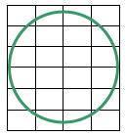
Instructing Concepts: (Pushing Pivots)

Circles

A circle is defined to be the set of all points in a plane equidistant from a point called the center. Thus to define a circle you must have a point (center) and a distance from the center (radius).

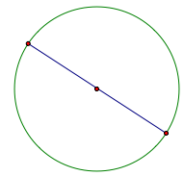 | Diameter – A chord of a circle that contains the center. Note a diameter is the longest chord.
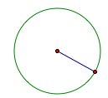 | Radius – distance from the center to the circle. Note: Diameter = 2 radii
Distance “around” the circle | Circumference =
Portion of the circumference  with a central angle of m degrees | Arc length =
 | Area =
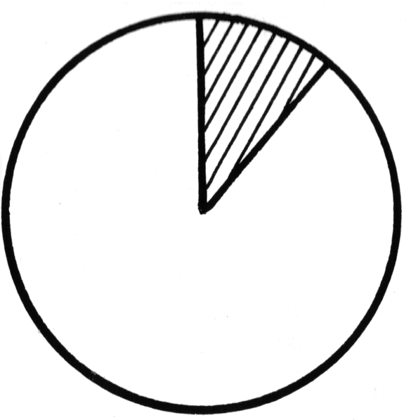 | A_{sector} =
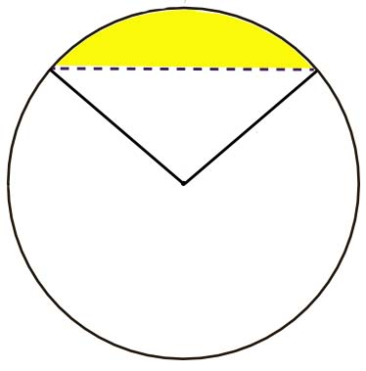 | A_{segment} = A_{sector} – Area Triangle
 | Measure central angle = measure subtended arc.
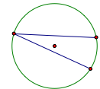 | m(inscribed angle) =
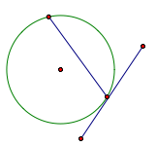 | m(tangent/chord angle) =
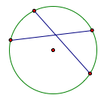 | m(chord/chord angle) = (sum of the intercepted arcs)
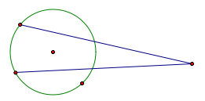 | m(secant/secant) = (difference of the intercepted arcs)
Organizing Learning: (Pushing Pivots)

Summary: Students will investigate the relationship between the area of a parallelogram and the area of a circle.

Outline:
- Students use a compass to draw a large circle on a piece of white paper
- Students cut out the circle
- Students fold the circle in half four times without unfolding between folds. They will end up with 16 sectors
- Student draw lines on the folds using a colored pencil
- Students cut out the sections and arrange them in a row with the curved part on top next to a section with the curved part on the bottom. When finished they should form a shape similar to a parallelogram.
- Students hypothesize how to calculate the area of a circle utilizing the formula for area of a parallelogram

Activity: Students will use a compass to draw a large circle on a piece of plain white paper. They will then cut out the circle. Students will fold their circle in half and, without unfolding, fold it in half again. They will repeat this process until they have 16 equal sectors on their circle. They will then unfold their circle and use a colored pencil and ruler to draw the fold lines. Students will then cut along the lines and arrange their sectors with the edges touching and each going opposite directions so the point of one sector is up and the next one has the point down. When they are finished their arrangement should resemble a parallelogram. Students will use their knowledge of the parts of a circle and the area formula for parallelograms to hypothesize the formula for area of a circle.

Guiding questions for the teacher:
- What part of the circle makes up the bases of the parallelogram? Circumference
- How long is just one base of the parallelogram? Half the circumference (2πr÷2)
- What part of the circle makes up the height of the parallelogram? Radius
- What is the area formula for a parallelogram? b•h
- By inserting the parts of the circle that make up the base and the height what is the formula for area of a circle? b x h = πr • r = π r²

Understanding Learning: (Pushing Pivots)

Summary: Students will write an explanation of the process used to develop the formula for the area of a circle. Students will solve problems involving area of a circle.

Outline:
- Formative assessment of area of a circle
- Summative assessment of area of a circle

Activity: Students will write about finding the area of circles and perform calculations related to area of circles and its application.

Formative Assessment
As students are engaged in the lesson ask these or similar questions:
- Were students able to transfer their understanding of parallelogram area to find the area of circle?
- Can students explain the process used to develop the formula for area of a circle?

Summative Assessment
Students can answer the following writing prompt:
Explain the method you learned to find the area of a circle and how it relates to a parallelogram using the method you explored in the lesson. Be sure to cite any measurements that you need to know to apply the formula.

Students can answer problems finding the area of a circle and real world applications for the area of a circle relating to Valmont Industries.

Attachments:
Summative Assessment: M066_SHINE_Pushing_Pivots-U-Assess.doc
