“Pushing Pivots” Worksheet Name _______________________
Circle Area Date _________________________

- Explain in detail the process we used to develop the formula for area of a circle.

- How did knowing the formula for circumference help you to derive the formula for area of a circle?

- Would cutting the circle into more than 16 pieces change the shape that is formed?

- Would cutting the circle into more than 16 pieces change the formula?

Using the formula for area of a circle, solve for each unknown. Use the π key on your calculator and round answers to the nearest hundredth.

5. Radius = 7 cm Area = x

6. Radius = 15 feet Area = x
7. Diameter = 26 m Area = x

8. Diameter = inches Area = x

9. Radius = x Area = 452.39 cm²

10. Diameter = x Area = 145.27 in²

11. An annulus is the area between two concentric circles. Find the area of the annulus shown below if r = 4 cm and R = 8 cm.
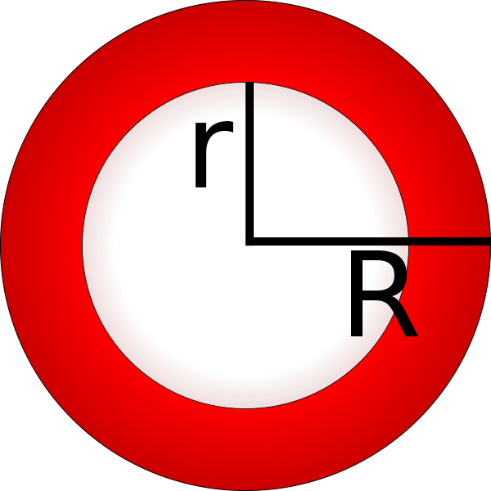

Image from: http://commons.wikimedia.org/wiki/File:Annulus.svg

12. Find the area of an annulus if r = 25 ft and R = 30 ft.

13. If the area of an annulus is 203π cm² and R = 18 cm, what is r?

14. At Valmont Industries in Valley, Nebraska, they manufacture center pivot irrigations systems. If the center pivot is 1260 feet long, how many square feet of land would be watered as the pivot runs in a complete circle?

15. When you purchase a center pivot you have an option of attaching an “end gun” on the end of the pivot that sprays water out an additional 166 feet.

- You are purchasing a pivot that is 1120 feet, how many square feet would be irrigated without the end gun.

- How many additional square feet would you gain if you purchase the end gun?

- If there are 43,560 square feet in one acre, how many acres will you be irrigating if you have the end gun?

- How many gallons of water would be needed to put an inch of water on your field? 1 acre-inch = 27,154 gallons.

