Project SHINE / SPIRIT2.0 Lesson:
This Teacher was mentored by:


www.vishay.com

In partnership with Project SHINE grant funded through the

National Science Foundation

Is There Room?
==========================Lesson Header ==========================
Lesson Title: Is There Room?
Draft Date: 7/15/10
1st Author (Writer): Julie Kreikemeier
Associated Business: Vishay
Instructional Component Used: Mathematics, Area
Grade Level: 9-12

Content (what is taught):
- Area
- Measuring
- Scale drawing

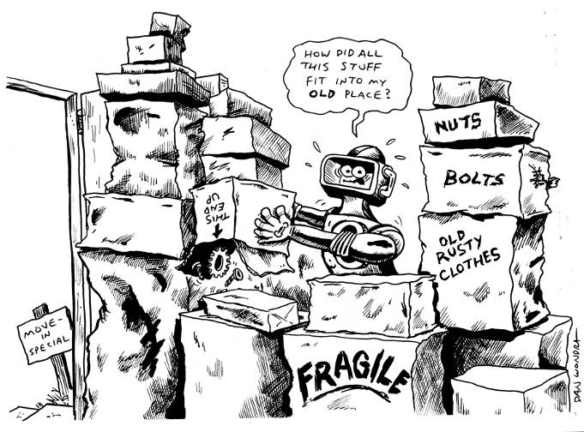
Context (how it is taught):
- Leading questions and discussion by teacher
- Students investigate area by redesigning classrooms with same objects in room and by accommodating new objects being added to room.
- Students use area to investigate designing soccer complex given a certain amount of square yards to work with by a city.
Activity Description:
In this lesson, students investigate the importance of area when designing and redesigning spaces in order to accommodate necessary objects without building or making more space.

Standards:

Technology: TA1, TD4 Engineering: EA4

Math: MA3, MC1, MC4, MD1, MD2

Materials List:
- Tape measures
- Rulers
- Grid Paper
- Poster board
- Google SketchUp (optional)
Asking Questions: (Is There Room?)

Summary: The teacher asks leading questions about area, perimeter, and approximating dimensions of classroom and objects.

Outline:
- Teacher asks students difference between area and perimeter.
- Teacher asks students to approximate dimensions of classroom and objects in classroom.
- Teacher asks students to approximate how many football fields the classroom and school would cover.

Activity: The teacher leads a discussion with the students on understanding the difference between area and perimeter. The teacher then leads the discussion to approximating dimensions of objects students can actually see to have students make connection with area and perimeter.

Questions | Answers
What does area measure? | Area measures the space an object occupies.
What does perimeter measure? | Perimeter measures the outside distance of an object.
What do you think the dimensions of this room would be? | The dimension of the room could be given in inches, feet, or yards. The students may use their feet as a reference to give dimensions or compare to objects they already know size. The dimensions will be different based on the room you are located.
What do you think the dimensions of the desk or tables would be? Other objects in classroom? | The dimension of the objects could be given in inches, feet, or yards. The students may use their feet as a reference to give dimensions or compare to objects they already know size. The dimensions will be different based on the objects located in classroom.
How many classrooms would cover a football field? How many football fields would a school cover? | Answer will depend on size of classroom and school. Answers may vary from half a football field to 6 football fields.
How many different ways do you think there are to rearrange this room? | The students’ answers will vary, but will lead to a good discussion or area and perimeter keeping in mind how much space is available in room.
Area
perimeter

Exploring Concepts: (Is There Room?)

Summary: Students will measure the square footage of the classroom and classroom objects. Students will redesign the classroom in a way that they think best optimizes the space.

Outline:
- Students work in pairs to find square footage of classroom and of objects in classroom
- Students work in pairs to redesign the classroom so the space is best optimized

Activity: Have students work in pairs to find the square footage of the classroom and objects in the classroom. After they have all the measurements needed, have them work in the same pairs to redesign the classroom in a way that they think would best optimize the space.

Teacher Tips:
- Have students sketch design on grid paper.
- Have students use the Internet to research other classroom designs.
- Have students provide a scale on their drawing in order to read measurements of drawing.

Resources:
- Printable Grid Paper: http://incompetech.com/graphpaper/
- Internet
Instructing Concepts: (Is There Room?)

Area of Polygons

There are two types of polygons concave and convex. Convex polygons have all interior angles less than 180 degrees. Concave polygons have one or more interior angles greater than 180 degrees. To find the area of a concave polygon it is necessary to subdivide the polygon into smaller convex polygons. Since finding the area of concave polygons involve using convex polygons this instructional component will focus on basic convex polygons.

 | Triangle  A 3-sided figure | Area = | b is the base and h is the height at a right angle to the base
 | Parallelogram  A 4-sided figure with both pair of opposite sides parallel | Area = | b is the base and h is the height of the parallelogram at a right angle to the base
 | Rectangle  A parallelogram with at least  1 right angle | Area = | b is the base and h is the height of the rectangle
 | Rhombus  A parallelogram in which at least  2 consecutive sides are congruent | Area = | d₁ and d₂ are the diagonals of the rhombus
 | Kite  A 4-sided figure in which the  2 disjoint pairs of consecutive sides are congruent | Area = | d₁ and d₂ are the diagonals of the kite
 | Square  A rectangle with 4 congruent sides | Area = | b is the base and h is the height of the square
 |  | Area = | d₁ and d₂ are diagonals of the square
 |  | Area = | s is the side length of the square
 | Trapezoid  A 4-sided figure with exactly  1 pair of parallel sides | Area = | b₁and b₂ are the parallel sides and h is the height at a right angle to the base
 | Regular polygon  A polygon with all sides and interior angles congruent | Area = | a is the apothem (distance from the center perpendicular to a side) and p is the perimeter

If the polygon doesn’t fit into one of the above classifications you can find the area by subdividing it into polygons that do fit into one of these types. The easiest method is to subdivide it into triangles and then add up the area of all the small triangles to find the area of the polygon.

Although a circle is not a polygon I will mention the area formula here: Area circle = where r is the radius of the circle. This formula is an extension of a regular polygon where the side length is approaching zero.
Organizing Learning: (Is There Room?)

Summary: Give students the example of schools consolidating and adding extra desks to each classroom. Students will measure the square footage of the classroom and classroom objects. Students will then redesign the classroom in order to accommodate the new desks.

Outline:
- Give students the example of schools consolidating and having to add extra desks in each classroom. This will simulate a business closing part of their operation in a different location and having to move machinery to back to a local plant.
- Have students work in pairs to measure square footage of the classroom and classroom objects.
- Have students work in the same pairs to redesign the classroom to accommodate the new desks being added to each classroom.

Activity: The teacher will give a scenario of a business closing and having to move machines into an already operating building without building on. Columbus, NE Example: Vishay closed a section of their plant in Japan. Therefore, Vishay must move 10 machines back to the Columbus plant without building on to the building. In order to simulate the idea of a business closing, tell the students that a school nearby is closing and consolidating with theirs. In order to accommodate the new students, five desks must be added to each classroom. Have students work in pairs to find the square footage of the classroom and objects in the classroom. Then have students design the classroom using the measurements they collected in order to accommodate the new desks. Depending on computer usage, the final project may be completed on a poster board or on Google SketchUp. The students need to make sure that their drawing is to scale.

Resources:
- Google SketchUp: http://sketchup.google.com/
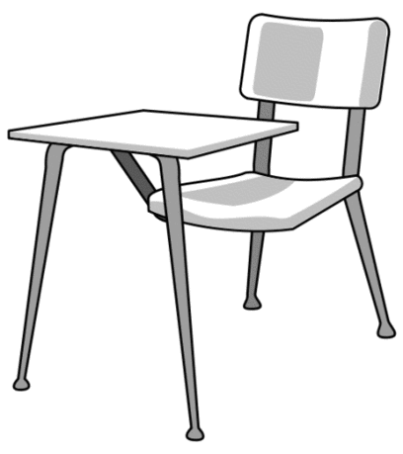
Understanding Learning: (Is There Room?)

Summary: Students will complete a mini-project by designing a soccer complex given 115,200 square yards to work with by the city.

Outline:
- Formative assessment of polygons (area)
- Summative assessment of polygons (area)

Activity:
Formative Assessment
As students are engaged in the lesson teacher walks around and ask these or similar questions:
- What obstacles did you find as you were creating your design?
- Which affects the design the most: area or perimeter? Why?
- Do you think the shape of the room has a major affect of the design?
- Which shape do you think has the most area that can be optimized when designing a room or soccer complex?

Summative Assessment/Performance Assessment
Scenario Example: You are selected by the mayor to provide a plan to the city for the new soccer complex. The city has 115,200 square yards in one area to use to create the soccer complex. You need to find the size regulations of a soccer field in order to create a design for the new soccer complex that includes numerous soccer fields, space for spectators, concession stand, restrooms, space between fields, etc. Be Creative!

Students will complete the following mini-project about area:
- Students will research size regulations for a soccer field.
- Students will sketch a design of a soccer complex given 115,200 square yards to work with by the city.
- Students will complete a final draft on poster board or Google SketchUp with the scale given.

Resources:
- Google SketchUp: http://sketchup.google.com/

