Project SHINE / SPIRIT2.0 Lesson:
This Teacher was mentored by:

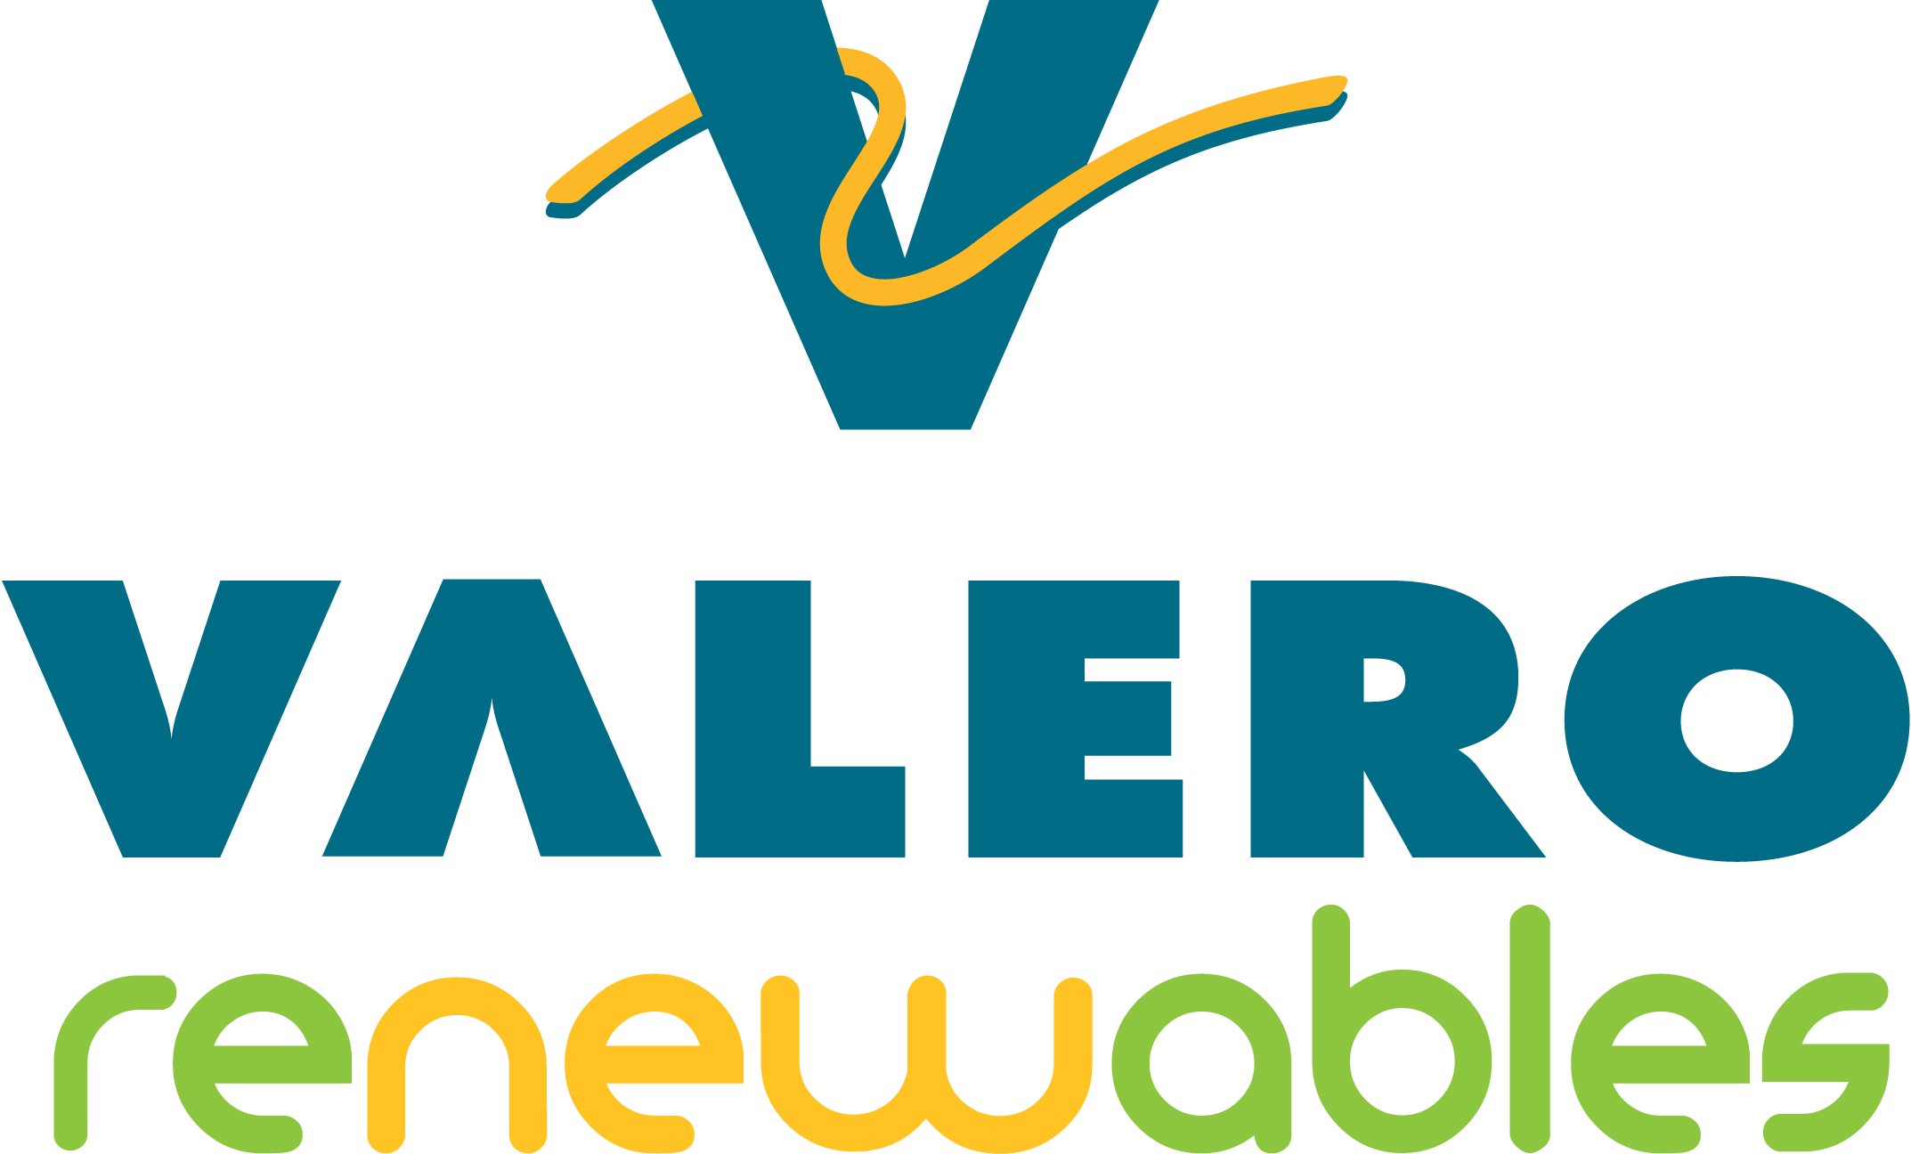
www.valero.com

In partnership with Project SHINE grant funded through the

National Science Foundation

Fill ‘Er Up
==========================Lesson Header ==========================
Lesson Title: Fill ‘Er Up
Draft Date: July 13, 2010
1st Author (Writer): Trina Hellbusch
2nd Author (Editor/Resource Finder):
Instructional Component Used: Volume
Grade Level: 7th & 8th

Content (what is taught):
- Volume
- Decide how many smaller units can be shared/taken out of a larger unit

Context (how it is taught):
- Identify items with a volume that must be emptied/transferred to smaller units of volume
- Record information in a chart
- Discover a formula to calculate volume
- Apply information to a large unit of volume
Activity Description:
This lesson will help students discover volume. First they will explore how to empty the contents of a larger object to smaller objects. Next, students will do some investigating by transferring different items (corn, rice, beans, liquid, etc.) from a larger container to a smaller container. After this, they will apply their knowledge by finding a way to transfer millions of gallons of ethanol to train cars for transport.

Standards:

Math: MA3, MC1, MD1

Materials List:
- Cylinders to transfer larger units of volume to smaller units
- Variety of items to fill the larger cylinders with (i.e., corn, rice, beans, liquid, etc.)
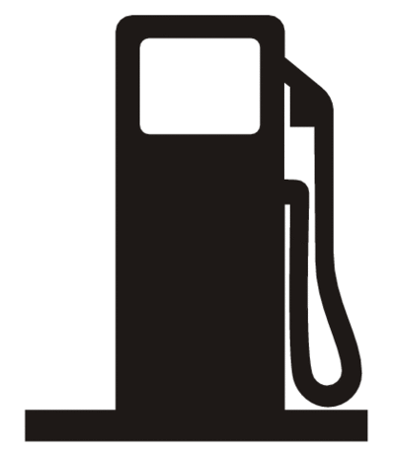
Asking Questions: Fill ‘Er Up

Summary: This activity will get students thinking about volume.

Outline:
- Students will identify items that come in large volumes
- Students will identify items with varying volumes (as simple as a bottle of soda on up to storage tanks) and how they are transported

Activity: The teacher will help guide students in identifying items that are used by a consumer, which come from a larger unit of storage.

Questions | Answers
If I have a liter of pop, what would I do if each of you wanted some? | You would pour it in to a cup/glass
What about a bag of chips? | Same thing, give each person some
Can you think of anything that would be a larger starting unit? | Food items, paper items, drinks, fuel, oil, ethanol, etc…
How are some of these items stored/transported? | Warehouses, by semi, trains, plains, etc…
Do any of you know what the measurement is when we calculate what’s inside a container? | Volume

Exploring Concepts: Fill ‘Er Up

Summary: Students will explore volume by taking a larger unit of a specific item and measuring out how many smaller units it would take to empty the unit.

Outline:
- Students will work in groups with each group having a larger canister of rice, beans, corn, or colored water.
- They will have a smaller cylinder that they will use to empty their larger canister, figuring out how many smaller units it will take.
- Groups will rotate through with each set of canisters making estimations and calculations as they go through each station.
- Students will identify that each of the larger canisters start with a certain volume and it takes so many smaller units, equaling the larger volume to empty it.

Activity: In this lesson, students will work through four stations of various sized canisters and smaller cylinders to explore how many smaller units it takes to empty the larger storage containers. As they work through each station, they may begin to estimate how many units are in the larger canister and how many smaller units will come out. They will identify they are working with volume and how to transport out the volume for transportation.

Instructing Concepts : Fill ‘Er Up

Surface Area and Volume of Right Solids With Regular Bases

Surface Area: The measure of how much exposed area a solid object has, expressed in square units.
Volume: How much three-dimensional space a shape occupies or contains, expressed in cubic units.

These formulas apply to right solids. If the solid is oblique it is much more difficult to find the SA and V. If the base is not regular these formulas apply but the LA is more difficult to find. You have to find the area of each face separately and add them together.
Right prism with base  regular polygon  Surface Area = LA + 2 BA  Volume = BA * h | 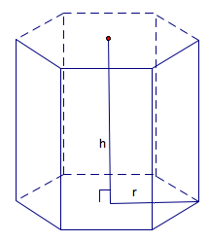 | BA = base area  LA = lateral area = perimeter base*h  h = height
Note: If the prism is rectangular then:
V =
Note: If the prism is a cube then:
SA = and V =
Right Pyramid with base regular polygon  SA = LA + BA  Volume = BA * h | 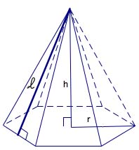 | BA = base area  LA=lateral area =  h = height  = slant height
Right Cylinder  Surface Area = 2 BA + LA  Volume = | 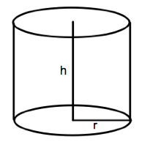 | BA = base area =  LA = lateral area =  r = radius of base  h = height
Right Cone  Surface Area = LA + BA  Volume = | 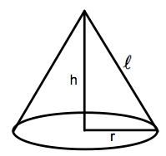 | BA = base area =  LA= lateral area =  r = radius  = slant height  h = height
Sphere  Surface Area =  Volume = | 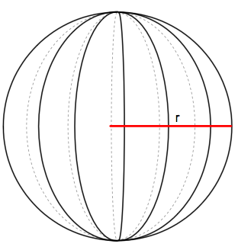 | r = radius
Organizing Learning: Fill ‘Er Up

Summary: Students identify how many smaller units it takes to empty a larger storage unit. Research will be done on bin sizes that fuel (ethanol) may be stored in and calculate the volume of the various bin sizes. They will also research tanker railcars and their capacity. Along with using formulas for volume, they will also work with conversion from volume in cubic meters/feet to capacity in gallons.

Outline:
- Students will identify that fuel is stored in bins for transport.
- Students will research bin sizes that are used at various sites locally or via Internet research.
- Students will calculate the volume the different bin sizes will hold.
- Students will need to research fuel distribution via tanker railcar and the volume that each tanker holds.
- They will need to calculate volume in cubic meters/feet and convert to gallons what each tanker holds using Internet conversion charts.
- Students then will identify how many tanker railcars will be needed to empty a full storage bin.

Activity: Students will research information on the Internet (or local fuel storage sites) on the different size bins (and their capacities) used to store fuel prior to distribution. From the bin/tank measurements, they will calculate the volume of each of the tanks. They will also research tanker railcars and their volume that can be transported. Using the Internet, students will then convert the volume to gallons and identify how many tanker railcars will be needed to empty each of the bins. Students would benefit from working in small groups during this activity. They will make a simple chart to show the different size storage bins and number of railcars needed to empty it when it is at capacity.

Size of Storage Bin | Number of Railcars Needed | Notes

Resources:
- Chemkeys: www.chemkeys.com/.../Best-Practices-for-Rail-Transport-of-Fuel-Ethanol.pdf
- Guide to Railcars: http://www.worldtraderef.com/WTR_site/Rail_Cars/Guide_to_Rail_Cars.asp
- Conversion Site: http://www.convertunits.com/from/cubic+feet/to/gallon
Understanding Learning: Fill ‘Er Up

Summary: Students will create a chart of the various size storage tanks for fuel (ethanol) and calculate the volume. Along with this information, they will identify how many tanker railcars will be needed to distribute the contents of the storage tank for distribution.

Outline:
- Formative assessment of volume
- Summative assessment of volume

Activity: Students will complete assessments relating to volume.

Formative Assessment
As students are engaged in the lesson ask these or similar questions:
- Are you able to completely empty each storage container for distribution?
- Are you able to calculate mathematically how many units are inside a storage container?
- Knowing how many units are inside the large storage container, can you figure out only with math how many smaller containers are needed to empty it? Or, do you need to fill each smaller unit to identify this?
- Do tanker railcar sizes vary like storage bin sizes do?
- How many gallons can a tanker railcar hold?

Summative Assessment
Students can answer the following writing prompt:
Explain the ethanol production process as it relates to distribution and transportation mode. What are the approximate volumes of the different transport methods? You must cite a minimum of 3 different methods.

Students will complete one of the following questions to apply their knowledge further.

- A railcar tanker holds 33,000 gallons of fuel. Why do you think bin sizes vary but tanker sizes do not? Explain.
- What size storage tank do you think gas stations have? If there are 50 customers a day who pump on average 12 gallons of fuel, when will the tank need refilled?
- Research how many gallons of fuel semi-trucks are able to distribute. How many semis are filled by one rail car? To empty your largest tank charted, how many semis would be needed?

