The Way Information Travels
Today we are going to look at how information has traveled over the years and graph the increasing amount of complexity that technology has delivered.
Methods of Delivery
Match the method with the year. You can use the internet to provide research.

- (1840)
- (1860)
- (1869)
- (1875)
- (1950’s)
- (1990’s)
- (1999)
- T1 lines first introduced
- Telegraph replaces the Pony Express for messages out to California OC-48 lines first introduced
- T3 lines first introduced
- First stamp was issued for a postal service.
- Telephone (DS0) is invented by Alexander Graham Bell.
- The Pony Express took 10 days for a bag of letters to get from St. Joseph, MO to Sacramento, CA

*note: these are approximate times gathered from Internet sites.
While doing research fill in the chart which you will graph using excel or a graphing utility.
Medium | Year | Amount of data | Number of Phone Calls
Typical Phone Line | 1875
T1 Line (24 DS0’s) | 1950
T3 Line (28 T1’s) | 1990
OC48 (48 T3’s) | 1999
Power companies use 12 pairs of OC48 for data transmission. | 2010
Now you are to make two graphs using an Excel spreadsheet.
Graph #1 – Graph the amount of data that can be transmitted across the 4 electrical transmission lines above. Use the years (1875, 1950, 1990, 1999, 2010) as your horizontal axis.

Graph #2 – On the same Excel file, graph the number of phone calls that can be transmitted on each of the 5 electrical transmission lines above. Use the years (1875, 1950, 1990, 1999, 2010) as your horizontal axis.
The Way Information Travels (notes for the teacher and answer key)
Today we are going to look at how information has travelled over the years and graph the increasing amount of complexity that technology has delivered.
Methods of Delivery
(1840) First stamp was issued for a postal service.
(1860) The Pony Express took 10 days for a bag of letters to get from St. Joseph, MO to Sacramento, CA.
(1869) Telegraph replaces the Pony Express for messages out to California.
(1875) Telephone (DS0) is invented by Alexander Graham Bell.
(1950’s) T1 lines first introduced
(1990’s) T3 lines first introduced
(1999) OC-48 lines first introduced
*note: these are approximate times gathered from Internet sites.
Medium | Amount of data |  | Number of Phone Calls
Typical Phone Line | 64 Kb/s or .064 Mb/s |  | 1 phone call
T1 Line (24 DS0’s) | 1536 Kb/s or 1.54 Mb/s |  | 24 phone calls
T3 Line (28 T1’s) | 43.12 Mb/s |  | 672 phone calls
OC48 (48 T3’s) | 2.07 Gb/s or 2070 Mb/s |  | 32,256 phone calls
Power companies use 12 pairs of OC48 for data transmission. | 49.68 Gb/s or 49680 Mb/s |  | 774,144 phone calls
Graph #1 |  | Graph #2
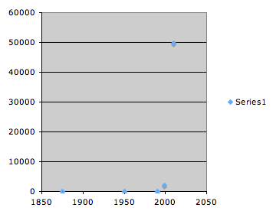 |  | 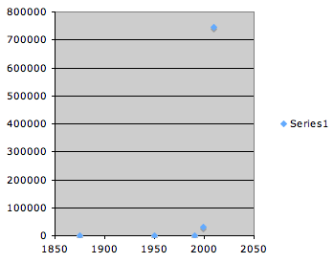

*Note: Power companies, on their largest transmission lines, have their ground wire as the top wire in the transmission lines and imbedded in this ground wire is a fiber optic cable. The fiber optic cable is a tremendously important way of communicating with the various sensors, substations, power plants, and sometimes individual large end-users. In case of a disruption in the power grid, i.e. a winter storm, the electrical company can reroute the power almost instantly through the power grid so that the flow of electricity is not interrupted. The control room at the power company’s headquarters needs to have instant information to help all customers get back on line. Also, the control room can control certain loads to various machines, i.e. electrical motors for irrigation pumps, so that they can better manage the flow of electricity at peak usage times. If one break in the fiber optic cable occurs, there is no disruption due to dual flow. If two breaks occur, then there are problems!

