Project SHINE / SPIRIT2.0 Lesson:
Slit The Width
==========================Lesson Header ==========================
Lesson Title: Slit The Width
This Teacher was mentored by:


www.valmont.com

In partnership with Project SHINE grant funded through the

National Science Foundation

Draft Date: July 15, 2010
1st Author (Writer): Rick Carter
2nd Author (Editor/Resource Finder): Valmont
Instructional Component Used: Circumference/Diameter Relationship
Grade Level: High School

Content (what is taught):
- Circumference/Diameter relationship in circles

Context (how it is taught):
- Hands on activity with different size circular objects

Activity Description:
In this activity, the students will have several circular objects that they will measure both the diameter and circumference of each using a cloth measuring tape. They would then divide the circumference by the diameter for each object and make observations. They would record the diameter, circumference and circumference/diameter calculation in a table and then make observations. This lesson would tie into Valmont where a slitting machine is used to cut flat sheet metal material to a desired width which will eventually become the circumference of a pipe. It is critical that the width is correct in order for the pipe that will be formed from this material to have the correct diameter.

Standards:

Math: MC1, MD1, ME3

Materials List:
- Circular objects including pipe
- Cloth tape measures
- Notebook
- Calculators
Asking Question: Slit The Width

Summary: Students will learn about circles and specifically focus on the definitions of diameter and circumference. How to measure diameter and circumference of circles used in the “real world” will be discussed.

Outline:
- Introduce the terms diameter and circumference
- Brainstorm ways of measuring the circumference of a circular object

Activity: The teacher will start by introducing the terms diameter and circumference and tell the students that they will be discovering the relationship between diameter and circumference in today’s activity. The students will think about how to measure the diameter and circumference of circles that are used in industry like pipes, culverts, tractor wheel rims, etc. Why this relationship is important in real world processes will be discussed.

Questions | Answers
How can the circumference of a circular object be measured? | - Using a cloth measuring tape is the easiest method  - You could also roll the object over a meter stick to see the distance traveled in one revolution  - A string could be used to go around the object and then measured afterwards
Why would someone need to know the circumference of a pipe if the diameter of the pipe is what is critical? | The pipe is produced by forming the pipe from sheet metal. The width of the sheet metal becomes the circumference of the pipe.
How much wider sheet metal material would be needed to produce a pipe that is double the diameter of another pipe? | Twice the width
About how many times greater is the circumference of a pipe compared to the diameter of the pipe? | A little more than 3 times greater. To be exact,  Pi times greater.

diameter
circumference
circumference
Exploring Concepts: Slit The Width

Summary: Students will investigate the relationship between the diameter and circumference of several circular objects including pipe.

Outline:
- Students will be given several circular objects
- They will measure the circumference and diameter of each object and compute the quotient of circumference divided by diameter for each object
- All measurements and calculations will be put into a table.

Activity: Groups of four students will be given several circular objects including pipe so the circumference and diameter can be measured. Have each student in the group measure both the circumference and diameter of the pipe and then average the measurements. NOTE: Outliers should not be averaged. Finally, for each circular object, the quotient of circumference and diameter will be computed. The data will be recorded in the chart below.

Object 1 | Circumference  (Measured) | Diameter  (Measured) | Circumference  Divided By  Diameter
Student 1
Student 2
Student 3
Student 4
Average

Object 2 | Circumference  (Measured) | Diameter  (Measured) | Circumference  Divided By  Diameter
Student 1
Student 2
Student 3
Student 4
Average

Object 3 | Circumference  (Measured) | Diameter  (Measured) | Circumference  Divided By  Diameter
Student 1
Student 2
Student 3
Student 4
Average
Instructing Concepts: Slit The Width

Circles

A circle is defined to be the set of all points in a plane equidistant from a point called the center. Thus to define a circle you must have a point (center) and a distance from the center (radius).

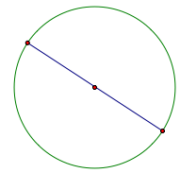 | Diameter – A chord of a circle that contains the center. Note a diameter is the longest chord.
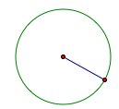 | Radius – distance from the center to the circle. Note: Diameter = 2 radii
Distance “around” the circle | Circumference =
Portion of the circumference  with a central angle of m degrees | Arc length =
 | Area =
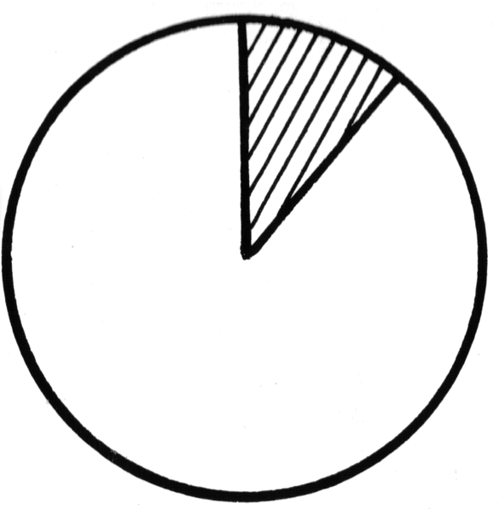 | A_{sector} =
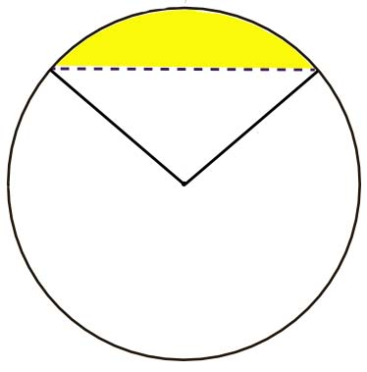 | A_{segment} = A_{sector} – Area Triangle
 | Measure central angle = measure subtended arc.
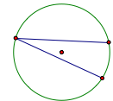 | m(inscribed angle) =
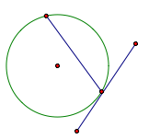 | m(tangent/chord angle) =
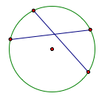 | m(chord/chord angle) = (sum of the intercepted arcs)
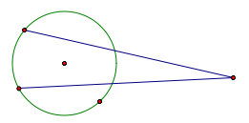 | m(secant/secant) = (difference of the intercepted arcs)
Organizing Learning: Slit The Width

Summary: Students will use the relationship between circumference and diameter for circular objects.

Outline:
- Calculate the circumference of a pipe given the desired diameter
- Calculate the diameter of a pipe given its circumference

Activity: The students will determine the circumference for pipes with various diameters which is an important procedure used by the metal pipe building industry. They will also determine the maximum diameter pipe that can be made out of a given sheet metal width. These are questions that students can use to practice.

- What would be the circumference of a pipe that is 2.5 inches in diameter?
- What would be the circumference of a pipe that is 5.0 inches in diameter?
- Could a 6-inch diameter pipe be formed from a piece of sheet metal that is 18.5 inches wide?
- How wide would a piece of sheet metal need to be if you were going to construct a 4.5-inch pipe?
- What would the circumference of pipe be is it has a 6-inch radius?
- If a pipe has a 2-inch radius, what would its circumference be? How wide would a piece of sheet metal need to be if you were going to make this pipe?
Understanding Learning: Slit The Width

Summary: Students will work several problems involving the circumference/diameter relationship of circles. Students will write short answer responses to questions involving circumference and diameter. Using paper, students will form a pipe having a specified diameter.

Outline:
- Formative assessment of the relationship between circumference and diameter in circles
- Summative assessment of the relationship between circumference and diameter in circles

Activity: Students will be assessed on the relationship between circumference and diameter by answering a writing prompt and several quiz questions.

Formative Assessment
As students are engaged in the lesson ask these or similar questions:
- How do you know that your measurements are accurate?
- What value are you getting for your circumference/diameter calculations?
- Do students understand why this is important in business?

Summative Assessment
Students can answer the following writing prompt:
- Describe the process you can use to find the relationship between circumference and diameter. State what the relationship is and then use it in a problem that you create about circles.
- In business, the relationship between circumference and diameter is often used. Cite at least 3 examples of where it could be utilized, explain each example and tell why measurement is a critical skill for these examples.

Students can answer the following quiz questions:
- What is the diameter of a pipe having a circumference of 31.4 inches?
- What is the circumference of a pipe having a diameter of 2.25 inches?
- Explain why or why not a 30-inch wide roll of sheet metal could be used to make a 9.5 inch diameter pipe.
- Form a 2 ¼ inch diameter pipe out of paper. Use a 1-inch overlap when creating the pipe. Show all calculations you performed allowing you to design and form this pipe.

